Additional file 1. The original blots for the figures
Note: For our gel data, the target proteins analyzed by western blot were transferred from SDS-PAGE and the PVDF membrane would be sliced into different strips according to their protein size identified with the loading marker. Then the panel of antibodies targeting these proteins were used for western blot analysis. Our SOP for processing the gel data only collected the pictures with target protein regions instead of the whole gel, so here are the original images of all repeat experiments that were performed for the different samples in the manuscript.

The first result
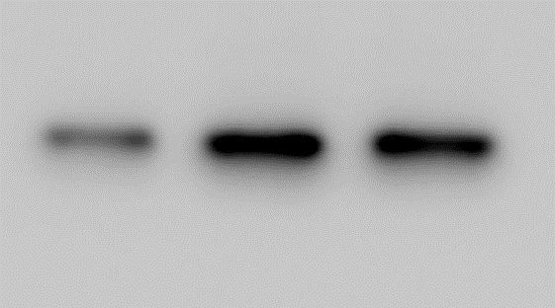
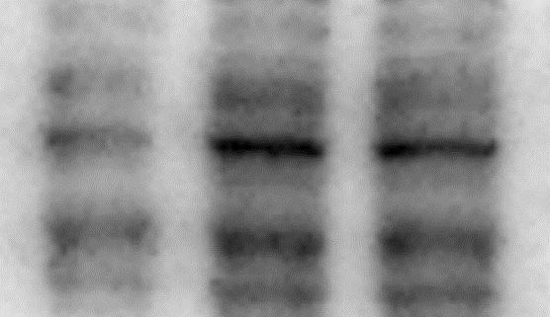
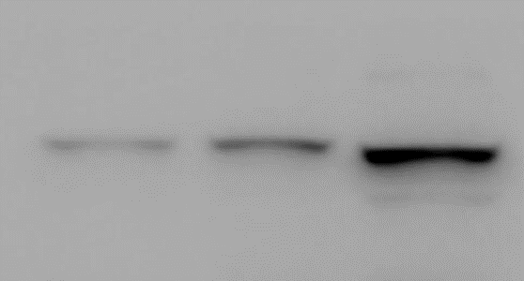
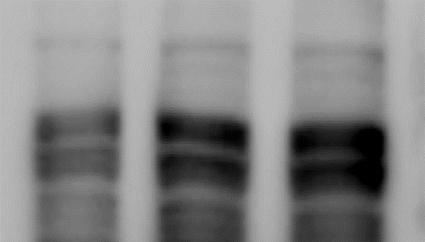
IκBα
39kd

MAVS
52kd

140kd

MDA-5

110kd

RIG-I
PIEC PCV2 Poly(I:C)

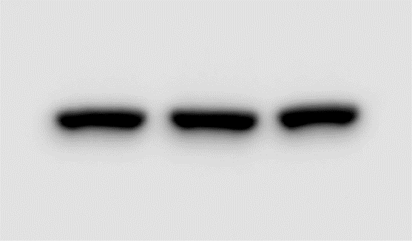
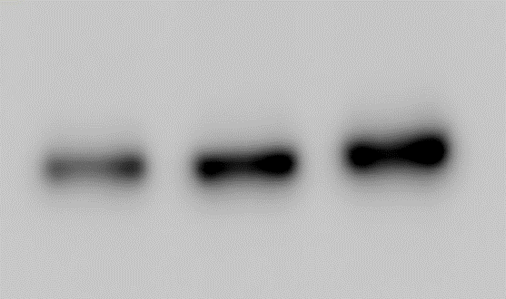
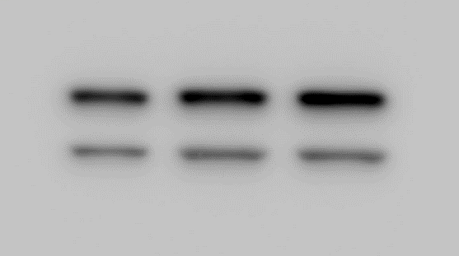
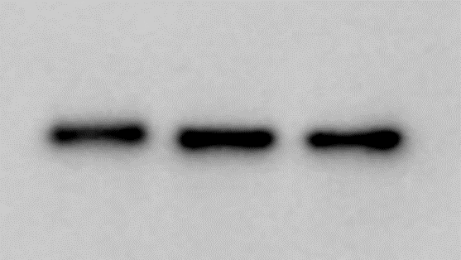
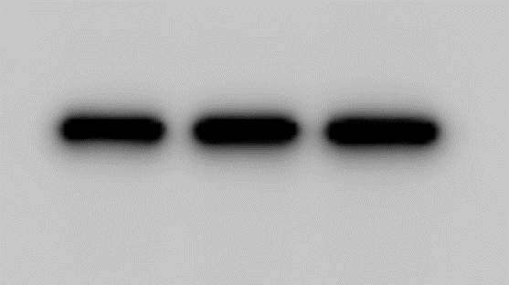
β-actin
42kd

c-Jun
43kd

JNK
54kd

p-p65
65kd

p65
65kd

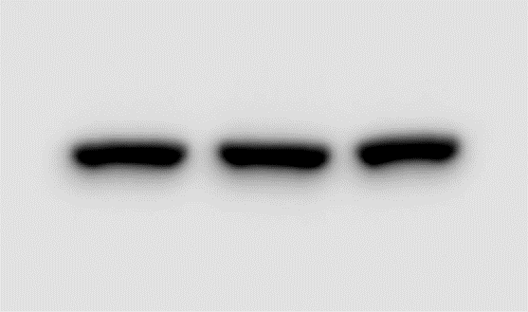

The second result
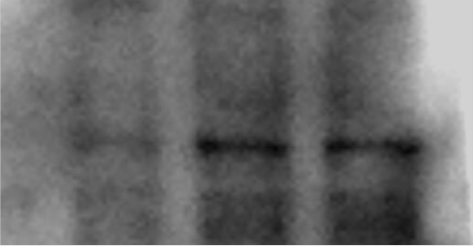
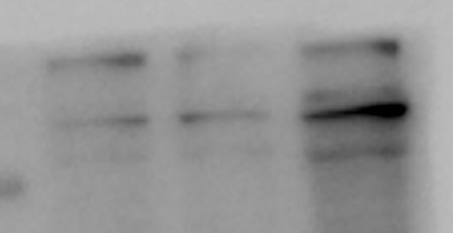
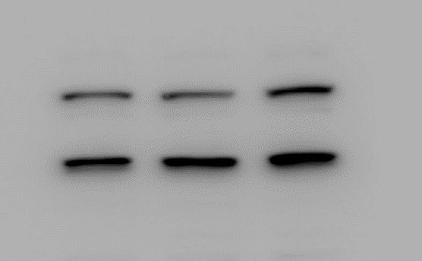
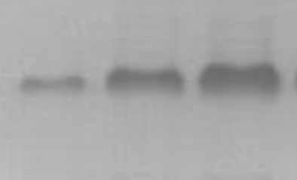
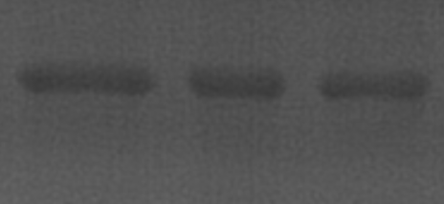
p65
IκBα
MAVS
52kd

39kd

65kd

MDA-5

140kd

RIG-I
110kd

PIEC PCV2 Poly(I:C)

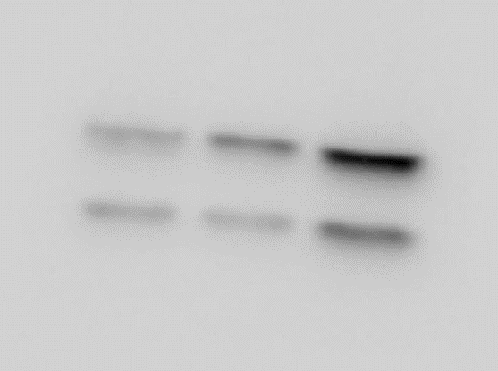
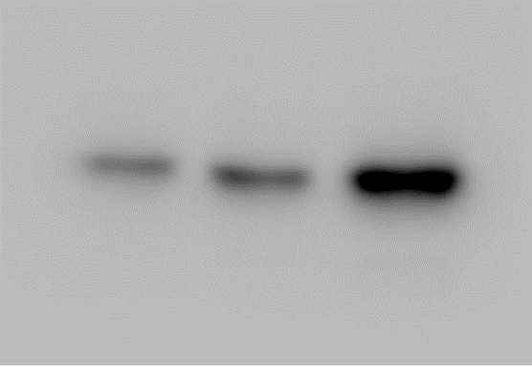
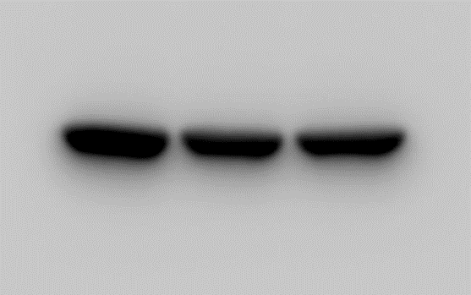
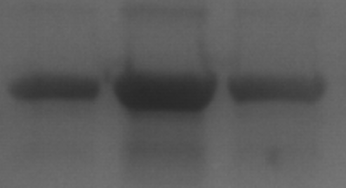
c-Jun
JNK
p-p65
42kd

43kd

54kd

β-actin

65kd

The third result
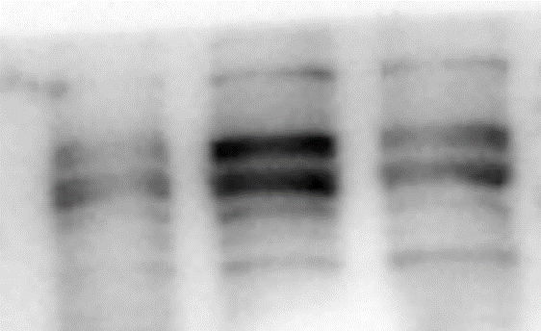
110kd

PIEC PCV2 Poly(I:C)
RIG-I

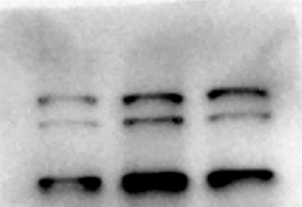

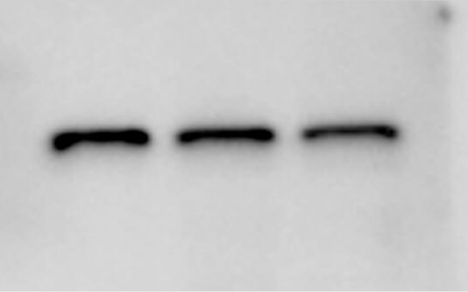
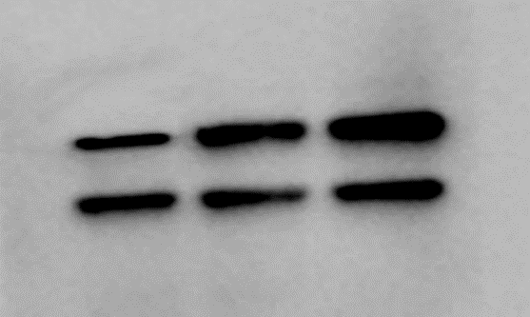
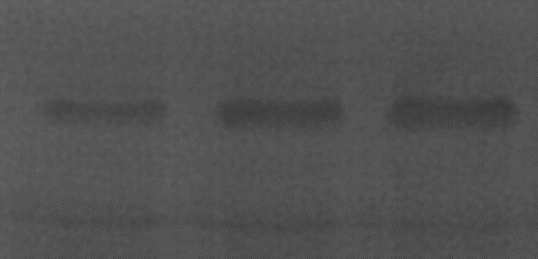
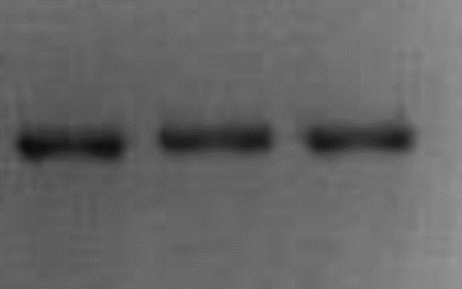
65kd

p65
39kd

IκBα
52kd

MAVS
140kd

MDA-5

65kd

p-p65
JNK
54kd

c-Jun
43kd

β-actin
42kd

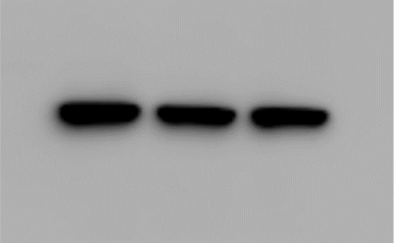
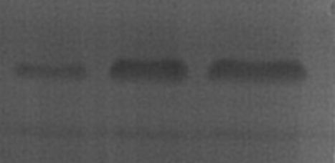
43kd

c-Jun
42kd

β-actin

