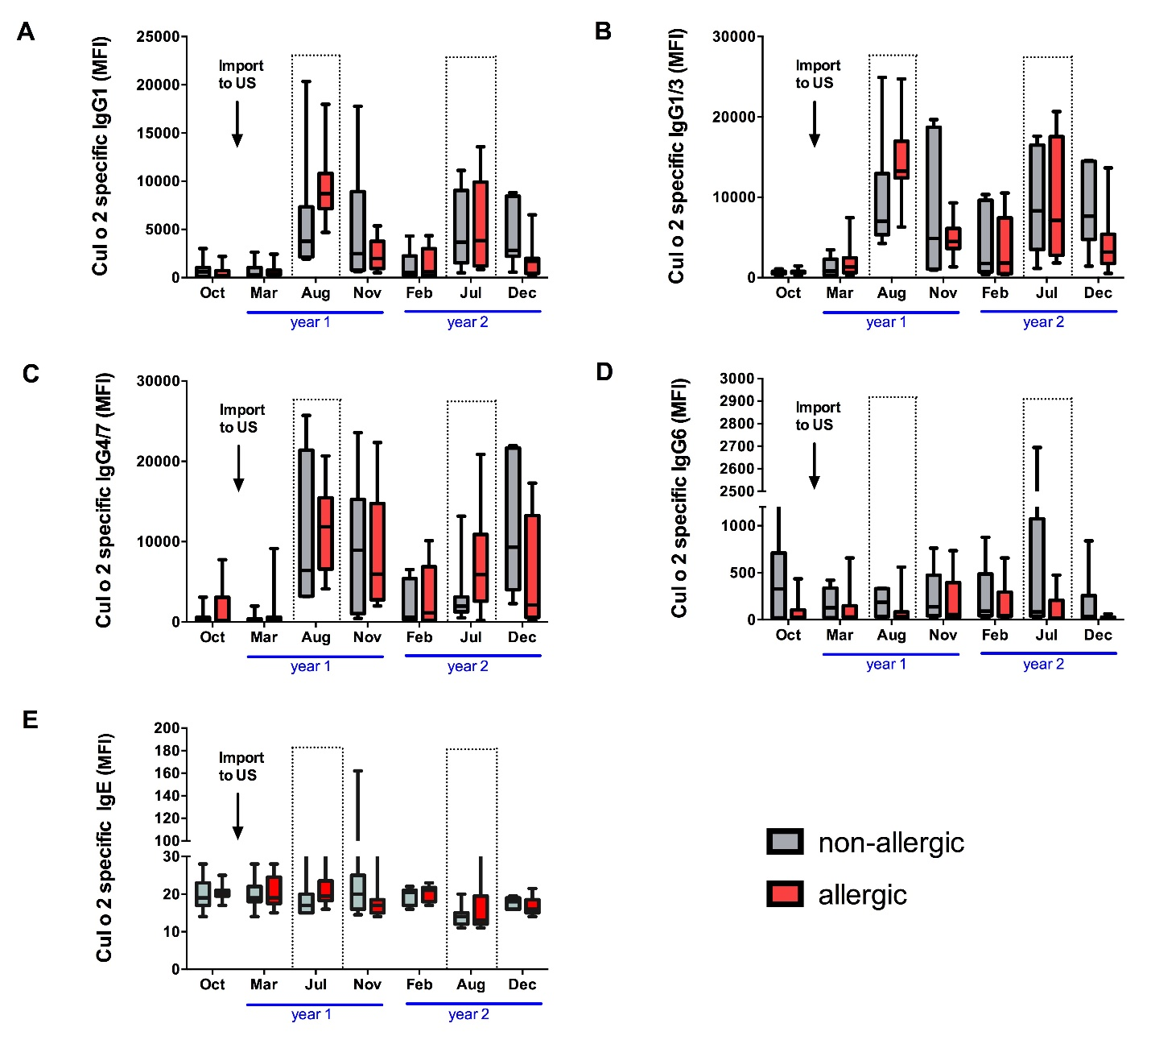
Additional file 2: Cul o 2 specific antibodies in serum of allergic and non-allergic horses. Antibodies in serum of allergic (n= 9) and non-allergic (n= 7) horses were determined using a Culicoides allergen multiplex assay. (A) Cul o 2 specific IgG1, (B) IgG1/3, (C) IgG4/7, (D) IgG6, and (E) IgE. Horses were imported to the US in the beginning of year 1 (arrow). The dotted lines represent the natural exposure times to Culicoides midges during the two-year study period. MFI = median fluorescence intensity.

