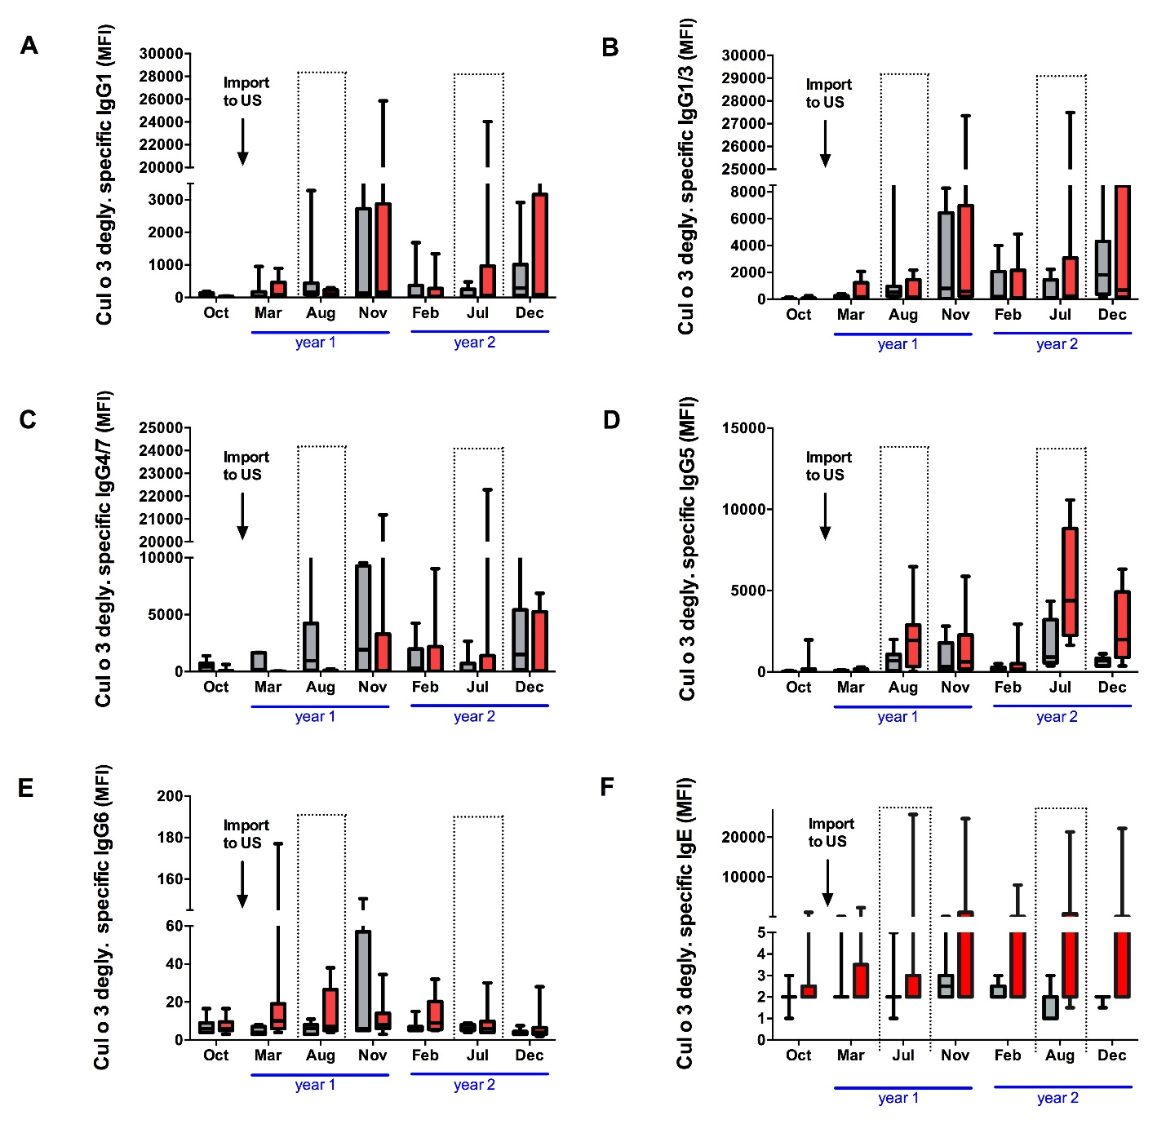
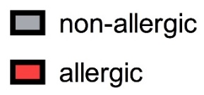

Additional file 3: Cul o 3 specific antibodies responses in serum of allergic and non-allergic horses. Longitudinal data representing (A) Cul o 3 specific IgG1, (B) IgG1/3 (C) IgG4/7 (D) IgG5, (E) IgG6, and (F) IgE antibodies in serum of allergic (n= 9) and non-allergic (n= 7) horses during the two-year study period. The arrow shows the time of import of the horses to the US. The dotted lines indicate natural exposure to Culicoides midges. MFI = median fluorescence intensity.

