Supplementary files
The impact of therapeutic-dose induced intestinal enrofloxacin concentrations in healthy pigs on fecal Escherichia coli populations
Joren De Smet¹, Filip Boyen², Siska Croubels¹, Geertrui Rasschaert³, Freddy Haesebrouck², Robin Temmerman¹, Patrick De Backer¹, Mathias Devreese¹*

¹Department of Pharmacology, Toxicology and Biochemistry, Faculty of Veterinary Medicine, Ghent University, Salisburylaan 133, 9820 Merelbeke, Belgium
²Department of Pathology, Bacteriology and Avian Diseases, Faculty of Veterinary Medicine, Ghent University, Salisburylaan 133, 9820 Merelbeke, Belgium
³Technology and Food Science Unit, Flanders Research Institute for Agriculture, Fisheries and Food, Brusselsesteenweg 370, 9090 Melle, Belgium

* Corresponding Author: Mathias Devreese e-mail: Mathias.Devreese@UGent.be tel: 32 (0)92647347

Experimental design

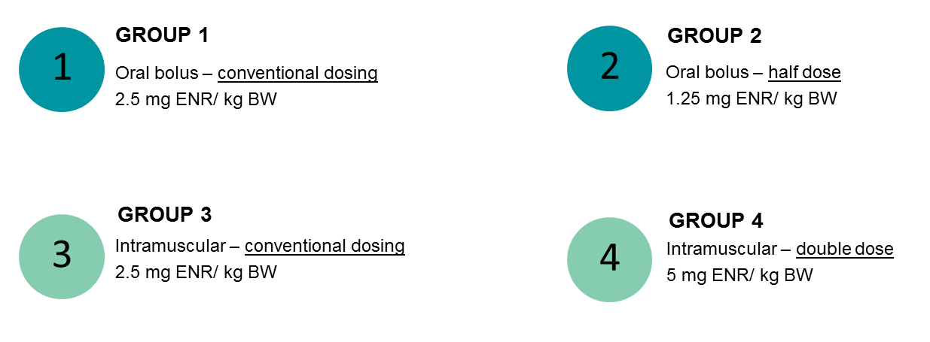

Figure A: Flow-chart of the experimental setup for the enrofloxacin (ENR) administrations with the dose per kg of bodyweight (BW).

Chromatographic separation and instrumentational parameters
Table A1. Gradient elution scheme for chromatographic separation with mobile phases: 0.1% acetic acid in H₂O (A) and acetonitrile (ACN) (B). Liquid chromatography (LC) was performed on a Surveyer ThermoFisher Scientific system (Breda, The Netherlands). Flow rate was 400 µL/mL.
Time (min) | Gradient
0 – 4 | 85% A, 15%B
4 – 4.5 | Linear to 10% A, 90%B
4.5 – 7 | 10% A, 90% B
7 – 7.5 | Linear to 85% A, 15% B
7.5 – 10 | 85% A, 15% B

Table A2. Liquid chromatography (LC) and mass spectrometry (MS) instrumentational parameters obtained after direct infusion of enrofloxacin (ENR) and internal standard (IS) ENR-d5 working solutions of 0.01 µg/mL in an H₂O/acetonitrile (ACN) mixture (80/20 v/v).
LC or MS parameter | Optimized value
Column oven temperature | 45°C
Autosampler tray temperature | 5°C
Spray voltage | 3,800 V
Vaporizer temperature | 300°C
Sheath gas pressure | 33 au (arbitrary units)
Ion sweep gas pressure | 2.0 au
Auxiliary gas pressure | 15 au
Capillary temperature | 300°C
Collision pressure | 1.5 mTorr

Validation parameters LC-MS/MS method
Table B1. Results of major validation parameters: linearity (with correlation coefficient r and goodness-of-fit g), limit of quantification (LOQ, n=6, mean value given ± standard deviation (SD)), limit of detection (LOD, n=6, mean value given ± SD) and signal suppression or enhancement (SSE, n=6, mean value given ± SD) for enrofloxacin (ENR) with calibrator range in feces: 0.050 – 25 µg/g and plasma: 0.035 – 25 µg/mL. Experimental samples always fitted within range.
Matrix | r | g | LOQ (µg/g or µg/mL) | LOD (µg/g or µg/mL) | SSE (%)
Feces | 0.9983 | 5.07 | 0.050 ± 0.00096 | 0.0057 | 52.65 ± 4.61
Plasma | 0.9978 | 5.59 | 0.035 ± 0.0027 | 0.0020 | 66.25 ± 5.83

Table B2. Validation results for the parameters accuracy and precision based on different theoretical concentration levels.
Matrix | Theoretical concentration  (µg/mL or µg/g) | Mean concentration ± SD  (µg/mL of µg/g) | Precision  RSD (%) | Accuracy  (%)
Faeces | 0.050ª | 0.0508 ± 0.000964 | 1.9 | 1.7
Faeces | 0.250ª | 0.251 ± 0.00537 | 2.1 | 0.4
Faeces | 25.00ª | 25.142 ± 1.0778 | 4.3 | 0.6
Faeces | 0.250^{b} | 0.249 ± 0.00529 | 2.1 | -0.4
Faeces | 25.00^{b} | 25.474 ± 1.163 | 4.6 | 1.9
Plasma | 0.035ª | 0.0363 ± 0.00271 | 7.5 | 3.7
Plasma | 0.250ª | 0.251 ± 0.00545 | 2.2 | 0.2
Plasma | 25.00ª | 25.910 ± 1.228 | 4.7 | 3.6
Plasma | 0.250^{b} | 0.243 ± 0.0135 | 5.5 | -2.6
Plasma | 25.00^{b} | 25.925 ± 0.690 | 2.7 | 3.7
ª Within-run accuracy and precision (n=6)
^{b} Between-run accuracy and precision (n=6)
SD: standard deviation; RSD: relative standard deviation. Acceptance criteria: accuracy: > 0.01 µg/mL or µg/g: −20% to +10%; within-run precision: RSD_{max}: ≥ 0.01 µg/mL or µg/g and < 0.1 µg/g or µg/mL: 15%, ≥ 0.1 µg/mL or µg/g: 10%; between-run precision: RSD_{max} = 2^{(1-0.5logC)} (with C (10-9) the concentration at which the samples were fortified).

