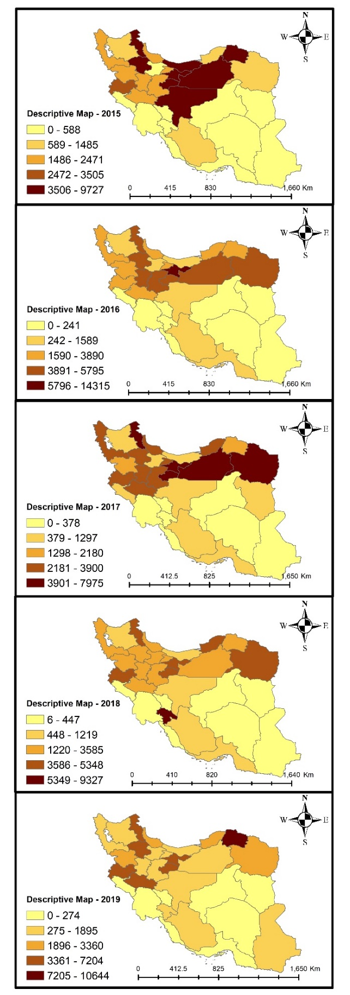
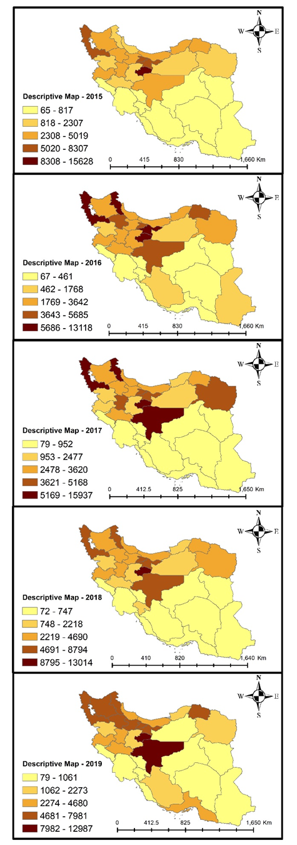
Dicrocoeliasis infection per 100,000 slaughtered cattle (left panels) and sheep and goats (right panels) in 31 Iranian provinces, 2015-2019.

