Supplementary File

Supplementary Table 1. Key words and phrases generated for VetCompass™ data extraction
Keywords
pruritus
itching
dermatitis
atopy
atopic
atopic flare
atopic dermatitis
allerg
allergy
allergic dermatitis
dermat
allerg test
dermat
flea
allerg
flea
dermat
food allerg dermat
food allerg
diet trial
pyoderma AND sarcoptic mange
chronic inflammatory skin disease AND acute moist dermat
hot spot AND yeast dermatitis
flea allerg dermat AND allerg
dermat AND allerg
immunotherapy AND allerg
test AND atopic
dermat AND flea
allerg AND flea
dermat AND food
cutaneous AND food
dermat AND food

Supplementary Table 2. Terms used in the regular expression matches in consultation examination notes
Keywords in consultations used to remove dogs
not atopy| not atopic| not pruritic
no allergies| not allergies| no known allergies| no known allergy
not allergic| not allergy| no pruritis
not atopy| not atopic| not pruritic
lump removal|bandage|bandages|elastoplast|solosite|melolin|ringworm|ringworms
stitches|s/o|sutures|diarrhoea|gi|git|vomit|diarrhoea|tumour|tumor|lump
haematoma| mass removal| rebandage| ultrasound| lumpectomy
torn nail| surgery| wound| dental
cruciate| suture| coughing| sneezing| bronchitis| dog fight| dog attack
neoplasia| vomit| upper airway| upper air way| mass
injured| castrate| spey| spay
limping| lame| limp| tick| allergic asthma| allergic bronchitis| allergic conjunctivitis
anal glands| anal gland| anus| radiographs
uti| urinary| stranguria| haematuria| lameness| hypothyroid| hypot
lip fold dermatitis| allergic rhinitis| dectomax| splint| vulval dermatitis
vulva fold dermatitis| vulval fold dermatitis| dermatitis of vulva
heart failure| dry eye| vaccine reaction

Keywords in consultations used to keep dogs
rash| itch| itchy| itching| scratch| scratching| hypoallergenic| hypo allergenic| allergen| licks feet| skin lesions
otitis| dermatitis| hot spot| hotspot| hot-spot| skin check| eczema| skin condition| ear issues
ear check| check skin| skin irritation| alopecia| erythema| chewing feet| lick at feet
flared|scratchign|scurf|scurfy|pruritic|pododermatitis|erythematous|chews feet
skin referral| ear infection| skin infection| pyoderma| ex skin| examine skin
skin appointment| skin irritated| skin irritation| prurutic| ch skin| skin problem| recheck skin
skin specialist| dermatologist| dermatology| red skin| pruritus| hair loss| painful skin| skin problems
skin issues| mucky ears| sore ears| ear pain| painful ears| painful ear
ears: inflammed| ears: inflammation| ears: chronic inflammation| ears: infected| skinology
recheck ear| ear infections| flare| atopy| check ears| yeast| yeasty| malassezia| sensitive skin| apoquel| allergy

Supplementary Table 3. Treatments flagged, identified and classified in cases and controls
Pharmaceutical group | Class | Search terms
Antibiotics | Tetracycline | Doxycycline, tetracycline  oxycycline
 | Cephalosporin first generation | Cephalexin, cephaforte
 | Cephalosporin third generation | Cefovecin
 | Penicillin without beta-lactamase inhibitors | Amoxicillin, amoxicillin, ampicillin, benacillin, penicillin, benzylpenicillin, depocillin, propercillin
 | Penicillin with beta-lactamase inhibitors | Noroclav, amoxyclav, clavulox, amoxycillin clavulanic acid, ticarcillin clavulanate, timentin
 | Sulfonamide | Trimethoprim, sulfadiazine
 | Nitroimidazole | Metronidazole
 | Lincosamide | Clindamycin, antirobe
 | Fluoroquinolone | Baytril, enroflaxacin, cirofloxacin
Antifungals |  | Ketoconazole, itraconazole  fluconazole, terbinafine  voriconazole, posaconazole
Cyclosporine |  | Cyclosporine, atopica, neural
Corticosteroids |  | Prednisolone, prednisone, delta cortef, methylprednisolone, cortisone, dermapred, macrolone, niralone, preddy granules, predmix, prednil, pred-x, solone, dexamethasone, triamcinolone, delta albaplex tabs, apex pmp, dermotic, hydrocortisone, neocort, neotopic, cortavance, canaural, betamethasone
Antihistamines |  | Niralone (contains c/s), chlorpheniramine, dexchlorpheniramine, cetirizine, hydroxyzine, cyproheptadine, terfenadine, clemastine, trimeprazine, fexofenadine, niramine, diphenhydramine
Topical antimicrobials (these medications contain more than one type of medication) |  | Prednoderm, dermapred, dermotic, isaderm, fuciderm, neocort, cortavance, neotopic-h, panolog, apex antibiotic, surolan, dermocil, dermaclens, dermoscent bio balm, paw triderm, otoflush, otiderm, otomax, canaural, aurizon, baytril ear drops, ciproxin hc ear drops
Omega 3/6 fatty acids |  | Omega, omegaderm, omega-3, megaderm, dermega
Hypoallergenic diets |  | z/d, d/d, advance dog sens skin, delicate care dog skin or stomach, euk dog sensitive skin, royal canin dog skin support, hills dog sens skin, nb delicate care dog skin, rcw dental and skin adult, royal canin canine skin support, euk dog dermatosis, hills derm defence, ppvd dry ha canine hypoallergenic
Medicated shampoos |  | Dermcare ear culture, fidos everyday shampoo, fidos white & bright conditioner, paw 2 in 1 conditioner & shampoo, paw 2in1 cond shampoo, paw classic care shampoo, natural shampoo 250ml dermcare, natural shampoo 500ml, paw nutriderm replenishing shampoo, paw puppy shampoo, troy pet gloss conditioner, wash mate shampoo, otoflush
Flea treatments |  | Advantage, advantix, advocate, bravecto, capstar, comfortis, nexgard, panoramis, revolution, sentinel, simparica, imidacloprid, permethrin, moxidectin, fluralaner, nitenpyram, spinosad, afoxolaner, selamectin, milbemycin oxime, sarolaner
Thyroid medication |  | Oroxine, thyroxine
Allergy vaccinations (immunotherapy) |  | Recorded as 1 for vaccinated and 0 for unvaccinated as allergens were not specified in item name
Individual drugs | Hydrocortisone | Hydrocortisone
 | Chlorpheniramine | Chlorpheniramine
 | Chlorhexidine | Chlorhexidine, chlorhex, malaseb, pyohex, topizole
 | Neomycin | Neomycin, neocort, neotopic
 | Polymixin B | polymixin B, apex pmp, dermotic
 | Amoxycillin clavulanic acid | Noroclav, amoxyclav, clavulox, amoxycillin clavulanic acid

Supplementary Table 4. The percentage distribution of different skin and ear condition categories in cases and controls at baseline.
Skin condition categories | Control (%) | Case (%)
Allergic dermatitis without infection | 92 | 93
Unknown | 6 | 4
Superficial pyoderma | 3 | 2
Deep pyoderma | 0 | 0
Ear condition categories | Control (%) | Case (%)
Unknown/not an ear condition | 89 | 88
Cocci present | 3 | 2
Rods present | 1 | 0
Malassezia present | 8 | 9

Supplementary Table 5. Search terms used for skin condition categories
Skin condition categories | Search terms
Superficial pyoderma | - Papules, pustules, erythema, collarettes  - Cytological evidence of infections  - Antibiotic or intensive topical therapy dispensed  - Clinical diagnosis  - At least 3 of the above should be identified
Deep bacterial pyoderma | - Nodules, draining tracts, cellulitis etc (furunculosis is technically a histopathological diagnosis but commonly used as a descriptor in records).  - Clinical diagnosis  - Antibiotics dispensed for more than 8 weeks
Allergic dermatitis with no infection | - No systemic or topical antibiotics dispensed  - No clinical mentioned of pyoderma

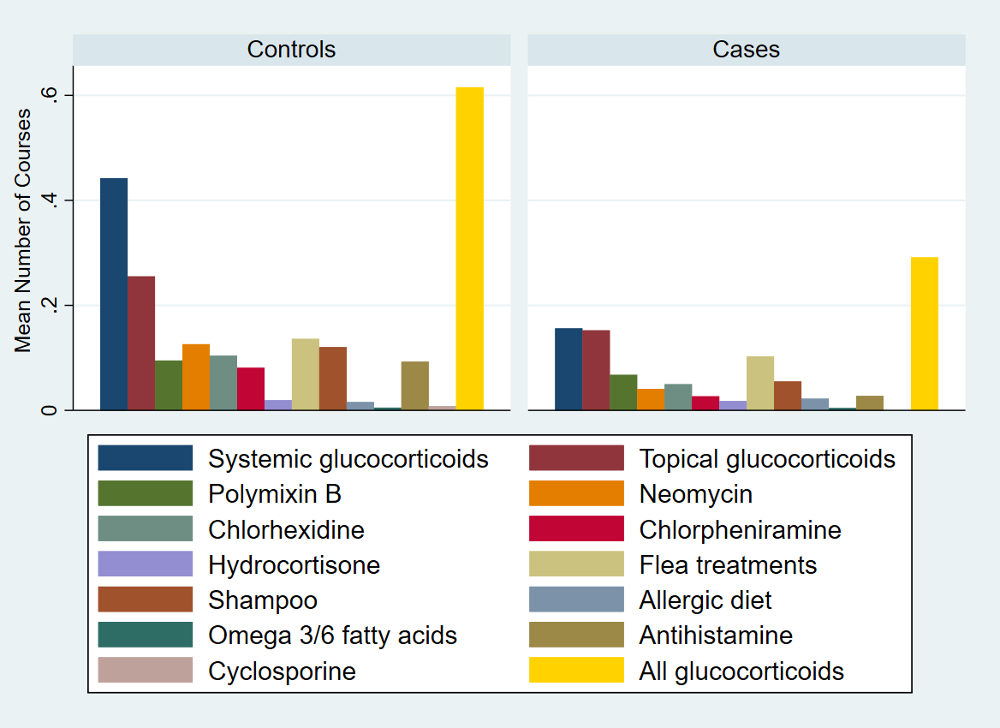
Supplementary Figure 1. Bar charts displaying the mean number of courses of antipruritic treatments other than oclacitinib used by 5380 controls (after their initial skin consultation) and 1345 cases (after initial oclacitinib use).

