Additional file 1. The original, full length blots of western blot.

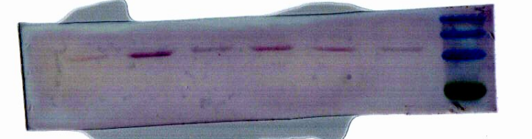
45 kDa
p-IĸBα
E. coli (10⁷ CFU/mL) - + - + + +
L. plantarum 17-5 (CFU/mL) - - 10⁵ 10⁴ 10⁵ 10⁶
36 kDa
60 kDa
35 kDa
25 kDa

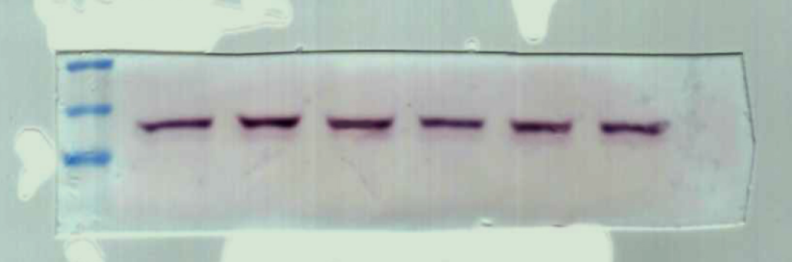
IĸBα
E. coli (10⁷ CFU/mL) - + - + + +
L. plantarum 17-5 (CFU/mL) - - 10⁵ 10⁴ 10⁵ 10⁶
60 kDa
45 kDa
35 kDa
36 kDa

80 kDa
60 kDa
45 kDa
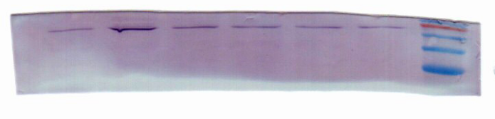
p-p65
E. coli (10⁷ CFU/mL) - + - + + +
L. plantarum 17-5 (CFU/mL) - - 10⁵ 10⁴ 10⁵ 10⁶
61 kDa

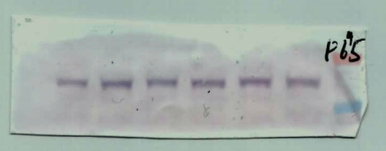
p65
E. coli (10⁷ CFU/mL) - + - + + +
L. plantarum 17-5 (CFU/mL) - - 10⁵ 10⁴ 10⁵ 10⁶
61 kDa
80 kDa
60 kDa

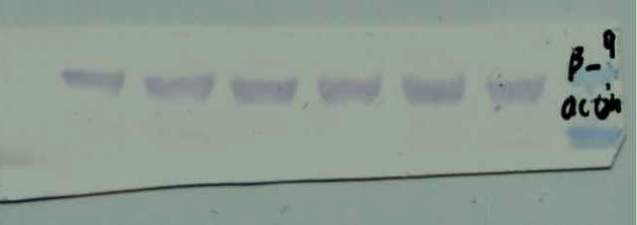
β-actin
E. coli (10⁷ CFU/mL) - + - + + +
L. plantarum 17-5 (CFU/mL) - - 10⁵ 10⁴ 10⁵ 10⁶
42 kDa
45 kDa
35 kDa

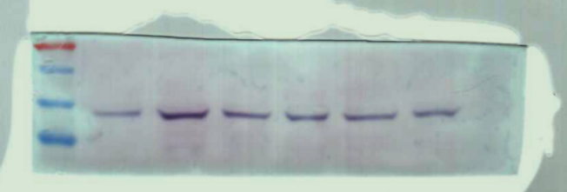
p-p38
E. coli (10⁷ CFU/mL) - + - + + +
L. plantarum 17-5 (CFU/mL) - - 10⁵ 10⁴ 10⁵ 10⁶
60 kDa
43 kDa
45 kDa
35 kDa

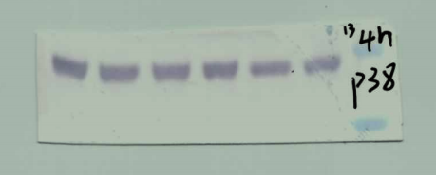
p38
E. coli (10⁷ CFU/mL) - + - + + +
L. plantarum 17-5 (CFU/mL) - - 10⁵ 10⁴ 10⁵ 10⁶
40 kDa
45 kDa

35 kDa

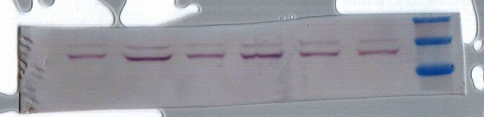
60 kDa
p-ERK
E. coli (10⁷ CFU/mL) - + - + + +
L. plantarum 17-5 (CFU/mL) - - 10⁵ 10⁴ 10⁵ 10⁶
44 kDa
45 kDa
42 kDa
35 kDa

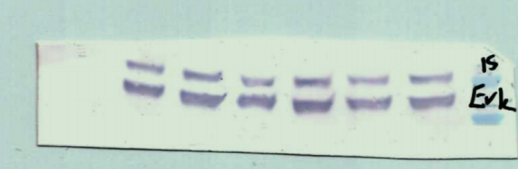
ERK
E. coli (10⁷ CFU/mL) - + - + + +
L. plantarum 17-5 (CFU/mL) - - 10⁵ 10⁴ 10⁵ 10⁶
44 kDa
45 kDa
42 kDa
35 kDa

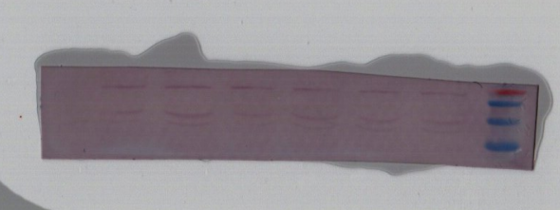
P-JNK
E. coli (10⁷ CFU/mL) - + - + + +
L. plantarum 17-5 (CFU/mL) - - 10⁵ 10⁴ 10⁵ 10⁶
46 kDa
60 kDa
44 kDa
35 kDa
45 kDa

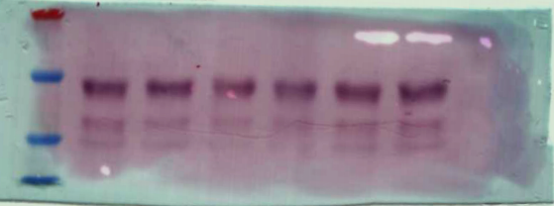
JNK
E. coli (10⁷ CFU/mL) - + - + + +
L. plantarum 17-5 (CFU/mL) - - 10⁵ 10⁴ 10⁵ 10⁶
60 kDa

46 kDa
45 kDa
44 kDa

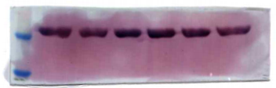
β-actin
E. coli (10⁷ CFU/mL) - + - + + +
L. plantarum 17-5 (CFU/mL) - - 10⁵ 10⁴ 10⁵ 10⁶
45 kDa
42 kDa

35 kDa

