Table 1. Semi-structured interview: Coding structure and response frequency of participatory meetings with hunters in Lithuania.
Code group | Code subgroup | No. of times mentioned | No. of focus groups mentioning the code
Known ASF control measures | Ban of driven hunting | 1 | 1
Known ASF control measures | Ban of supplementary feeding | 4 | 4
Known ASF control measures | Biosecurity implementation | 1 | 1
Known ASF control measures | Effective removal of carcasses | 5 | 4
Known ASF control measures | Physical barriers | 1 | 1
Known ASF control measures | Wild boar population control | 1 | 1
Consequences of ASF persistence in the Lithuanian wild boar population | Difficult work for hunters | 4 | 4
 | Economic impact for pig keepers | 4 | 3
 | Financial cost for hunters | 4 | 3
 | Inconvenient ASF testing procedures | 4 | 2
 | Lack of information for hunters regarding ASF | 2 | 2
 | Reduced wild boar populations | 9 | 3
 | Ruined hobby for hunters | 8 | 4
Potential routes of virus introduction into the Lithuanian wild boar population | Migration of wild boar from affected countries | 6 | 6
 | Pigs breeding complexes | 2 | 2
 | Various fomites import from affected countries | 9 | 5
Transmission pathways of the virus | Contact between wild boar | 2 | 2
Transmission pathways of the virus | Contaminated feed | 4 | 4
Transmission pathways of the virus | Contaminated trash, food leftovers | 3 | 3
Transmission pathways of the virus | Dense wild boar population | 1 | 1
Transmission pathways of the virus | Lack of biosecurity | 10 | 7
Transmission pathways of the virus | Liquids from infected wild boar | 1 | 1
Transmission pathways of the virus | Movement of sick animals | 11 | 5
Transmission pathways of the virus | People movement | 12 | 7
Transmission pathways of the virus | Wild boar carcasses | 4 | 3

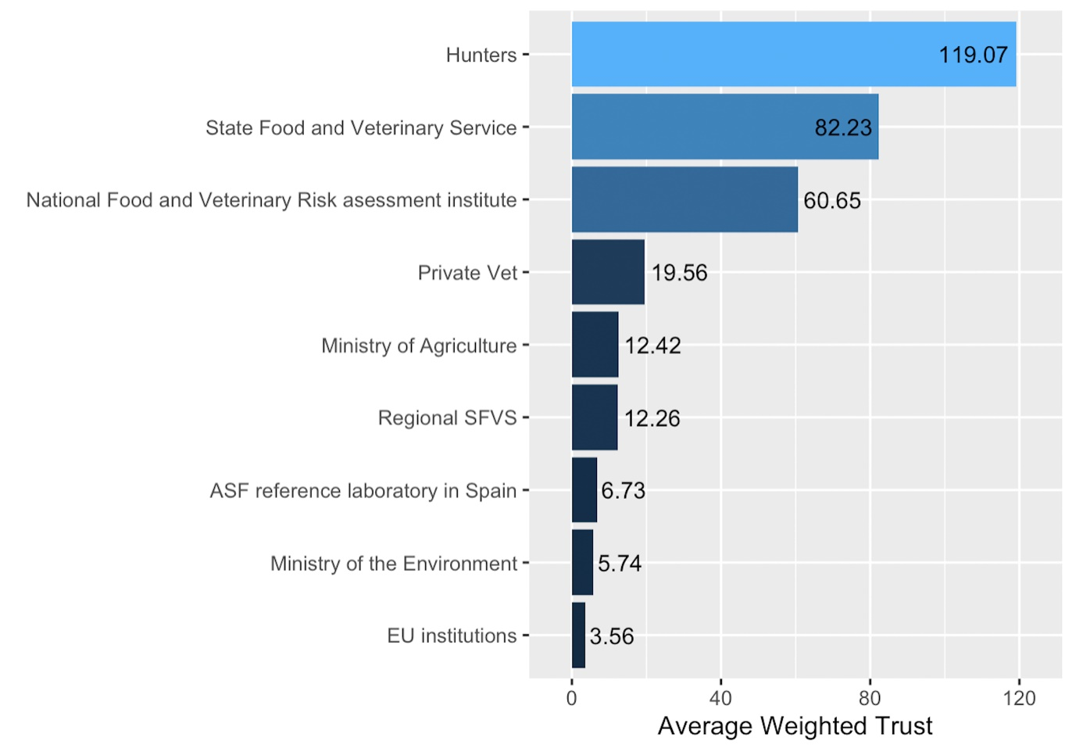
Figure 1: Values of the average trust in the performance of stakeholders listed in the flow diagram to effectively implement ASF control measures in Lithuania.
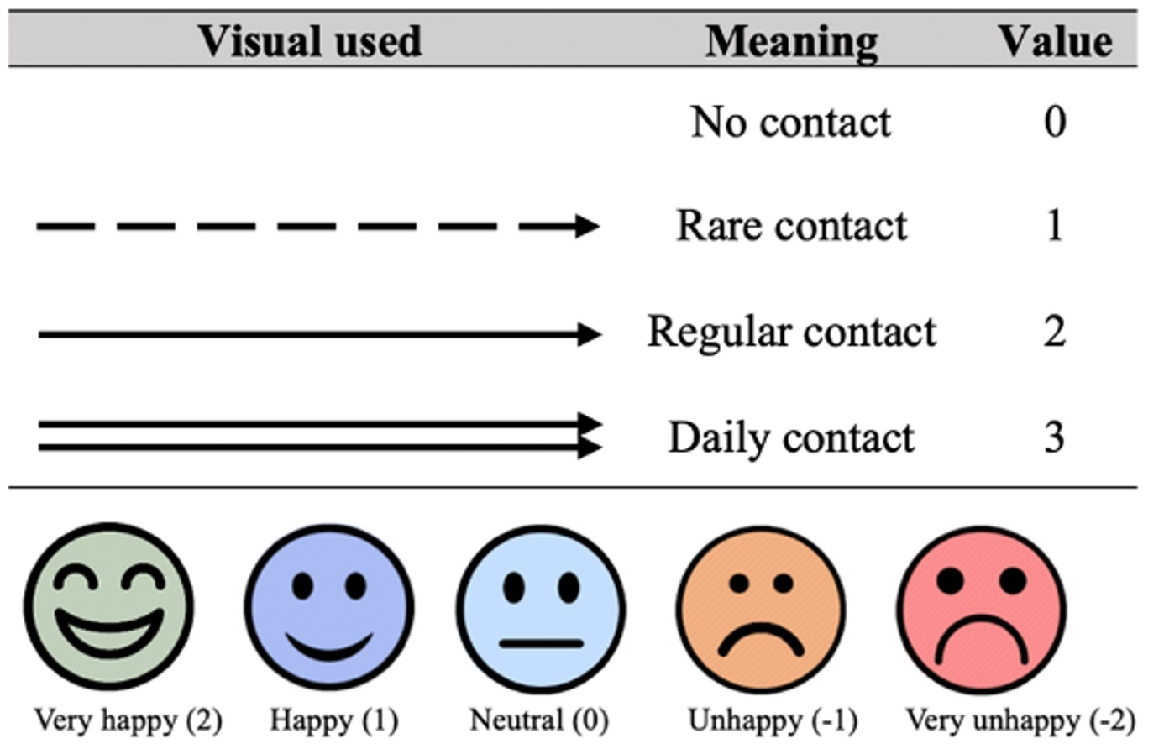
Figure 2: Visualization tools to define quantity and quality of the contact between hunters and other stakeholders involved in the ASF network.

