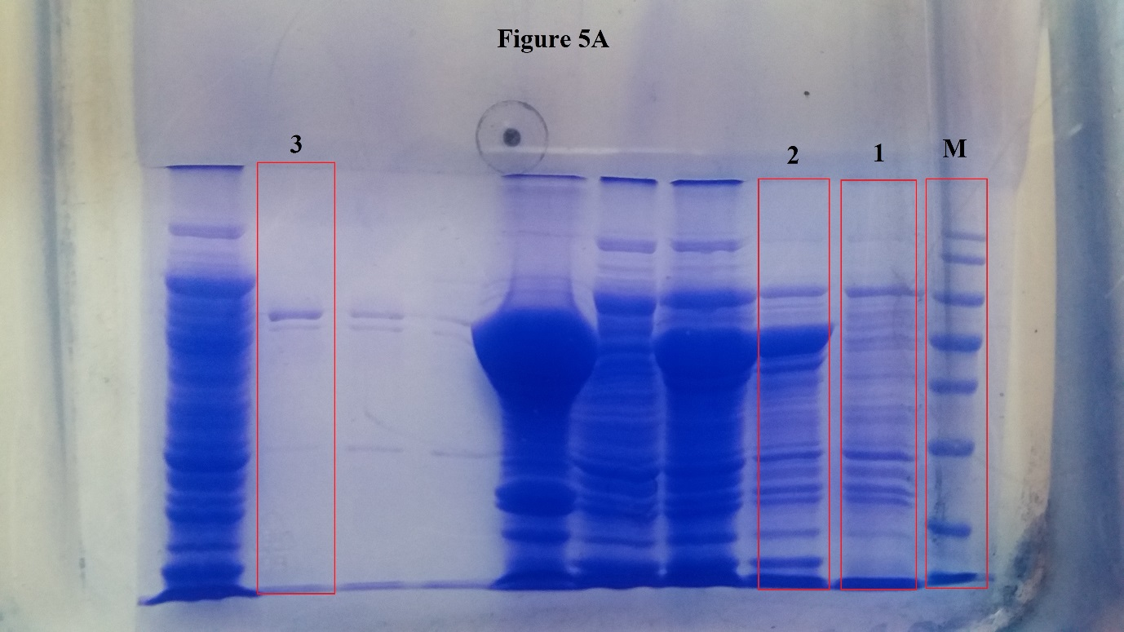
Fig 5 A

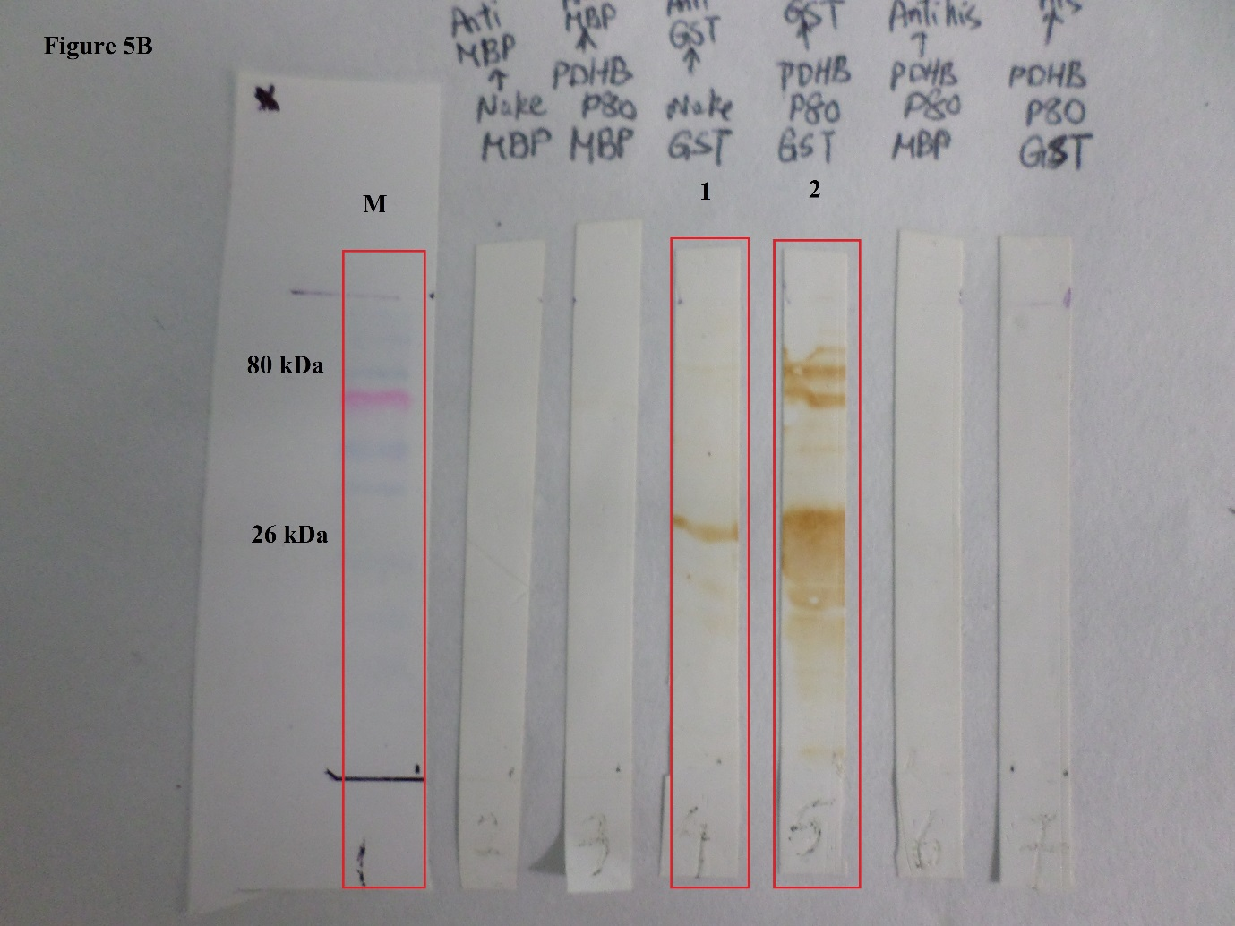
Fig 5 B
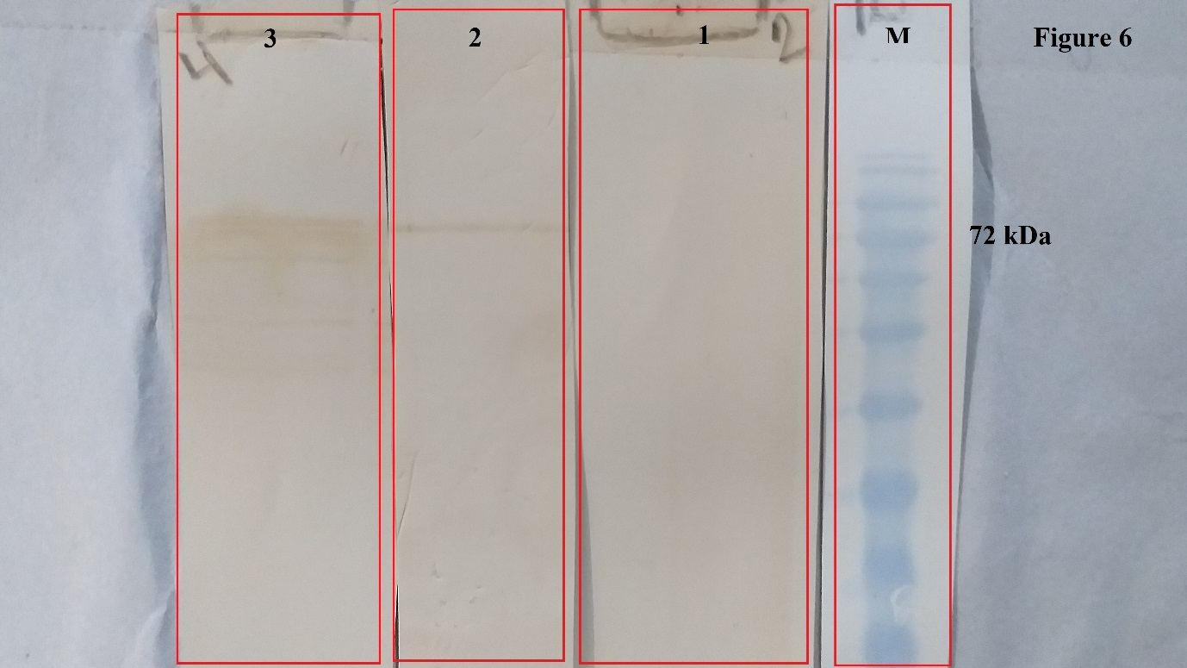
Fig 6

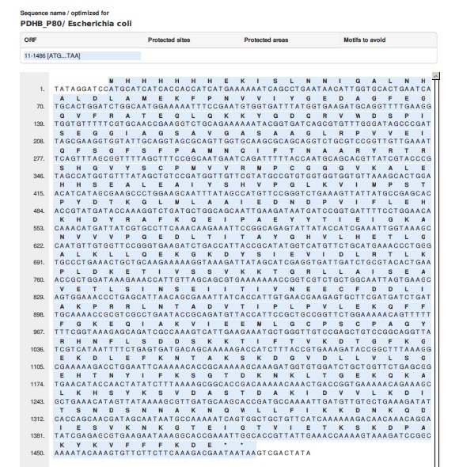
Fig 1S. PDHB-P80 sequence. From nucleotide 1 to 1015 is PDHB sequence and 1027 to the end is P80 antigenic region.
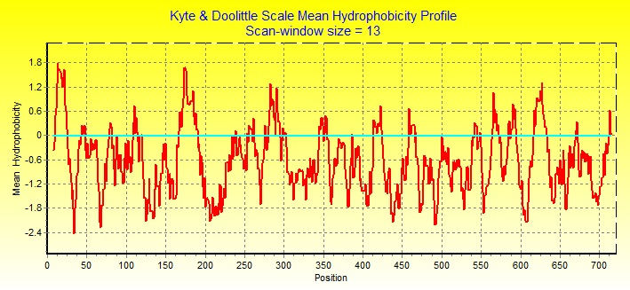
Fig 2S. The hydrophobicity of whole P80 sequence estimated by BioEdit Sequence Alignment Editor. The more antigenic (hydrophilic) regions of P80 (from amino acid 373 to 524) were selected to construct the fusion protein.
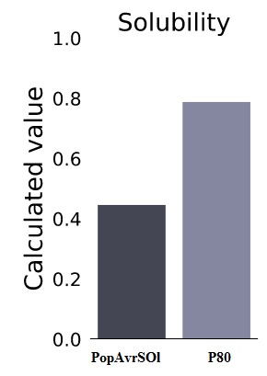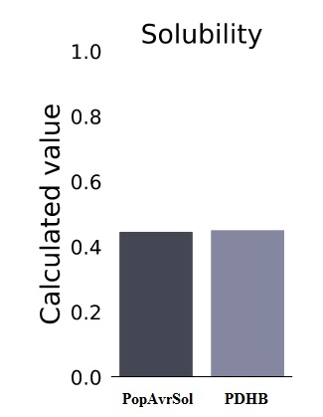
Fig 3S. Separated solubility analysis of PDHB and P80 using Pro-Sol online server.

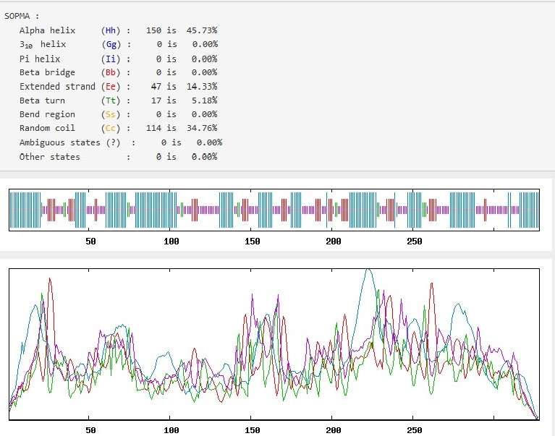
Fig 4S. Secondary structure of PDHB protein estimated by SOPMA online server.
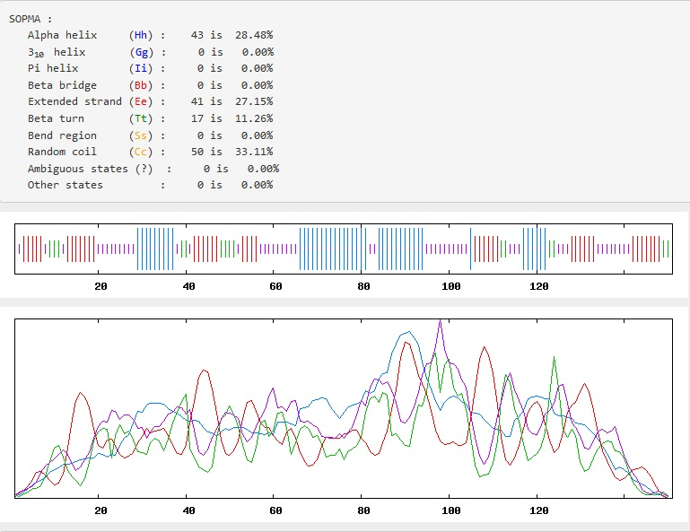
Fig 5S. Secondary structure of P80 protein estimated by SOPMA online server.

