Supplementary materials
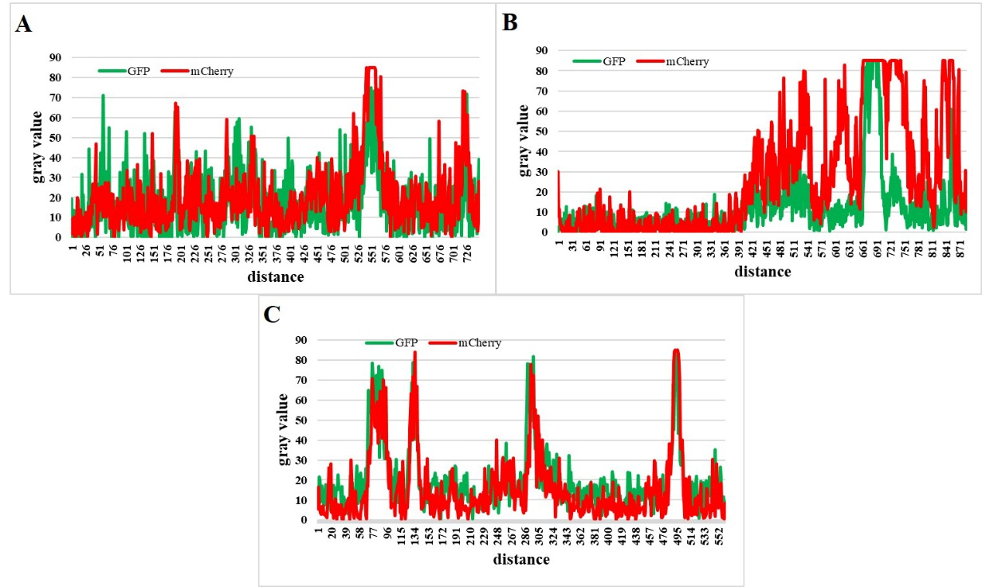
Fig.S1 Fluorescence intensity and co-localization analysis of Cherry and GFP. Vero cells were transfected with pmCherry-GFP-LC3B for 24 h, followed by CDV infection (MOI = 1) and treatment with E64d. The fluorescence signals were visualized by confocal immunofluorescence microscopy. (A) Image J software analysis of fluorescence intensity and co-location of GFP and mCherry at 24 hpi. (B) Image J software analysis of fluorescence intensity and co-location of GFP and mCherry at 32 hpi. (C) Image J software analysis of fluorescence intensity and co-location of GFP and mCherry after E64d treatment.

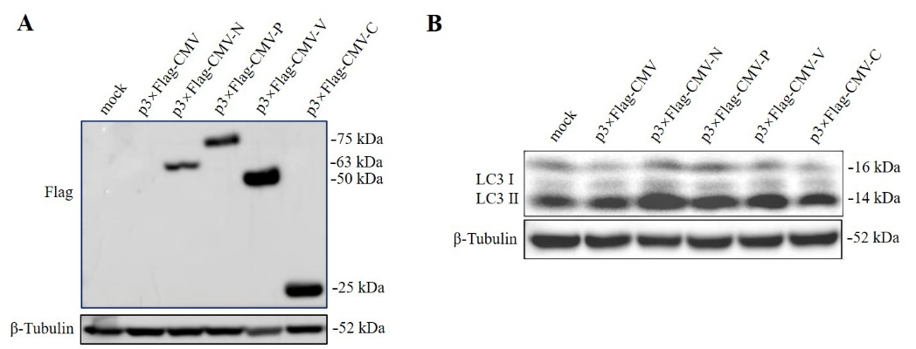
Fig.S2 N protein significantly increased the level of LC3-II. Vero cells were transfected with empty vectors or various plasmids expressing Flag-tagged N, P, V, and C proteins for 48 h. (A) The cell samples were analyzed by immunoblotting with an anti-Flag antibody. (B) The cell samples were analyzed by immunoblotting with anti-LC3 and anti-β-tubulin (loading control) antibodies.

