Matrine combined with Osthole inhibited the PERK apoptosis of splenic lymphocytes in PCV2-infected mice model

Yinlan Xu^{1,2#}, Shuangxiu Wan^{1,6#}, Panpan Sun³, Ajab Khan¹, Jianhua Guo⁴, Xiaozhong Zheng⁵, Yaogui Sun¹, Kuohai Fan³, Wei Yin¹, Hongquan Li¹ and Na Sun^{1*}

#These authors contributed equally to this work.

*Corresponding author: Na Sun：E-mail: snzh060511@126.com
College of Veterinary Medicine, Shanxi Agricultural University, Taigu, Shanxi 030801 China.
The original PCR and HE staining images of Fig. 2

a The original PCR images of Fig. 2a
200 bp
100 bp
Spleen
Thymus
Liver
M K 1 2 3 4 5 1 2 3 4 5 1 2 3 4 5 M
M K 1 2 3 4 5 1 2 3 4 5 1 2 3 4 5
Blood
Lung
Lymph nodes
200 bp
100 bp

b The original HE staining images of Fig. 2b
Normal group
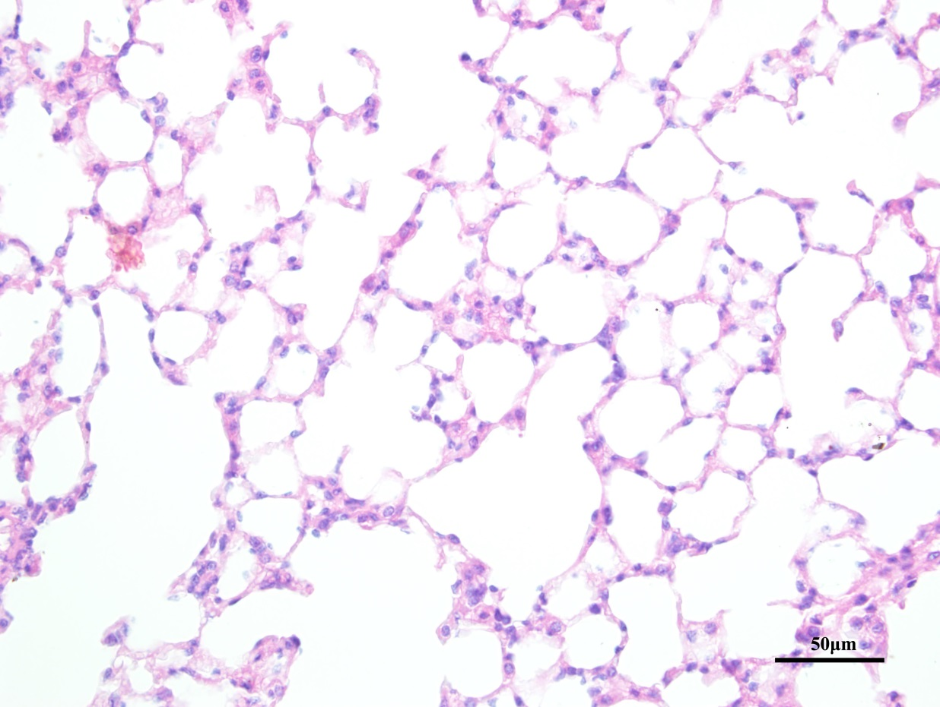
PCV2 group
