Matrine combined with Osthole inhibited the PERK apoptosis of splenic lymphocytes in PCV2-infected mice model

Yinlan Xu^{1,2#}, Shuangxiu Wan^{1,6#}, Panpan Sun³, Ajab Khan¹, Jianhua Guo⁴, Xiaozhong Zheng⁵, Yaogui Sun¹, Kuohai Fan³, Wei Yin¹, Hongquan Li¹ and Na Sun^{1*}

#These authors contributed equally to this work.

*Corresponding author: Na Sun：E-mail: snzh060511@126.com
College of Veterinary Medicine, Shanxi Agricultural University, Taigu, Shanxi 030801 China.
Original IHC image of Fig. 6a

a Normal group
b PCV2 group
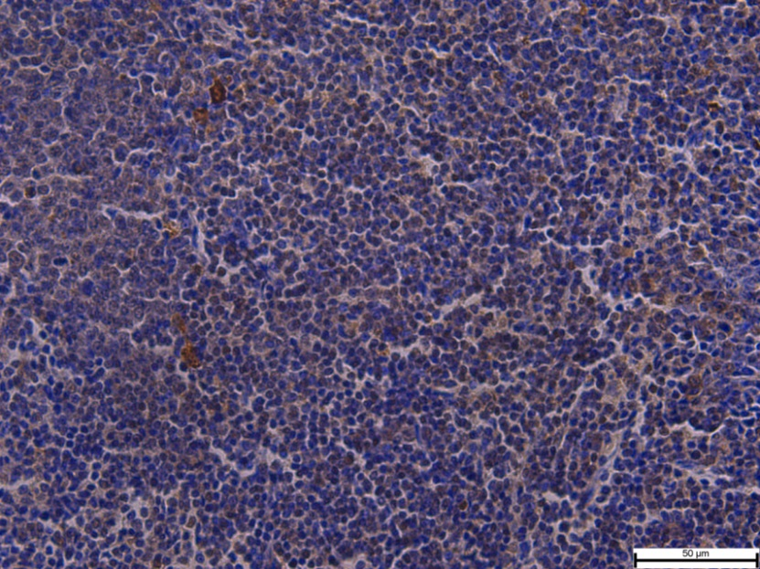

c High dose (40+12) mg/kg group
d Middle dose (20+6) mg/kg group

e Low dose (10+3) mg/kg group
f Matrine 40 mg/kg group

g Osthole 12 mg/kg group
h Ribavirin 40 mg/kg group
