Matrine combined with Osthole inhibited the PERK apoptosis of splenic lymphocytes in PCV2-infected mice model

Yinlan Xu^{1,2#}, Shuangxiu Wan^{1,6#}, Panpan Sun³, Ajab Khan¹, Jianhua Guo⁴, Xiaozhong Zheng⁵, Yaogui Sun¹, Kuohai Fan³, Wei Yin¹, Hongquan Li¹ and Na Sun^{1*}

#These authors contributed equally to this work.

*Corresponding author: Na Sun：E-mail: snzh060511@126.com
College of Veterinary Medicine, Shanxi Agricultural University, Taigu, Shanxi 030801 China.
Original blot image of 6b

a Cleaved-caspase 3

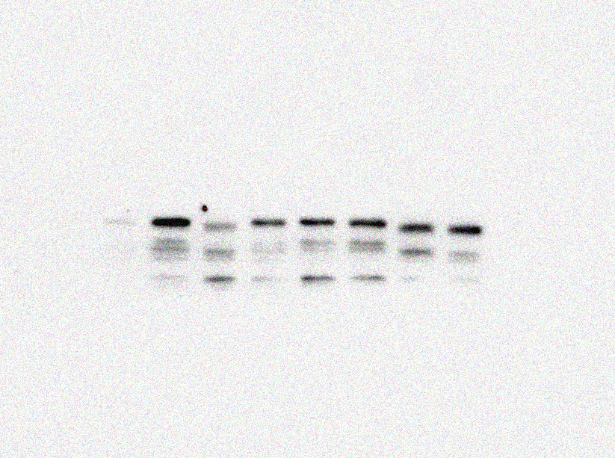
Cleaved caspase-3
(32KDa)

PCV2 group
Normal control
High group (10+3)mg/kg
Matrine 40 mg/kg
Low group (40+12)mg/kg
Ribavirin 40 mg/kg
Middle group (20+6)mg/kg
Osthole 12 mg/kg

b Bax
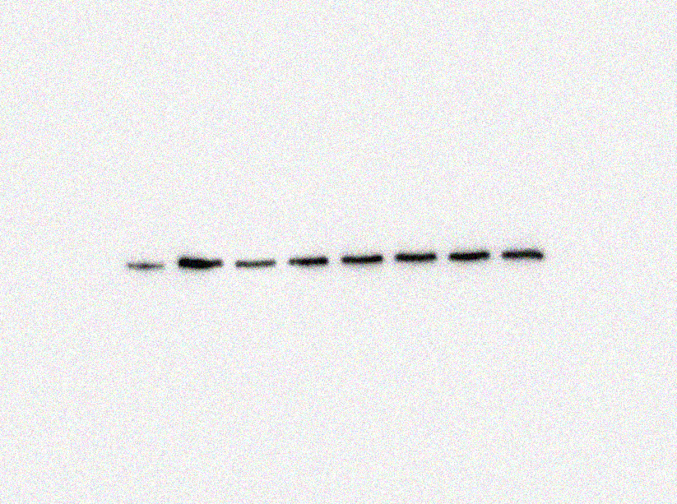
Bax
(21KDa)

PCV2 group
Normal control
High group (10+3)mg/kg
Matrine 40 mg/kg
Low group (40+12)mg/kg
Ribavirin 40 mg/kg
Middle group (20+6)mg/kg
Osthole 12 mg/kg

c Bcl-2

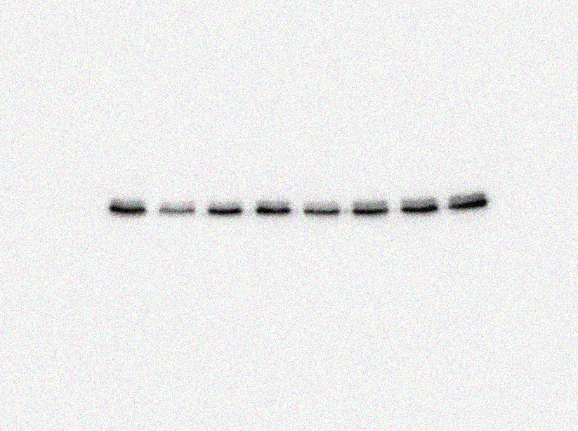
Bcl-2
(26KDa)

PCV2 group
Normal control
High group (10+3)mg/kg
Matrine 40 mg/kg
Low group (40+12)mg/kg
Ribavirin 40 mg/kg
Middle group (20+6)mg/kg
Osthole 12 mg/kg

d GAPDH
GAPDH
(36KDa)

PCV2 group
Normal control
High group (10+3)mg/kg
Matrine 40 mg/kg
Low group (40+12)mg/kg
Ribavirin 40 mg/kg
Middle group (20+6)mg/kg
Osthole 12 mg/kg


