Matrine combined with Osthole inhibited the PERK apoptosis of splenic lymphocytes in PCV2-infected mice model

Yinlan Xu^{1,2#}, Shuangxiu Wan^{1,6#}, Panpan Sun³, Ajab Khan¹, Jianhua Guo⁴, Xiaozhong Zheng⁵, Yaogui Sun¹, Kuohai Fan³, Wei Yin¹, Hongquan Li¹ and Na Sun^{1*}

#These authors contributed equally to this work.

*Corresponding author: Na Sun：E-mail: snzh060511@126.com
College of Veterinary Medicine, Shanxi Agricultural University, Taigu, Shanxi 030801 China.
Original blot image of 7A and 7b

a GRP78 of Fig. 7a
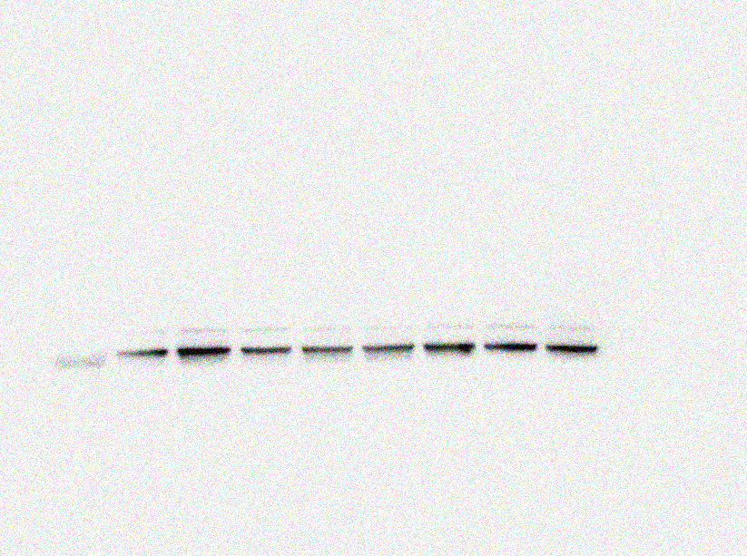
GRP78
(78KDa)

PCV2 group
Normal control
High group (10+3)mg/kg
Matrine 40 mg/kg
Low group (40+12)mg/kg
Ribavirin 40 mg/kg
Middle group (20+6)mg/kg
Osthole 12 mg/kg
b p^{-PERK} of Fig. 7a
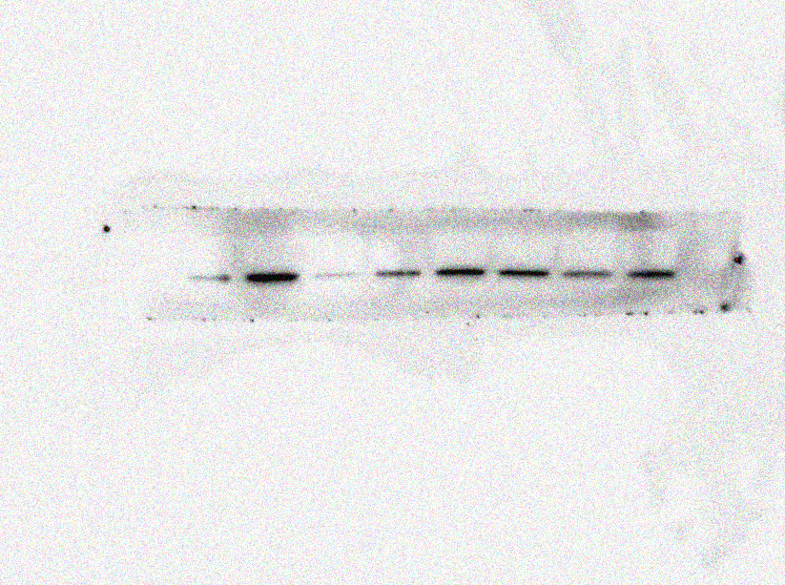
p^{-PERK} (150KDa)

PCV2 group
Normal control
High group (10+3)mg/kg
Matrine 40 mg/kg
Low group (40+12)mg/kg
Ribavirin 40 mg/kg
Middle group (20+6)mg/kg
Osthole 12 mg/kg
c t^{-PERK} of Fig. 7a
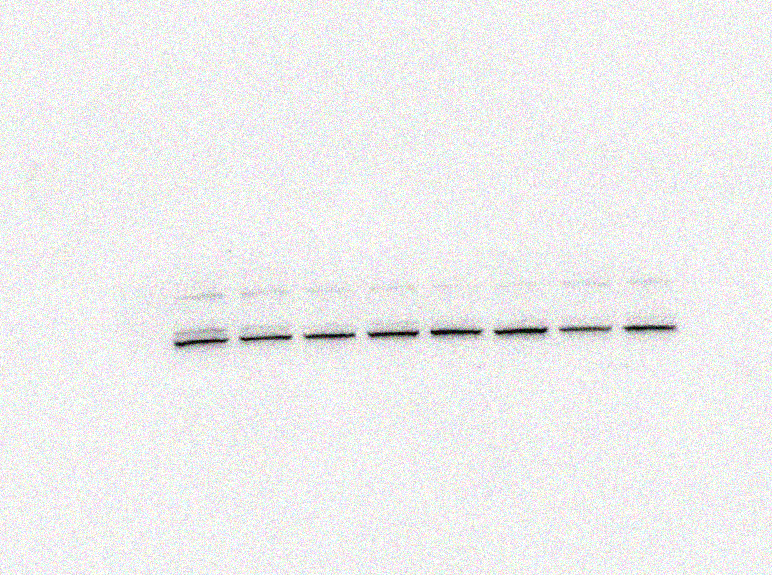
t^{-PERK} (150KDa)

PCV2 group
Normal control
High group (10+3)mg/kg
Matrine 40 mg/kg
Low group (40+12)mg/kg
Ribavirin 40 mg/kg
Middle group (20+6)mg/kg
Osthole 12 mg/kg

d GAPDH of Fig. 7a
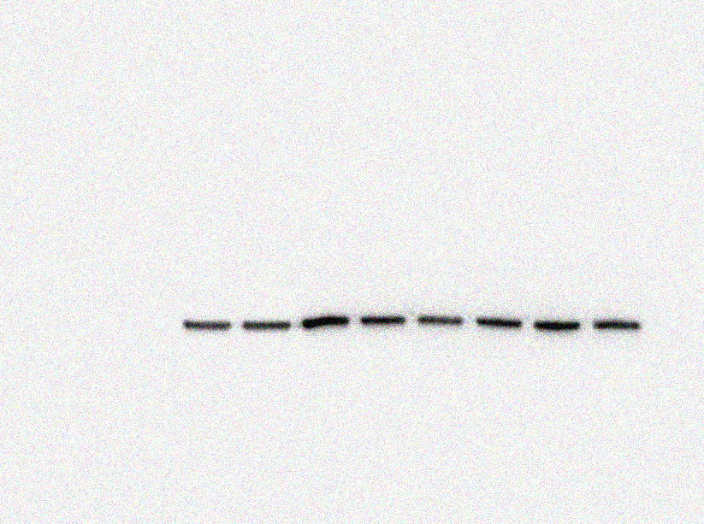
GAPDH
(36KDa)

PCV2 group
Normal control
High group (10+3)mg/kg
Matrine 40 mg/kg
Low group (40+12)mg/kg
Ribavirin 40 mg/kg
Middle group (20+6)mg/kg
Osthole 12 mg/kg
a p^{-eIF2α} of Fig. 7b
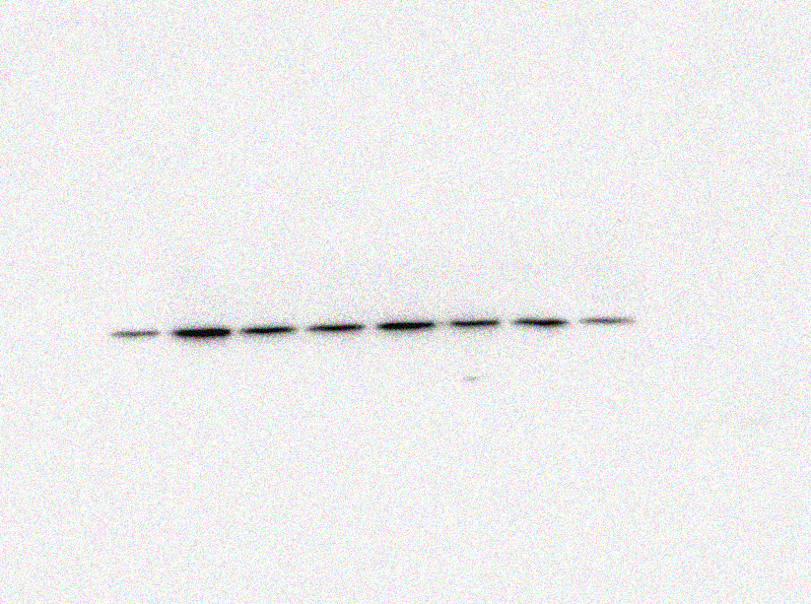
P^{-eIF2α}
(36KDa)

PCV2 group
Normal control
High group (10+3)mg/kg
Matrine 40 mg/kg
Low group (40+12)mg/kg
Ribavirin 40 mg/kg
Middle group (20+6)mg/kg
Osthole 12 mg/kg
b t^{-eIF2α} of Fig. 7b
t^{-eIF2α}
(65KDa)

PCV2 group
Normal control
High group (10+3)mg/kg
Matrine 40 mg/kg
Low group (40+12)mg/kg
Ribavirin 40 mg/kg
Middle group (20+6)mg/kg
Osthole 12 mg/kg
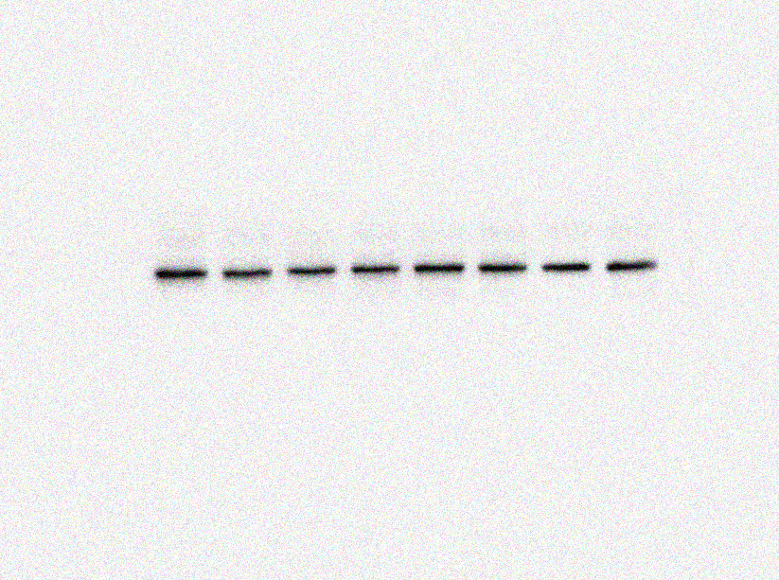

c ATF4 of Fig. 7b
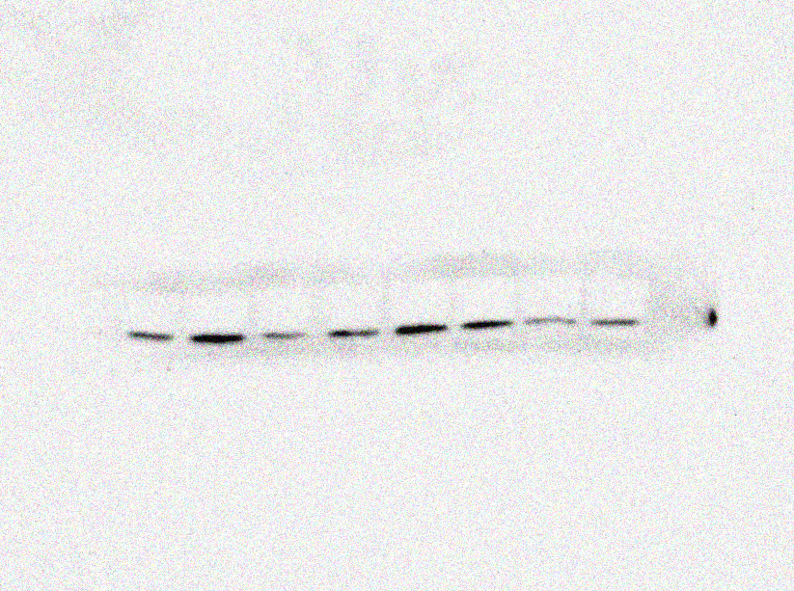
ATF4
(76KDa)

PCV2 group
Normal control
High group (10+3)mg/kg
Matrine 40 mg/kg
Low group (40+12)mg/kg
Ribavirin 40 mg/kg
Middle group (20+6)mg/kg
Osthole 12 mg/kg
d CHOP of Fig. 7b
CHOP
(27KDa)

PCV2 group
Normal control
High group (10+3)mg/kg
Matrine 40 mg/kg
Low group (40+12)mg/kg
Ribavirin 40 mg/kg
Middle group (20+6)mg/kg
Osthole 12 mg/kg
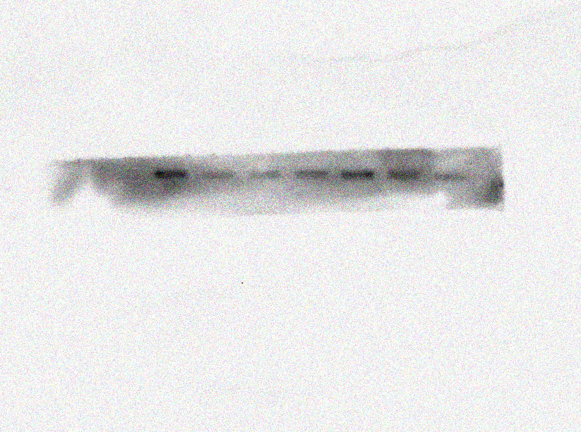
e GAPDH of Fig. 7b
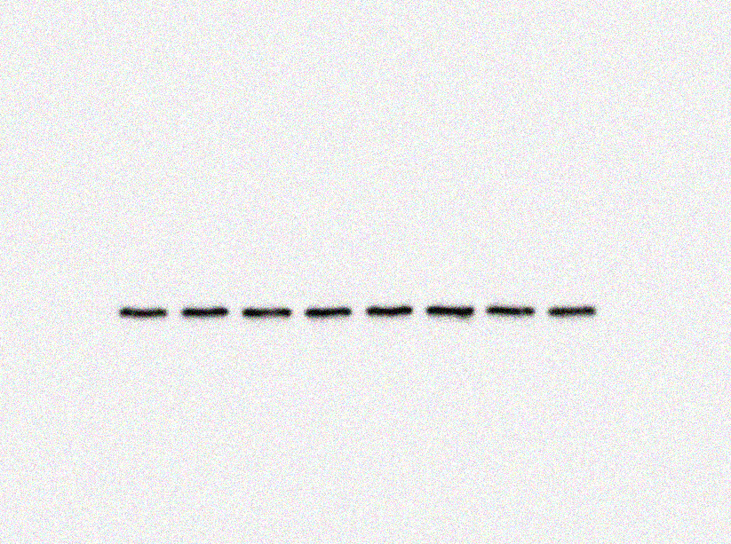
GAPDH
(36KDa)

PCV2 group
Normal control
High group (10+3)mg/kg
Matrine 40 mg/kg
Low group (40+12)mg/kg
Ribavirin 40 mg/kg
Middle group (20+6)mg/kg
Osthole 12 mg/kg

