Matrine combined with Osthole inhibited the PERK apoptosis of splenic lymphocytes in PCV2-infected mice model

Yinlan Xu^{1,2#}, Shuangxiu Wan^{1,6#}, Panpan Sun³, Ajab Khan¹, Jianhua Guo⁴, Xiaozhong Zheng⁵, Yaogui Sun¹, Kuohai Fan³, Wei Yin¹, Hongquan Li¹ and Na Sun^{1*}

#These authors contributed equally to this work.

*Corresponding author: Na Sun：E-mail: snzh060511@126.com
College of Veterinary Medicine, Shanxi Agricultural University, Taigu, Shanxi 030801 China.
Added blot images without overexposure that were not provided previously

Fig. 4d original blot images after cutting
a GAPDH
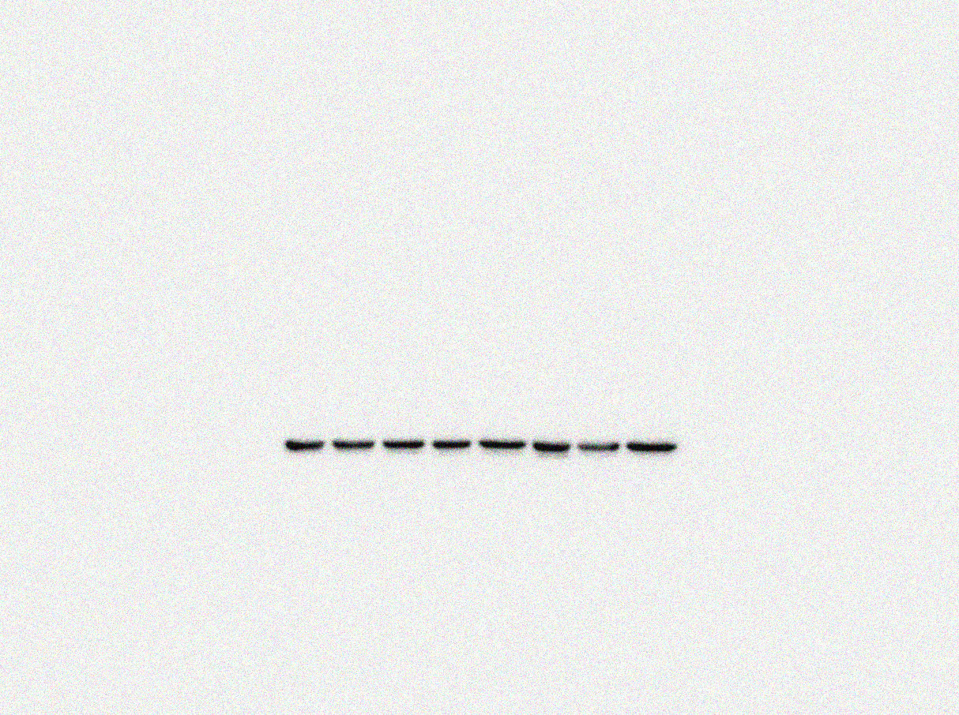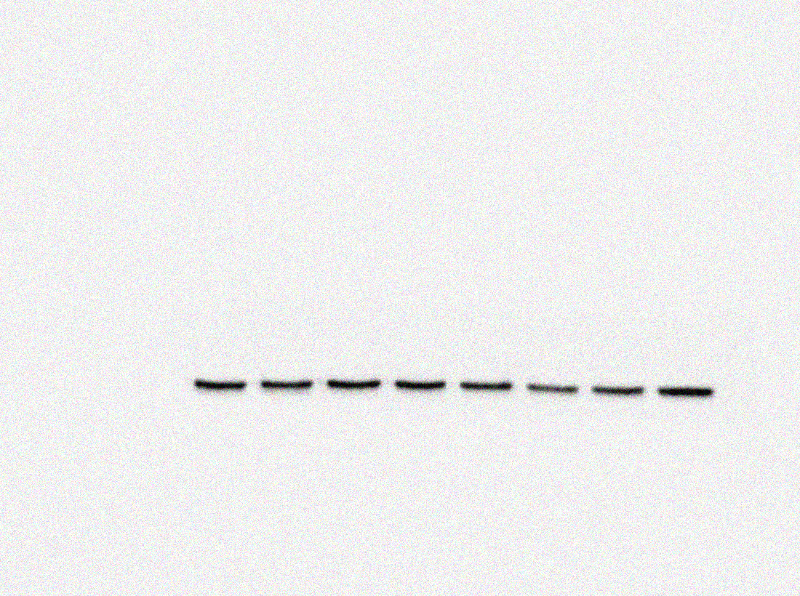
GAPDH
(36KDa)
PCV2 group
Normal control
High group (10+3)mg/kg
Matrine 40 mg/kg
Low group (40+12)mg/kg
Ribavirin 40 mg/kg
Middle group (20+6)mg/kg
Osthole 12 mg/kg
GAPDH
(36KDa)
PCV2 group
Normal control
High group (10+3)mg/kg
Matrine 40 mg/kg
Low group (40+12)mg/kg
Ribavirin 40 mg/kg
Middle group (20+6)mg/kg
Osthole 12 mg/kg
b Cap

Cap
(28KDa)
PCV2 group
Normal control
High group (10+3)mg/kg
Matrine 40 mg/kg
Low group (40+12)mg/kg
Ribavirin 40 mg/kg
Middle group (20+6)mg/kg
Osthole 12 mg/kg
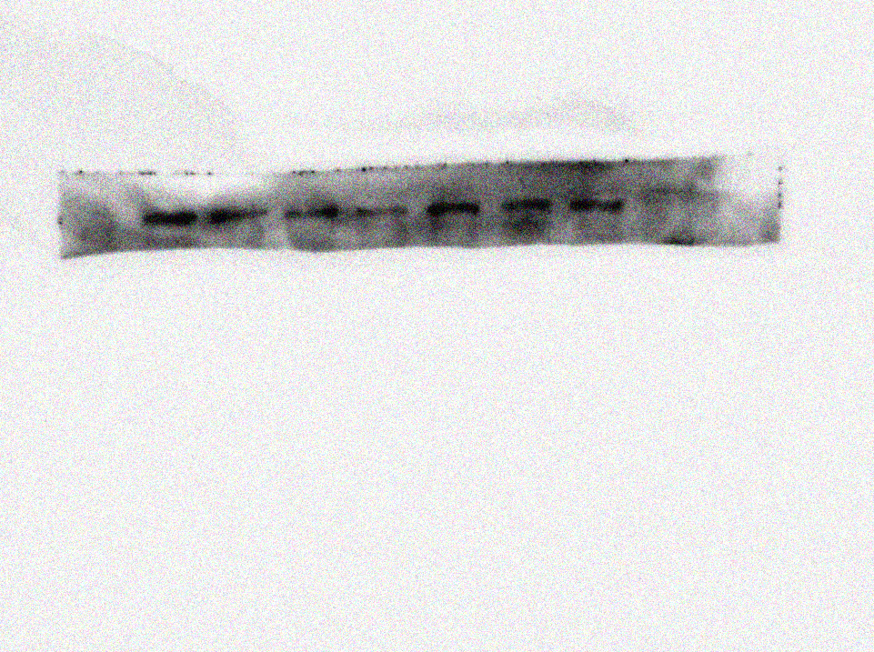
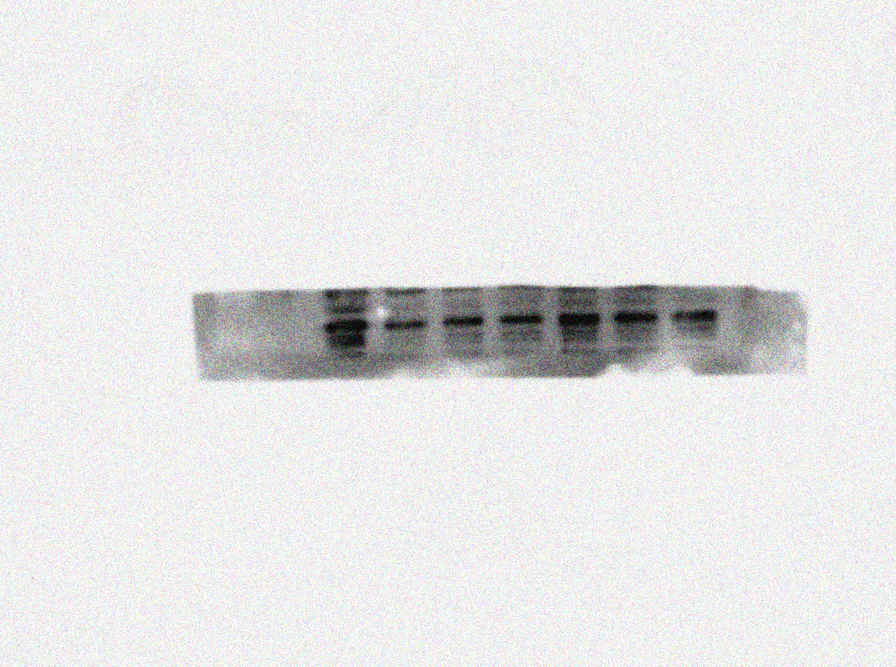
Cap
(28KDa)
PCV2 group
Normal control
High group (10+3)mg/kg
Matrine 40 mg/kg
Low group (40+12)mg/kg
Ribavirin 40 mg/kg
Middle group (20+6)mg/kg
Osthole 12 mg/kg

Fig. 6b original blot images after cutting

a Cleaved-caspase 3

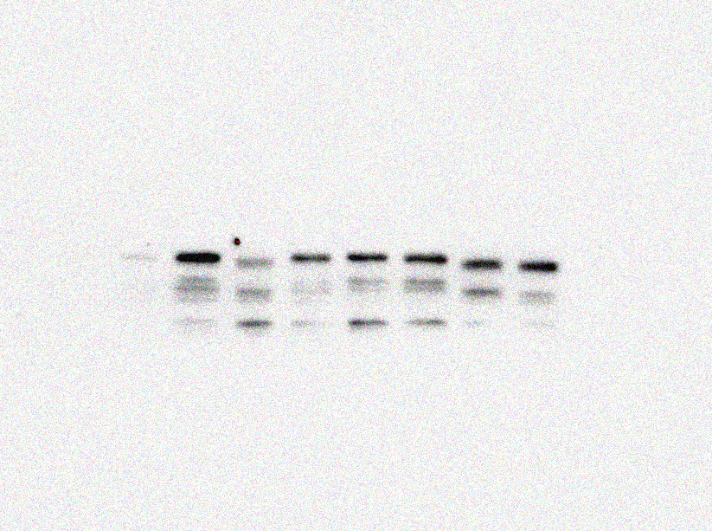
Cleaved caspase-3
(32KDa)

PCV2 group
Normal control
High group (10+3)mg/kg
Matrine 40 mg/kg
Low group (40+12)mg/kg
Ribavirin 40 mg/kg
Middle group (20+6)mg/kg
Osthole 12 mg/kg
Cleaved caspase-3
(32KDa)

PCV2 group
Normal control
High group (10+3)mg/kg
Matrine 40 mg/kg
Low group (40+12)mg/kg
Ribavirin 40 mg/kg
Middle group (20+6)mg/kg
Osthole 12 mg/kg

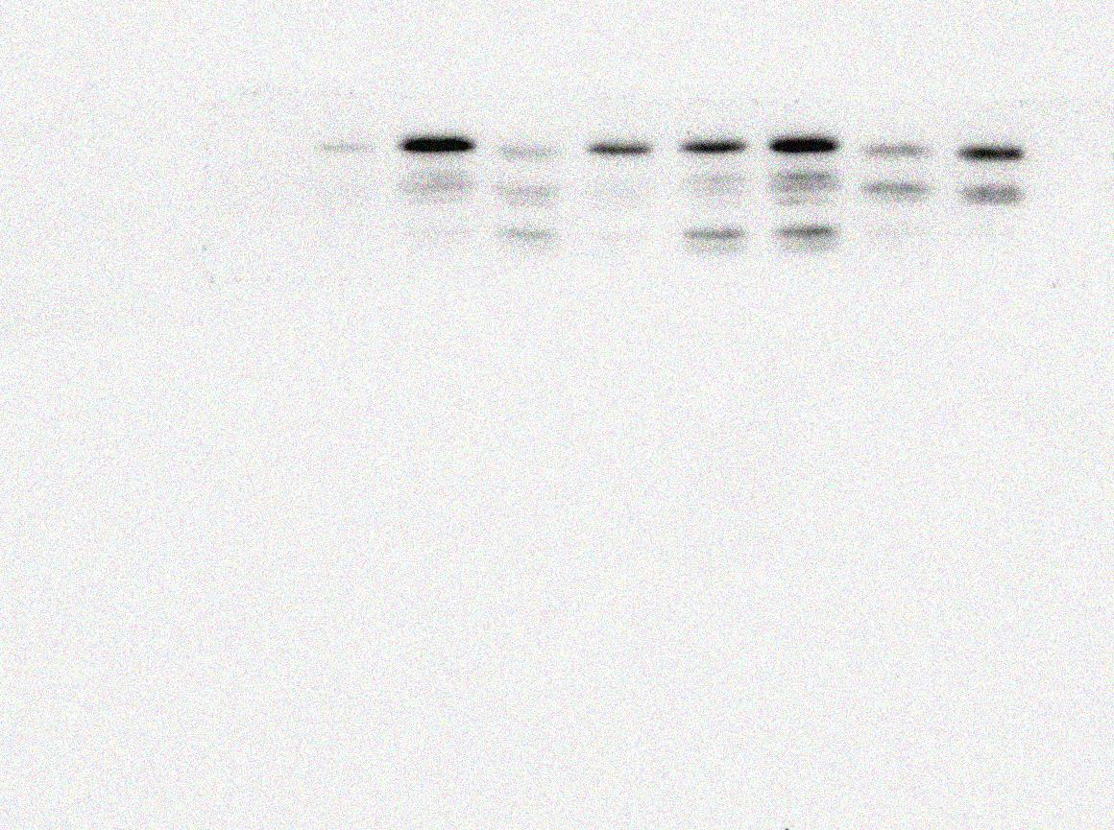

b Bax

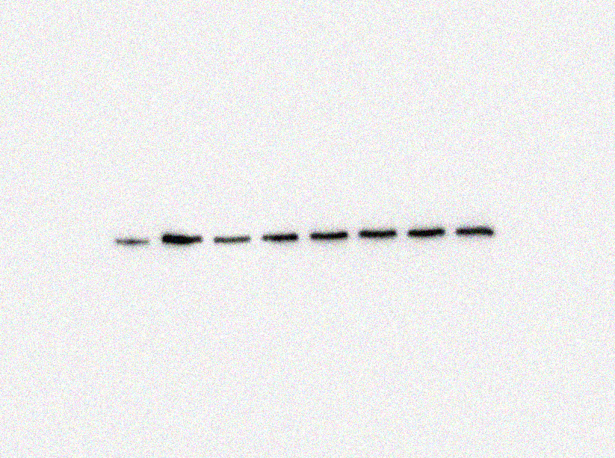
Bax
(21KDa)

PCV2 group
Normal control
High group (10+3)mg/kg
Matrine 40 mg/kg
Low group (40+12)mg/kg
Ribavirin 40 mg/kg
Middle group (20+6)mg/kg
Osthole 12 mg/kg

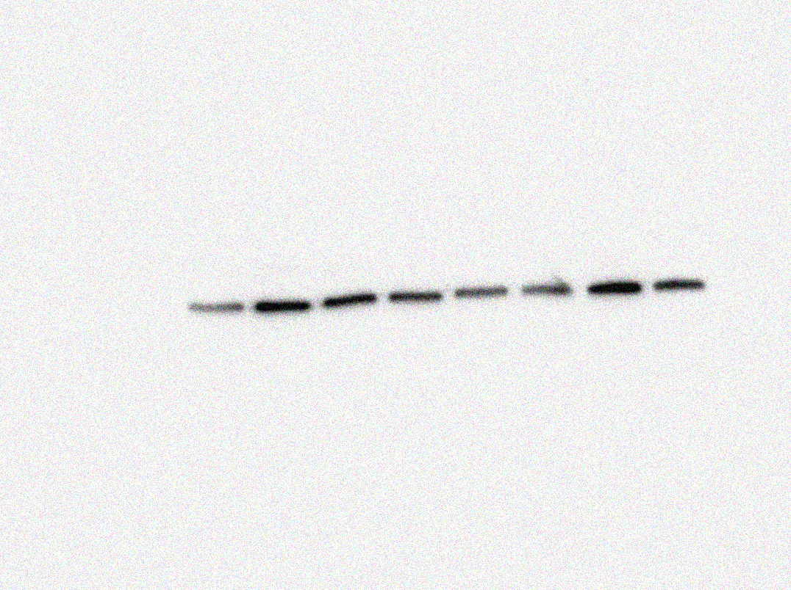
Bax
(21KDa)

PCV2 group
Normal control
High group (10+3)mg/kg
Matrine 40 mg/kg
Low group (40+12)mg/kg
Ribavirin 40 mg/kg
Middle group (20+6)mg/kg
Osthole 12 mg/kg

c Bcl-2

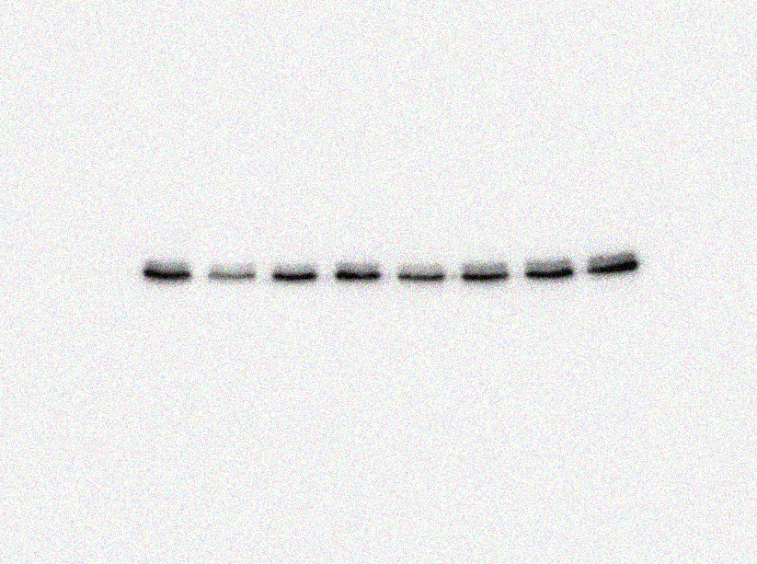
Bcl-2
(26KDa)

PCV2 group
Normal control
High group (10+3)mg/kg
Matrine 40 mg/kg
Low group (40+12)mg/kg
Ribavirin 40 mg/kg
Middle group (20+6)mg/kg
Osthole 12 mg/kg

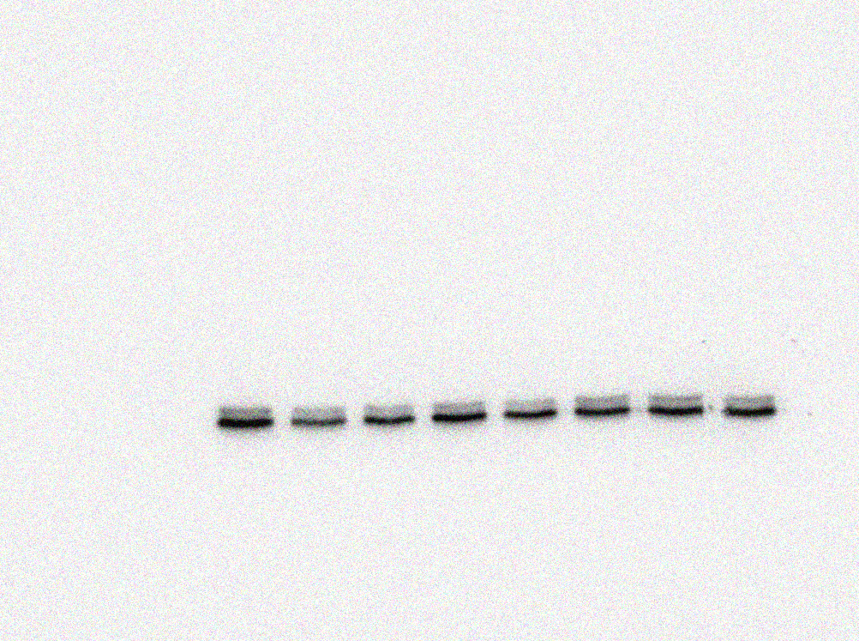
Bcl-2
(26KDa)

PCV2 group
Normal control
High group (10+3)mg/kg
Matrine 40 mg/kg
Low group (40+12)mg/kg
Ribavirin 40 mg/kg
Middle group (20+6)mg/kg
Osthole 12 mg/kg

d GAPDH

GAPDH
(36KDa)

PCV2 group
Normal control
High group (10+3)mg/kg
Matrine 40 mg/kg
Low group (40+12)mg/kg
Ribavirin 40 mg/kg
Middle group (20+6)mg/kg
Osthole 12 mg/kg
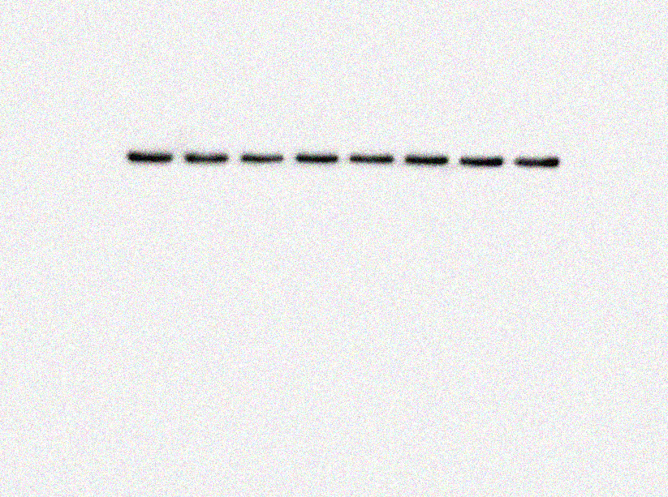
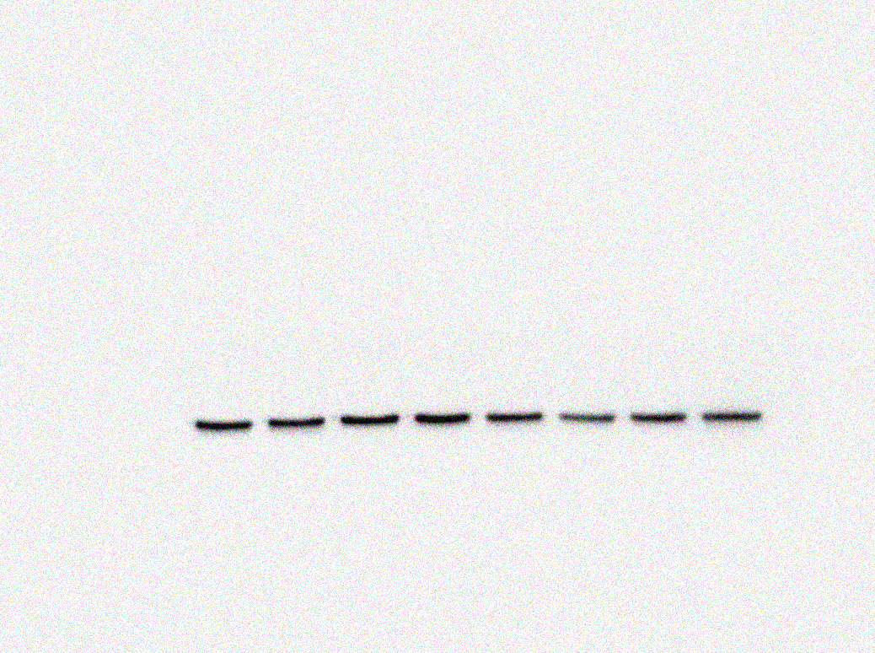
GAPDH
(36KDa)

PCV2 group
Normal control
High group (10+3)mg/kg
Matrine 40 mg/kg
Low group (40+12)mg/kg
Ribavirin 40 mg/kg
Middle group (20+6)mg/kg
Osthole 12 mg/kg
Fig. 7a and 7b original blot images after cutting

a GRP78 of Fig. 7a
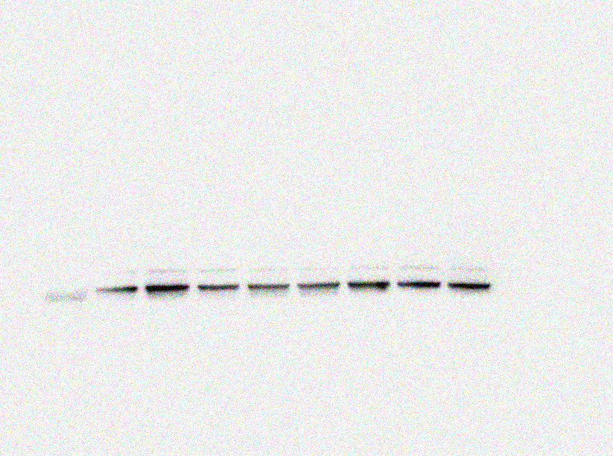
GRP78
(78KDa)

PCV2 group
Normal control
High group (10+3)mg/kg
Matrine 40 mg/kg
Low group (40+12)mg/kg
Ribavirin 40 mg/kg
Middle group (20+6)mg/kg
Osthole 12 mg/kg
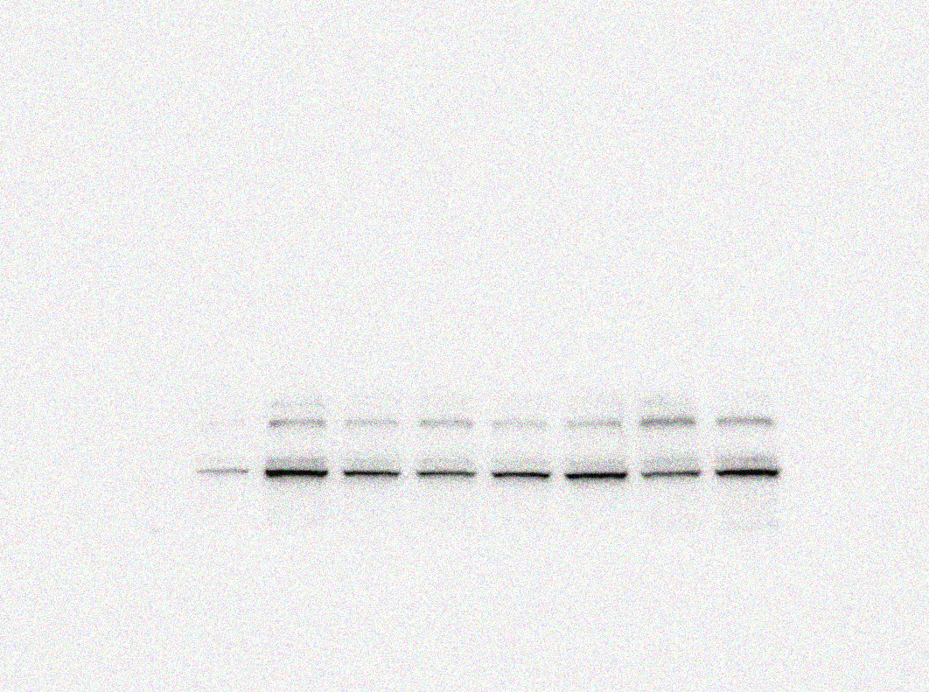
GRP78
(78KDa)

PCV2 group
Normal control
High group (10+3)mg/kg
Matrine 40 mg/kg
Low group (40+12)mg/kg
Ribavirin 40 mg/kg
Middle group (20+6)mg/kg
Osthole 12 mg/kg

b p^{-PERK} of Fig. 7a

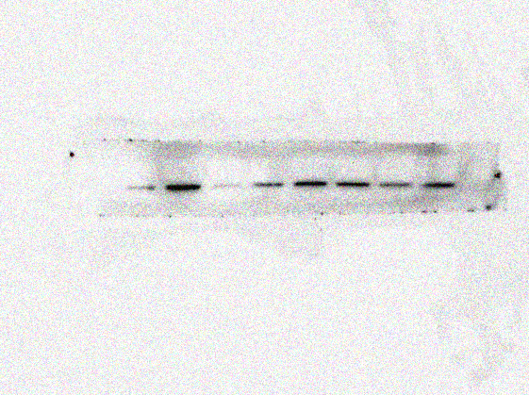
p^{-PERK} (150KDa)

PCV2 group
Normal control
High group (10+3)mg/kg
Matrine 40 mg/kg
Low group (40+12)mg/kg
Ribavirin 40 mg/kg
Middle group (20+6)mg/kg
Osthole 12 mg/kg

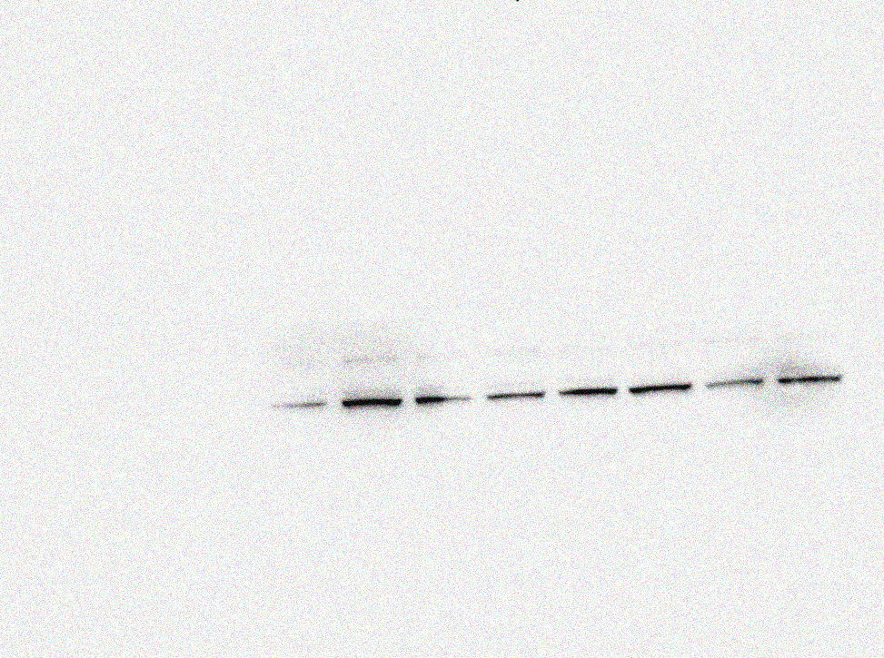
p^{-PERK} (150KDa)

PCV2 group
Normal control
High group (10+3)mg/kg
Matrine 40 mg/kg
Low group (40+12)mg/kg
Ribavirin 40 mg/kg
Middle group (20+6)mg/kg
Osthole 12 mg/kg

c t^{-PERK} of Fig. 7a

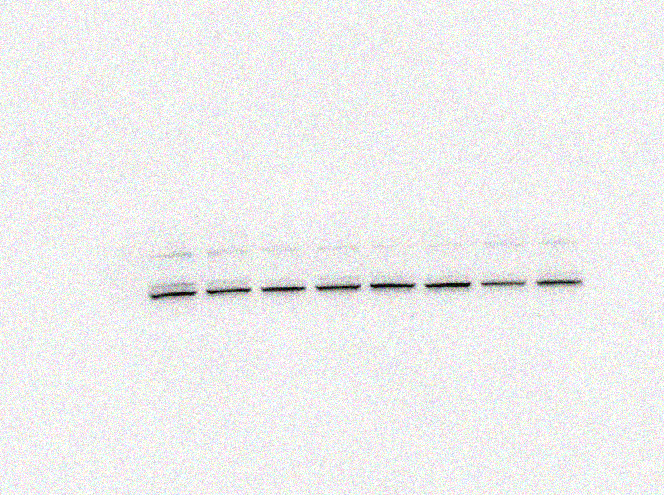
t^{-PERK} (150KDa)

PCV2 group
Normal control
High group (10+3)mg/kg
Matrine 40 mg/kg
Low group (40+12)mg/kg
Ribavirin 40 mg/kg
Middle group (20+6)mg/kg
Osthole 12 mg/kg

t^{-PERK}
(150KDa)

PCV2 group
Normal control
High group (10+3)mg/kg
Matrine 40 mg/kg
Low group (40+12)mg/kg
Ribavirin 40 mg/kg
Middle group (20+6)mg/kg
Osthole 12 mg/kg
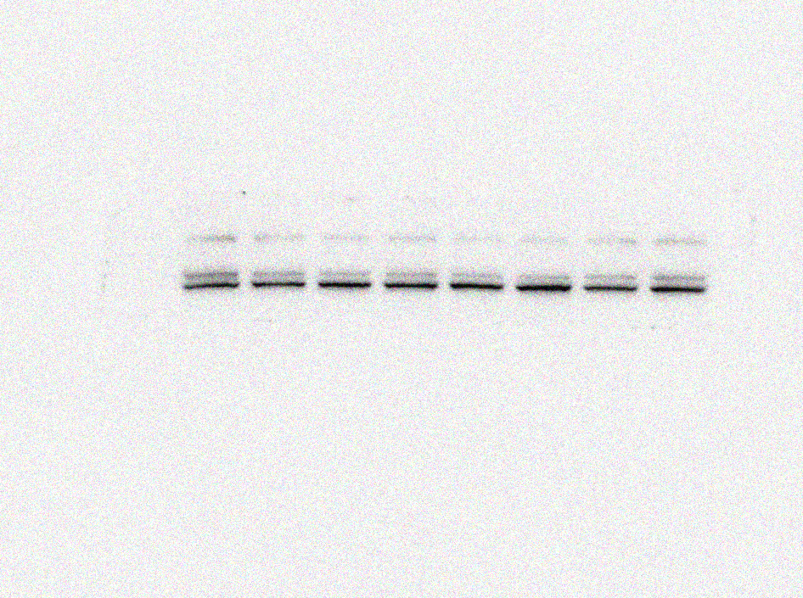
d GAPDH of Fig. 7a

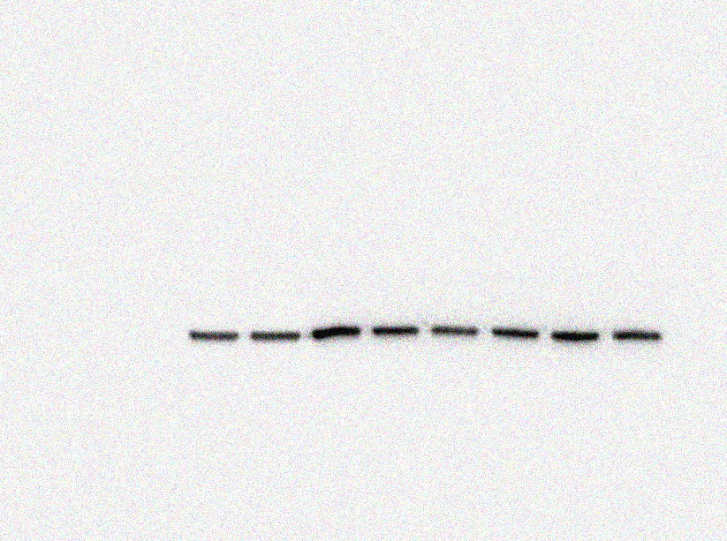
GAPDH
(36KDa)

PCV2 group
Normal control
High group (10+3)mg/kg
Matrine 40 mg/kg
Low group (40+12)mg/kg
Ribavirin 40 mg/kg
Middle group (20+6)mg/kg
Osthole 12 mg/kg

GAPDH
(36KDa)

PCV2 group
Normal control
High group (10+3)mg/kg
Matrine 40 mg/kg
Low group (40+12)mg/kg
Ribavirin 40 mg/kg
Middle group (20+6)mg/kg
Osthole 12 mg/kg

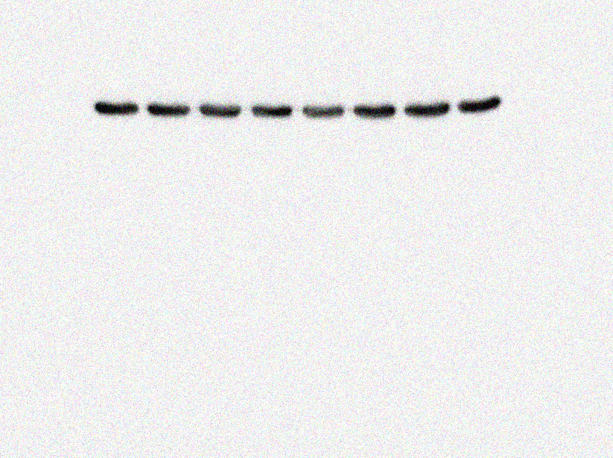

e p^{-eIF2α} of Fig. 7b
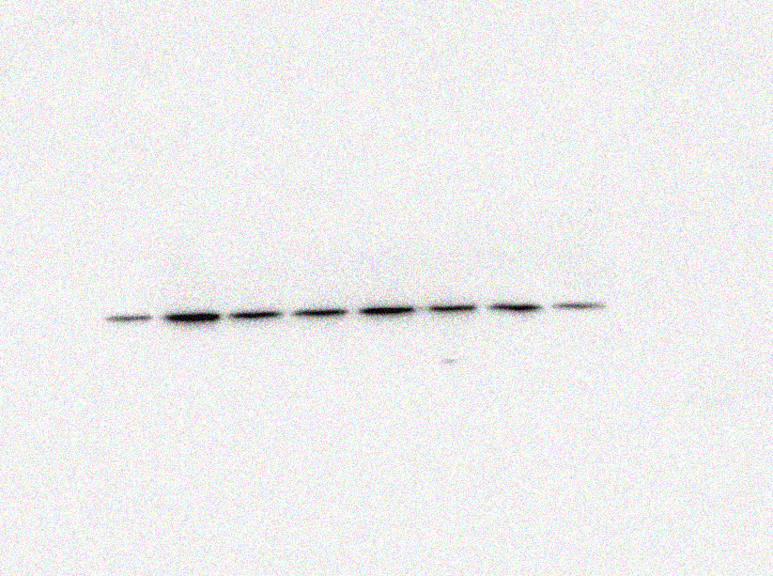
P^{-eIF2α}
(36KDa)

PCV2 group
Normal control
High group (10+3)mg/kg
Matrine 40 mg/kg
Low group (40+12)mg/kg
Ribavirin 40 mg/kg
Middle group (20+6)mg/kg
Osthole 12 mg/kg
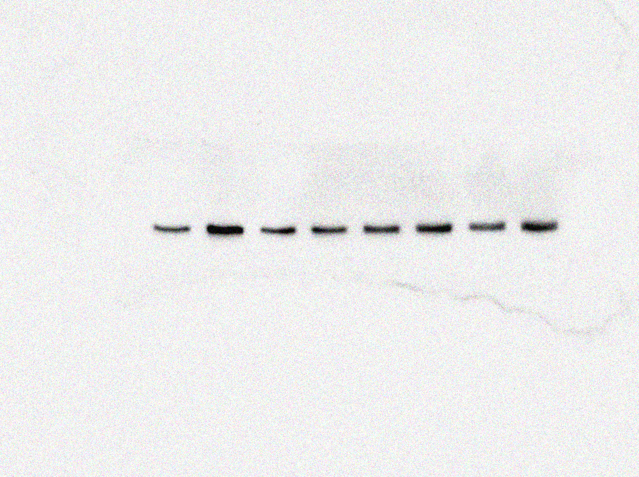
P^{-eIF2α}
(36KDa)

PCV2 group
Normal control
High group (10+3)mg/kg
Matrine 40 mg/kg
Low group (40+12)mg/kg
Ribavirin 40 mg/kg
Middle group (20+6)mg/kg
Osthole 12 mg/kg

f t^{-eIF2α} of Fig. 7b
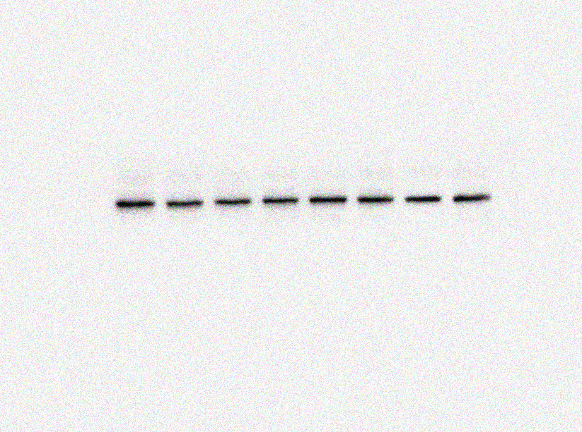
t^{-eIF2α}
(65KDa)

PCV2 group
Normal control
High group (10+3)mg/kg
Matrine 40 mg/kg
Low group (40+12)mg/kg
Ribavirin 40 mg/kg
Middle group (20+6)mg/kg
Osthole 12 mg/kg
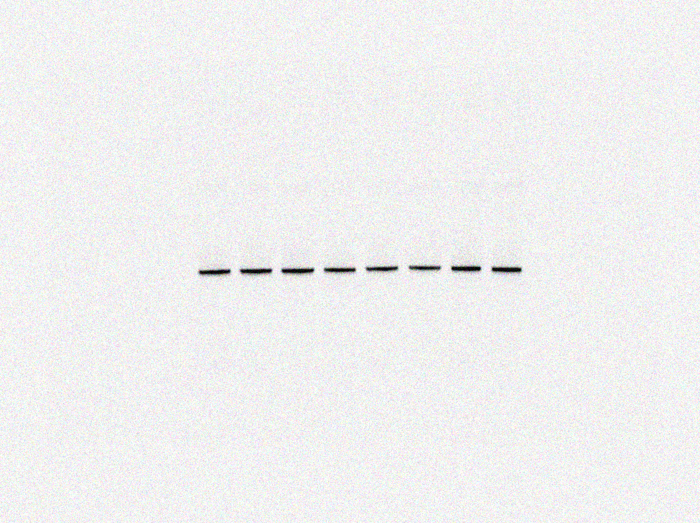
t^{-eIF2α}
(65KDa)

PCV2 group
Normal control
High group (10+3)mg/kg
Matrine 40 mg/kg
Low group (40+12)mg/kg
Ribavirin 40 mg/kg
Middle group (20+6)mg/kg
Osthole 12 mg/kg

g ATF4 of Fig. 7b
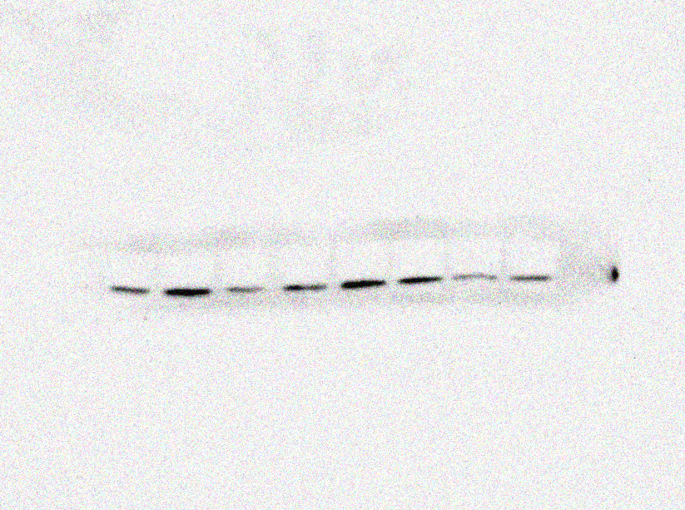
ATF4
(76KDa)

PCV2 group
Normal control
High group (10+3)mg/kg
Matrine 40 mg/kg
Low group (40+12)mg/kg
Ribavirin 40 mg/kg
Middle group (20+6)mg/kg
Osthole 12 mg/kg
ATF4
(76KDa)

PCV2 group
Normal control
High group (10+3)mg/kg
Matrine 40 mg/kg
Low group (40+12)mg/kg
Ribavirin 40 mg/kg
Middle group (20+6)mg/kg
Osthole 12 mg/kg

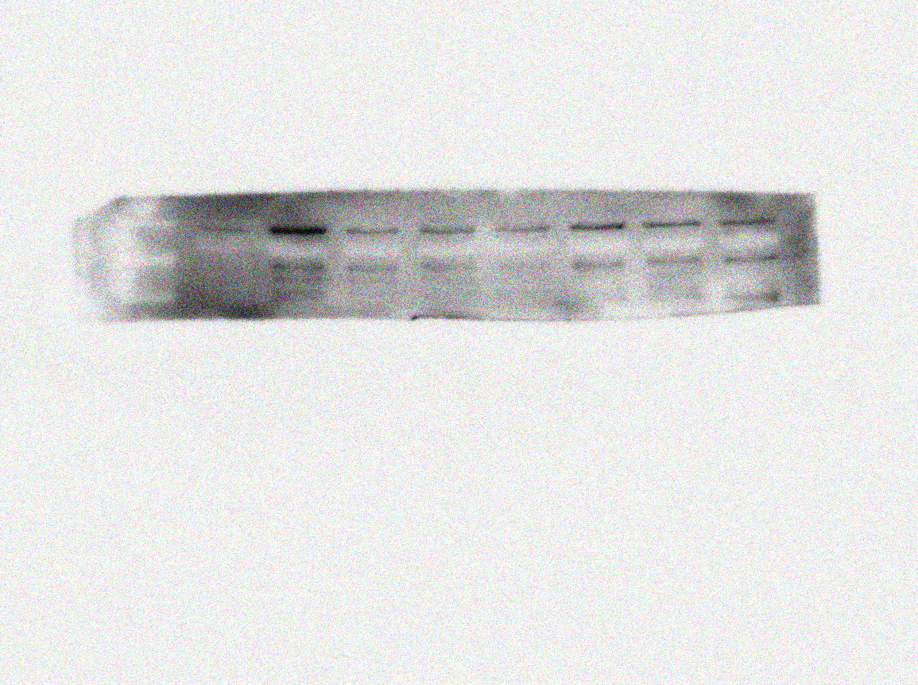
h CHOP of Fig. 7b
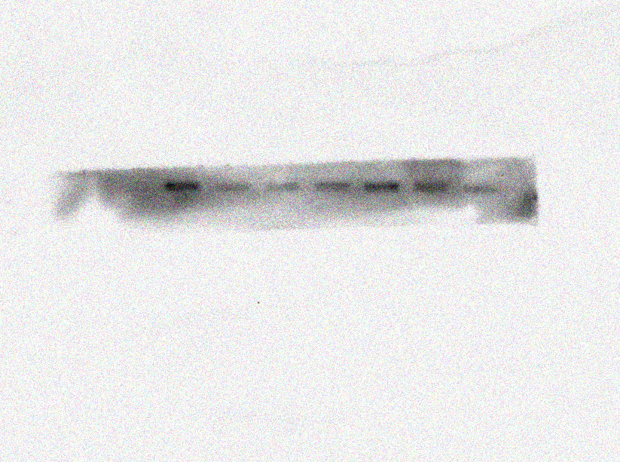
CHOP
(27KDa)

PCV2 group
Normal control
High group (10+3)mg/kg
Matrine 40 mg/kg
Low group (40+12)mg/kg
Ribavirin 40 mg/kg
Middle group (20+6)mg/kg
Osthole 12 mg/kg
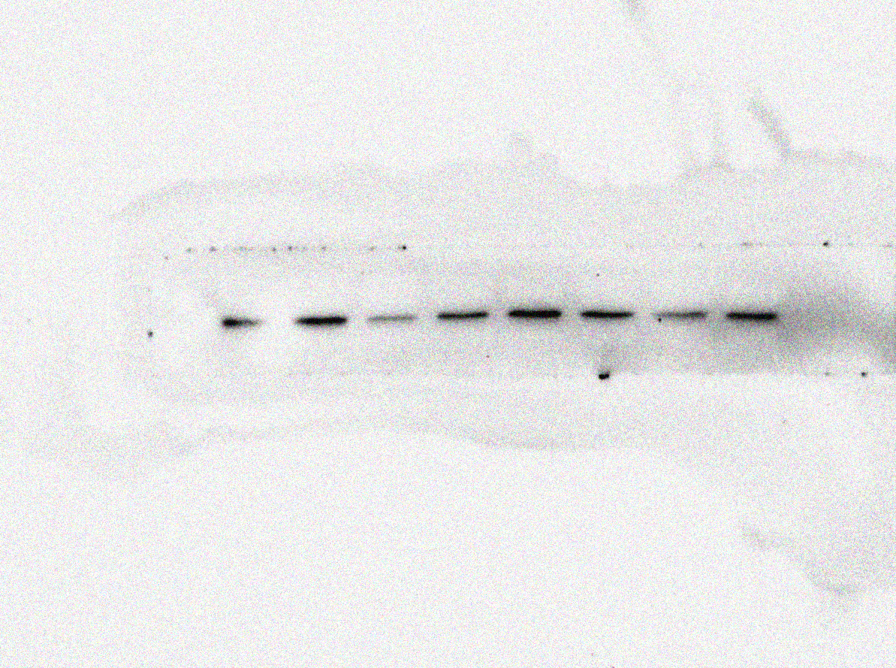
CHOP
(27KDa)

PCV2 group
Normal control
High group (10+3)mg/kg
Matrine 40 mg/kg
Low group (40+12)mg/kg
Ribavirin 40 mg/kg
Middle group (20+6)mg/kg
Osthole 12 mg/kg

i GAPDH of Fig. 7b
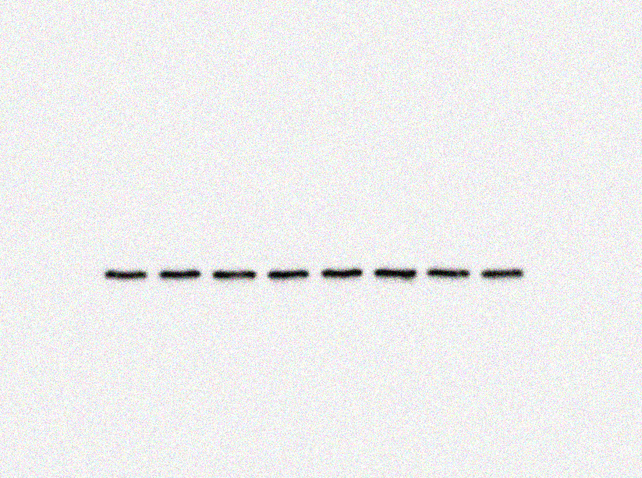
GAPDH
(36KDa)

PCV2 group
Normal control
High group (10+3)mg/kg
Matrine 40 mg/kg
Low group (40+12)mg/kg
Ribavirin 40 mg/kg
Middle group (20+6)mg/kg
Osthole 12 mg/kg

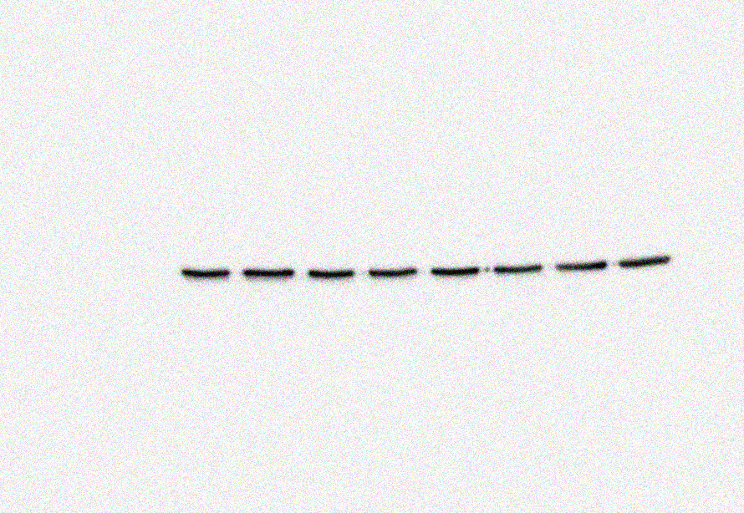
GAPDH
(36KDa)

PCV2 group
Normal control
High group (10+3)mg/kg
Matrine 40 mg/kg
Low group (40+12)mg/kg
Ribavirin 40 mg/kg
Middle group (20+6)mg/kg
Osthole 12 mg/kg

