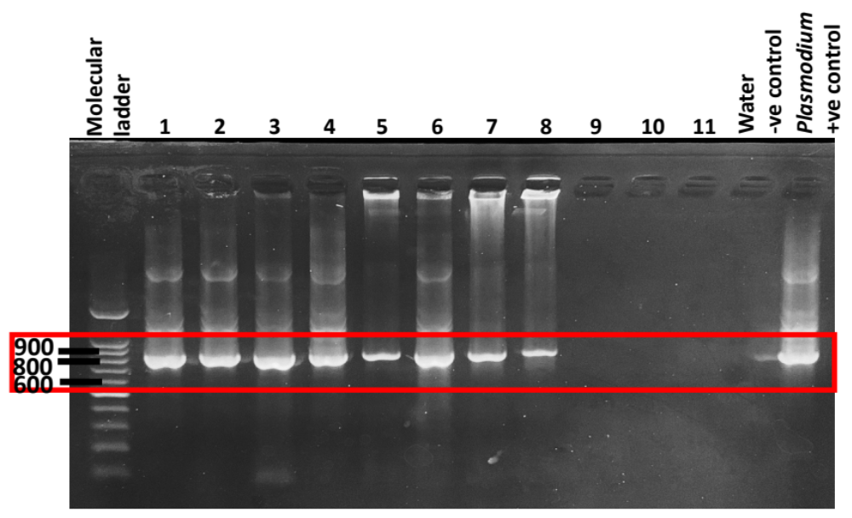
Additional file 4: Figure S3. Uncropped electrophoresis gel of nested PCR of amplification of CytB gene of avian Plasmodium using Haemoproteus-specific primer set HaemF/AE982 producing amplicons of 820bp only. Cropped region presented in the manuscript is denoted by the red box and labelled as Figure 2B.

