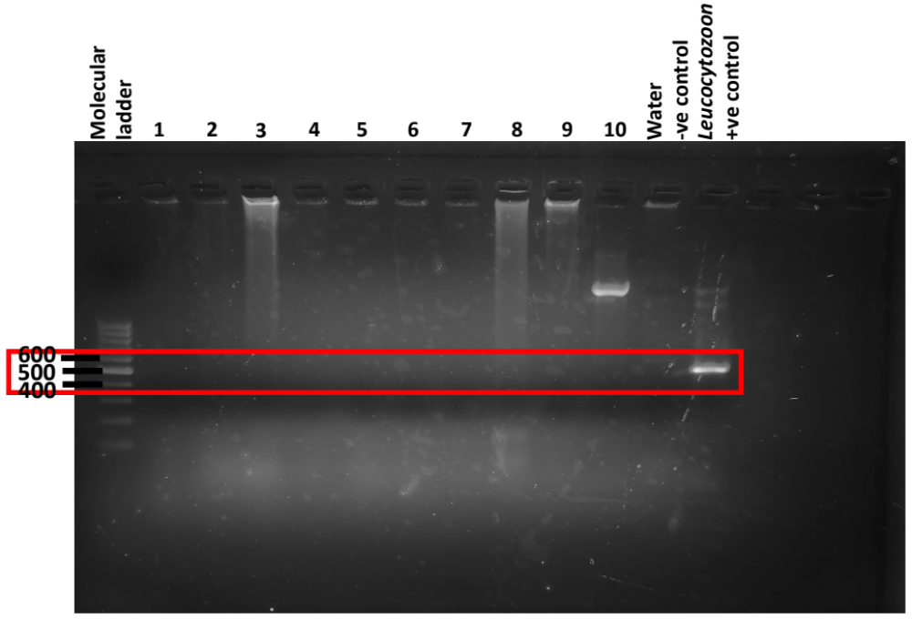
Additional file 5: Figure S4. Uncropped electrophoresis gel of nested PCR of amplification of CytB gene of avian Leucocytozoon using nested primer set HaemFL/HaemRL2 producing amplicon of 523 bp. Cropped regions presented in the manuscript is denoted by the red box and labelled as Figure 2C.

