Virulent-MDR-ESBL E. coli and Klebsiella pneumoniae report from North Sinai calves diarrhea and In Vitro antimicrobial by Moringa oleifera
*Sahar A. Allam^{1, 2}, Sara M. Elnomrosy³ Samy M. Mohamed⁴
*1- Infectious Disease Unit, Animal and poultry Health Department, Animal and Poultry Production Division, Desert Research Center, 1 Mataria Museum Street, Cairo 11753, Egypt.
*2- Technology Incubator for Nano Agricultural Application, Desert Research Center, Cairo, Egypt.
3- Genome Research Unit, Animal Health Research Institute, Agriculture Research Center, Giza, Egypt.
4- Medicinal and Aromatic Plants Research Department, Pharmaceutical and Drug Industries Research Institute, National Research Center- Al-Buhouth Street, Dokki, Giza, Egypt.
*Corresponding author: Sahar A. Allam Saharallam@drc.gov.eg

Table 1S. Antibiotic discs used under study
Sympole | Commercial name | Concentration | Family | Mode of action( Lorian , 1999) ¹²
F | Nitrofurantoin | 300 mcg/Disc | nitrofuran family | inhibit DNA synthesis
CN | Gentamycin | 10 mcg/Disc | Aminoglycoside | protein synthesis inhibitor
LE | Levofloxacine | 5mcg/Disc | fluoroquinolones | Interfere with DNA replication by preventing bacterial DNA from unwinding and duplicating
AK | Amikacin | 30 mcg/Disc | Aminoglycoside | protein synthesis inhibitor
E | Erythromycin | 15 mcg/Disc | Macrolides | protein synthesis inhibitor
CFR | Cefadroxil | 30 mcg/Disc | first-generation cephalosporin –Beta-lactam | Cell-wall biosynthesis
AZM | Azithromycin | 15 mcg/Disc) | Macrolides | protein synthesis inhibitor
DO | Doxycycline | 30 mcg/Disc | Tetracyclines | protein synthesis inhibitor
AX | Amoxicillin | 25 mcg/Disc | Beta-lactam | Cell-wall biosynthesis inhibition
CAZ | Ceftazidime | 30 mcg/Disc | third-generation cephalosporin | Cell-wall biosynthesis inhibition
NOR | Norfloxacine-Fluoroquinolone | 10 mcg/Disc | fluoroquinolones | Interfere with DNA replication by preventing bacterial DNA from unwinding and duplicating

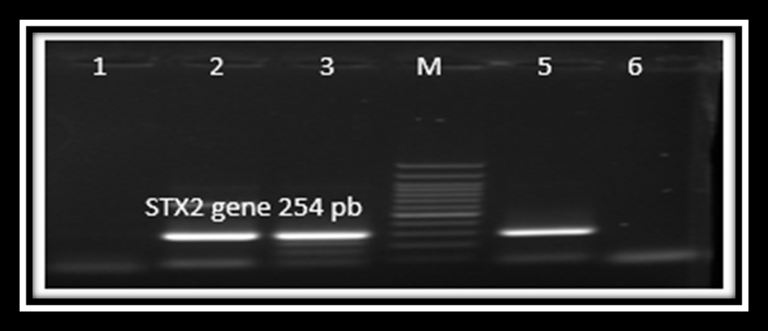

Figure 1S. Agar gel electrophoresis showed results of conventional PCR virulent gene STX2 genes in E. coli isolates number (2-3-5) were positive STX2 254bp, 1and 6 were negative. M: represented the molecular size marker (100pb ladder)

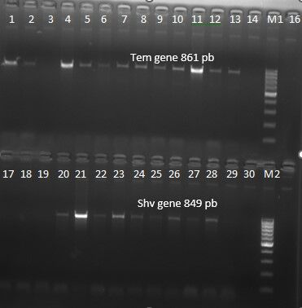

17 18 19 20 21 22 23 24 25 26 27 28 29 30 M2
Figure 2S. Agar gel electrophoresis showed results of conventional PCR Antibiotic resistance of bla^{TEM} gene of E. coli isolates number (1-2,4-13) were positive bla^{TEM} gene 861bp. Lane 3 and 14 were negative. M1: represented the molecular size marker (100pb ladder). Isolates number (20-21-22-23-24-25-26-28) were positive to of bla^{Shv} gene 849bp of E. coli isolates. Lane 17, 18, 19 and 29 were negative. M2: represented the molecular size marker (100pb ladder)

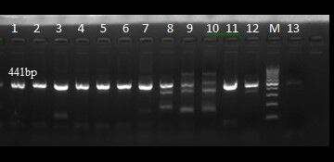

Figure 3S. Agar gel electrophoresis showed results of conventional PCR of virulent gyrA- gene of Klebsiella pneumoniae number (1-13) were positive gyrA-gene 441bp. M: represented the molecular size marker (100pb ladder)

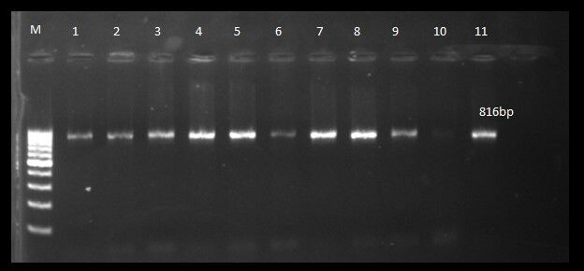

816bp
Figure 4S. Agar gel electrophoresis showed results of conventional PCR antibiotic resistance of bla^{TEM} gene of Klebsiella pneumoniae number (1-11) were positive bla^{TEM} 816bp. M: represented the molecular size marker (100pb ladder)

