Table (1.S) ¹H- and ¹³C-NMR spectral data of arabincoside B (DMSO-d₆)
 | ¹H-NMR | ¹³C-NMR |  | ¹H-NMR | ¹³C-NMR
No. |  |  | No. | Dig
1 | 1.01 (1H, m), 1.80 (1H, m) | 37.18 | 1` | 4.20 (1H, d, J= 7.60) | 101.75
2 | 1.48 (2H, m) | 29.76 | 2` | 3.58 (1H, m) | 69.11
3 | 3.40 (1H, m) | 77.58 | 3` | 3.07 (1H, m) | 84.49
4 | 1.52 (1H, m), 2.35 (1H, dd, J= 2.84, 10.48) | 38.71 | 4` | 4.05 (1H, b.s) | 74.00
5 | - | 139.66 | 5` | 3.52 (1H, m) | 69.75
6 | 5.35 (1H, br d, J= 5.24) | 122.19 | 6` | 1.13 (3H, d, J= 6.2) | 17.62
7 | 1.74 (1H, m), 2.16 (1H, m) | 27.40 | OCH₃ | 3.38 (3H, s) | 58.22
8 | 1.58 (1H, m) | 37.14 | Glc
9 | 1.10 (1H, m) | 45.89 | 1`` | 4.28 (1H, d, J= 7.72) | 103.50
10 | - | 36.98 | 2`` | 2.95 (1H, m) | 74.63
11 | 1.32 (1H, m), 1.43 (1H, m) | 20.82 | 3`` | 3.05 (1H, m) | 77.19
12 | 1.34 (1H, m), 2.12 (1H, m) | 38.85 | 4`` | 3.07 (1H, m) | 70.92
13 | - | 49.07 | 5`` | 3.31 (1H, m) | 76.82
14 | - | 84.62 | 6`` | 3.97 (1H, d, J= 11.64), 3.58 (1H, m) | 69.47
15 | 1.93 (1H, m), 1.61 (1H, m) | 33.85 | Glc
16 | 1.83 (1H, m), 1.93 (1H, m) | 23.79 | 1``` | 4.36 (1H, d, J= 7.68) | 103.92
17 | 2.72 (1H, dd, J= 4.8, 9.2) | 62.99 | 2``` | 2.98 (1H, m) | 73.96
18 | 0.88 (3H, s) | 15.70 | 3``` | 3.05 (1H, m) | 77.19
19 | 0.93 (3H, s) | 19.66 | 4``` | 3.02 (1H, m) | 70.52
20 | - | 215.61 | 5``` | 3.10 (1H, m) | 77.36
21 | 2.20 (3H, s) | 31.94 | 6``` | 3.67 (2H, dd, J= 5.6, 11.60) | 61.54
 | ¹H-NMR | ¹³C-NMR |  | ¹H-NMR | ¹³C-NMR
No. |  |  | No. | Dig
1 | 1.01 (1H, m), 1.80 (1H, m) | 37.18 | 1` | 4.20 (1H, d, J= 7.60) | 101.75
2 | 1.48 (2H, m) | 29.76 | 2` | 3.58 (1H, m) | 69.11
3 | 3.40 (1H, m) | 77.58 | 3` | 3.07 (1H, m) | 84.49
4 | 1.52 (1H, m), 2.35 (1H, dd, J= 2.84, 10.48) | 38.71 | 4` | 4.05 (1H, b.s) | 74.00
5 | - | 139.66 | 5` | 3.52 (1H, m) | 69.75
6 | 5.35 (1H, br d, J= 5.24) | 122.19 | 6` | 1.13 (3H, d, J= 6.2) | 17.62
7 | 1.74 (1H, m), 2.16 (1H, m) | 27.40 | OCH₃ | 3.38 (3H, s) | 58.22
8 | 1.58 (1H, m) | 37.14 | Glc
9 | 1.10 (1H, m) | 45.89 | 1`` | 4.28 (1H, d, J= 7.72) | 103.50
10 | - | 36.98 | 2`` | 2.95 (1H, m) | 74.63
11 | 1.32 (1H, m), 1.43 (1H, m) | 20.82 | 3`` | 3.05 (1H, m) | 77.19
12 | 1.34 (1H, m), 2.12 (1H, m) | 38.85 | 4`` | 3.07 (1H, m) | 70.92
13 | - | 49.07 | 5`` | 3.31 (1H, m) | 76.82
14 | - | 84.62 | 6`` | 3.97 (1H, d, J= 11.64), 3.58 (1H, m) | 69.47
15 | 1.93 (1H, m), 1.61 (1H, m) | 33.85 | Glc
16 | 1.83 (1H, m), 1.93 (1H, m) | 23.79 | 1``` | 4.36 (1H, d, J= 7.68) | 103.92
17 | 2.72 (1H, dd, J= 4.8, 9.2) | 62.99 | 2``` | 2.98 (1H, m) | 73.96
18 | 0.88 (3H, s) | 15.70 | 3``` | 3.05 (1H, m) | 77.19
19 | 0.93 (3H, s) | 19.66 | 4``` | 3.02 (1H, m) | 70.52
20 | - | 215.61 | 5``` | 3.10 (1H, m) | 77.36
21 | 2.20 (3H, s) | 31.94 | 6``` | 3.67 (2H, dd, J= 5.6, 11.60) | 61.54

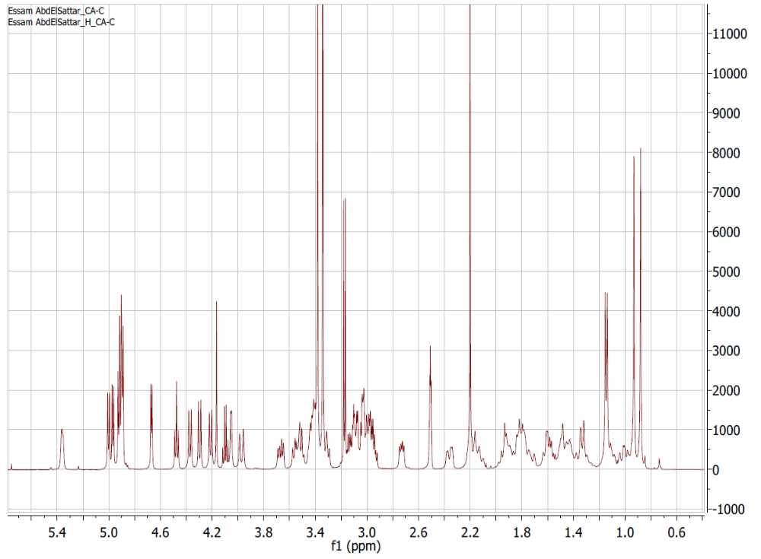
Arabincoside B
Fig (1.S) ¹H-NMR spectrum of arabincoside B (DMSO-d₆)
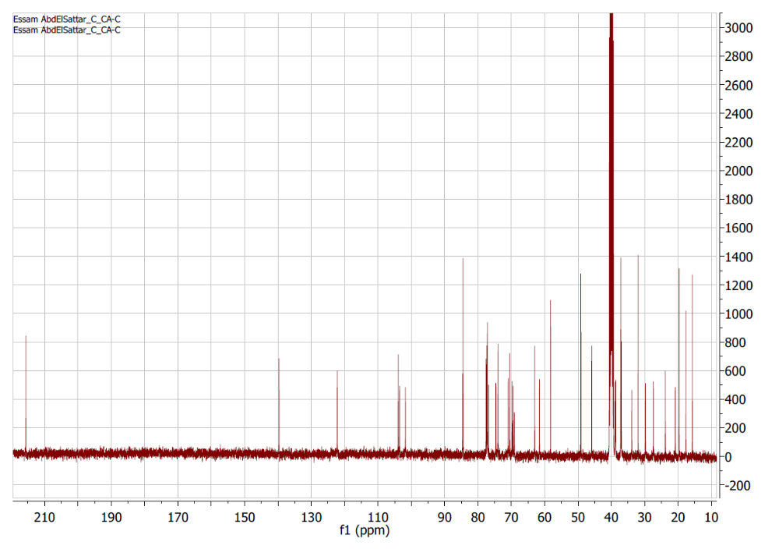
Arabincoside B
Fig (2.S) ¹³C-NMR spectrum of arabincoside B (DMSO-d₆)

