Original unprocessed photo

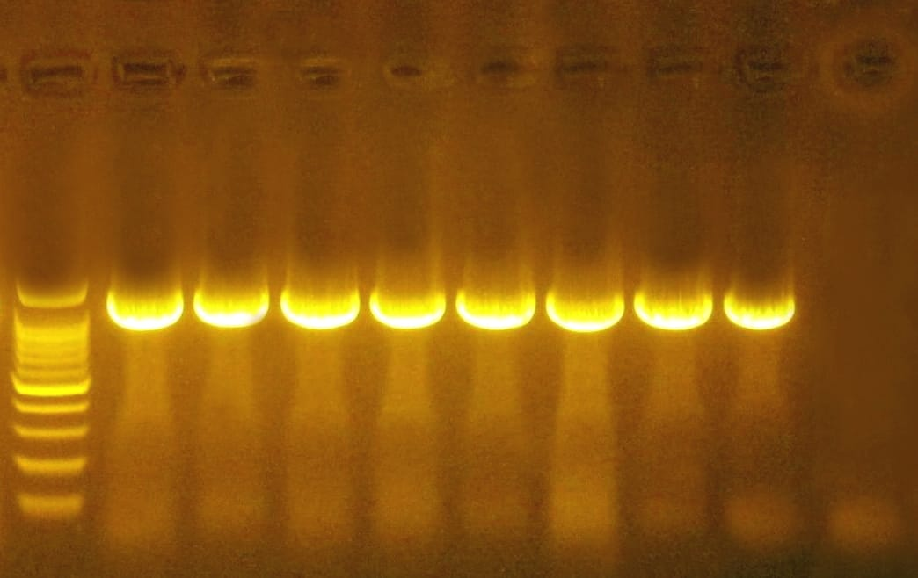

Figure (1): Agarose gel electrophoresis of amplified 16s rRNA gene PCR product (1200 bp).

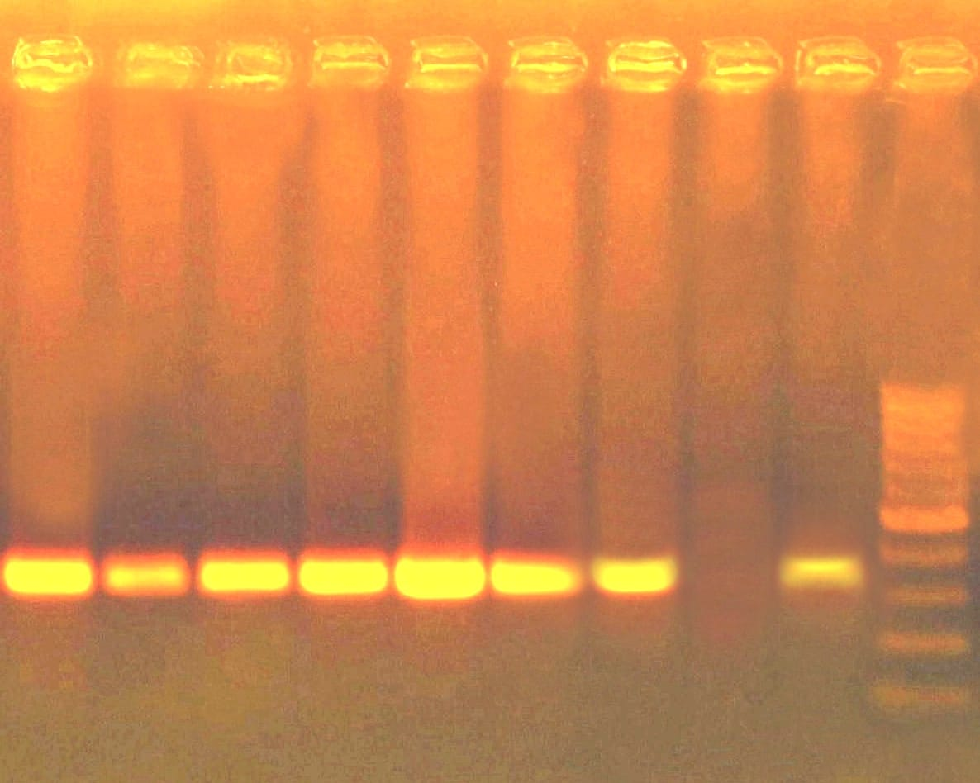

Figure (2): Agarose gel electrophoresis of amplified inlB gene PCR product (343 bp).

