Reusable drapes SOPs

Cleaning and packaging reusable drapes

Cleaning after use
- Drapes and gowns must be soaked in cold water immediately after surgery to dissolve any blood (a detergent can be used if heavily soiled)
- Reusable surgical gowns, drapes, scrubs and hand towels should be washed together in the washing machine on a 60⁰ C wash, separately from bedding or towels as this risks contamination with hair/ fur.
- Do not tumble dry drapes as they will shrink and attract hair: air dry only.
- Use a scrubbing brush or lint roller to remove any hairs once dry.
- Inspect items after washing- try washing any stained drapes again and discard if excessive staining persists.

Packaging for autoclave: fenestrated drapes

Fold fenestrated drapes in a concertina pattern and pack with the fenestration facing outwards and visible.

The TST strip should be placed in the centre of the drape fold, it should not be visible through the fenestration.

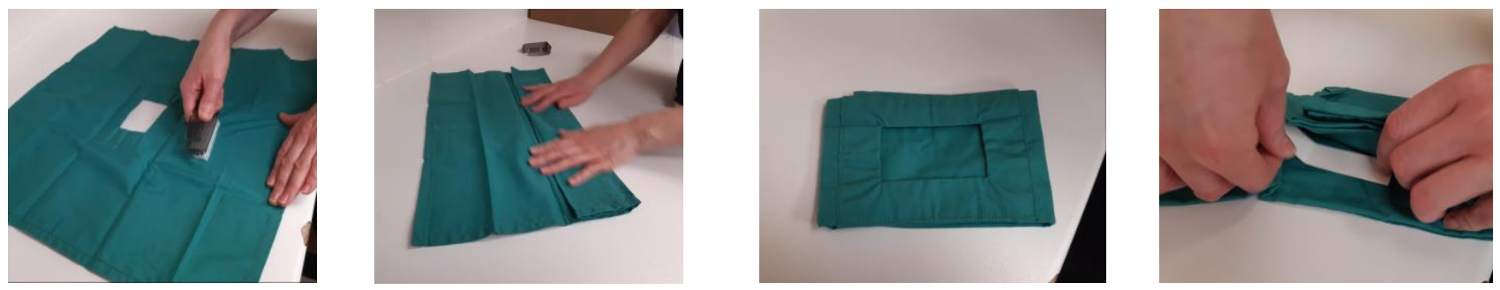

Packaging for autoclave: non-fenestrated drapes

These must be folded in a concertina pattern and placed in a pack of 4 drapes of the same size with the TST strip in the centre of the stack and not visible.

Lifecycle of reusable drapes

When using reusable surgical textiles it is important to keep in mind that reusable does not mean immortal!

Life cycle studies suggest reusable textiles have a life span of ~70 washes. Without robust evidence to guide this in veterinary medicine and the difficulties of tracking use in first opinion practice we would advise inspecting drapes for signs of wear and discarding when present.

Drapes kept in circulation should have crisp edges, be visibly clean with no defects.

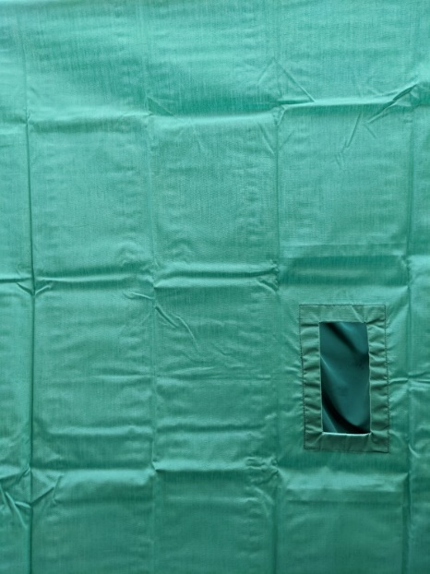
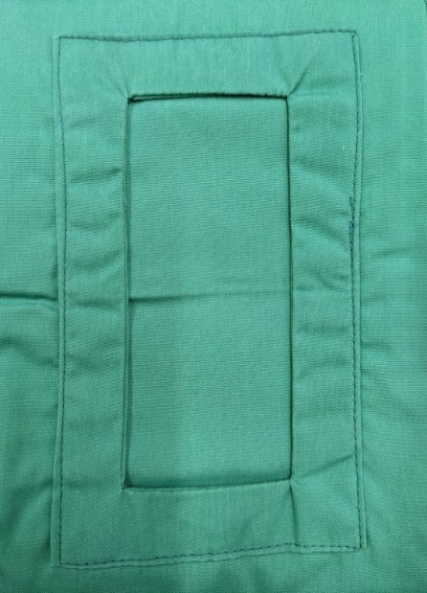

Clean drapes with crisp edges

Examples of wear that should prompt disposal include:

Excessive staining  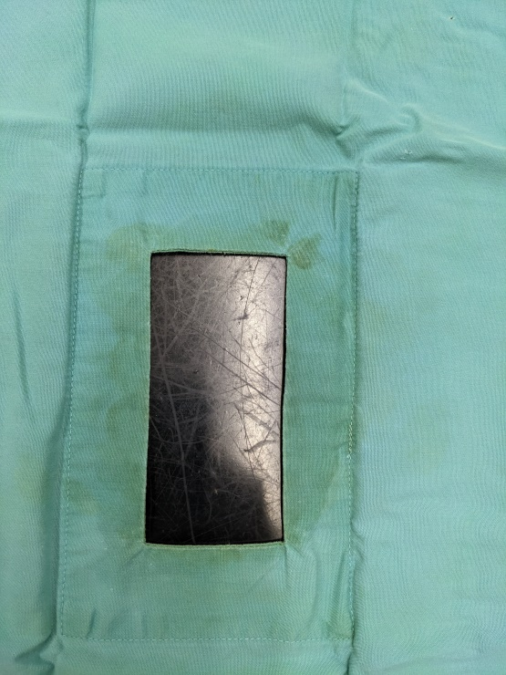 | 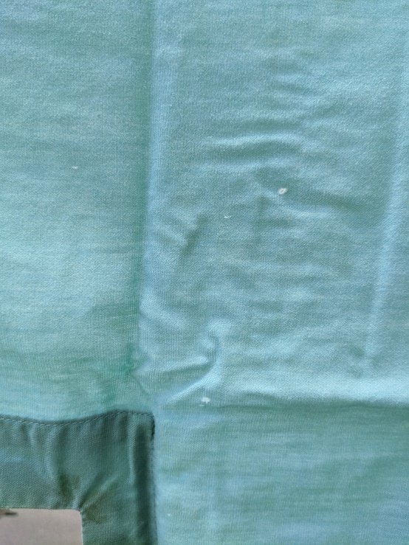  Visible holes or defects
Fraying, especially around fenestration  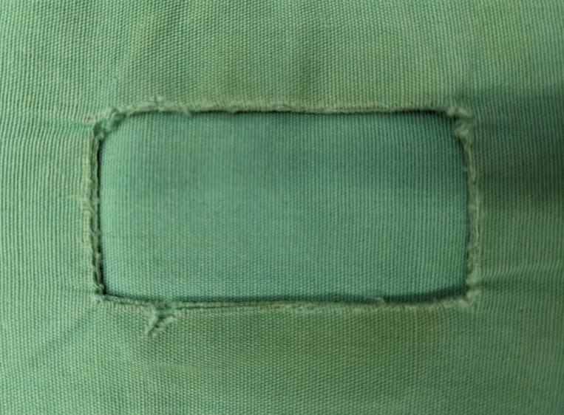 | Threadbare appearance  