Additional file (1)
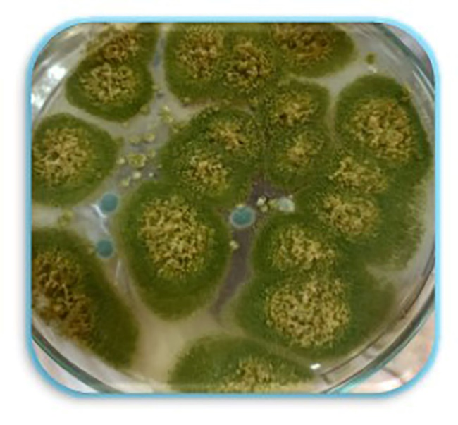 | 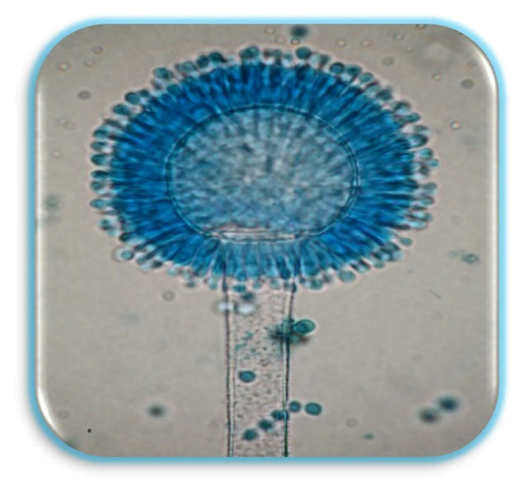
Growth of Aspergillus flavus on Sabaroud Dextrose Agar (SDA) | Microscopical examination of Aspergillus flavus strains.

