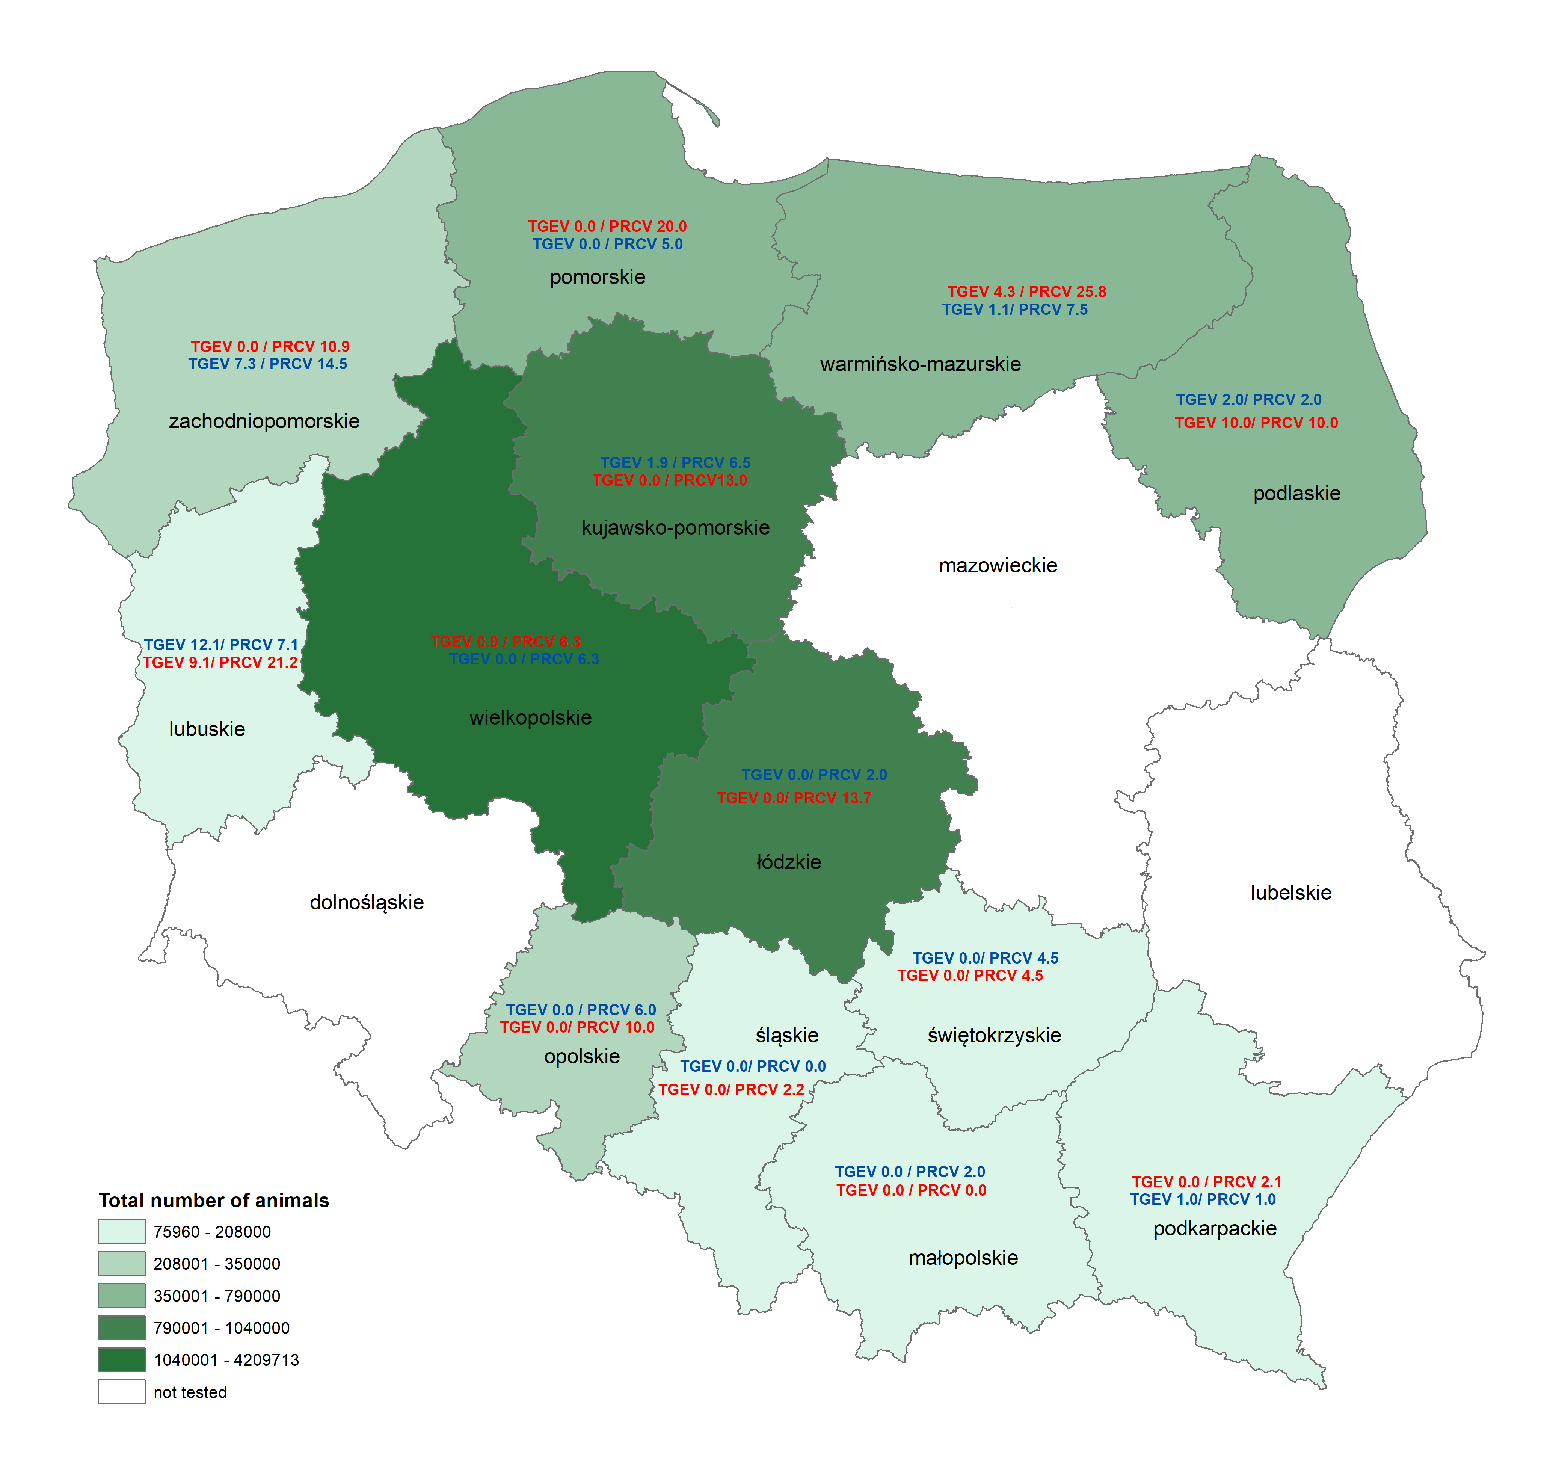
Figure S1. Geographic distribution of pigs that were positive (red color) or inconclusive (blue color) for transmissible gastroenteritis virus (TGEV) and porcine respiratory coronavirus (PRCV) by ELISA. The values are presented in percentages.

