Supplementary information

Wide spectrum of tick-borne pathogens in juvenile Ixodes ricinus collected from autumn-migrating birds in the Vistula River Valley, Poland

Joanna Kulisz^{1*}, Zbigniew Zając¹, Angelique Foucault-Simonin², Aneta Woźniak¹, Maciej Filipiuk³, Janusz Kloskowski⁴, Robert Rudolf⁵, Alexandra Corduneanu^{6,7}, Katarzyna Bartosik¹, Sara Moutailler², Alejandro Cabezas-Cruz^{2*}

¹Department of Biology and Parasitology, Medical University of Lublin, Radziwiłłowska 11, 20-080 Lublin, Poland
²Anses, INRAE, Ecole Nationale Vétérinaire d'Alfort, UMR BIPAR, Laboratoire de Santé Animale, 94700 Maisons-Alfort, France
³Department of Zoology and Nature Protection, Institute of Biological Sciences, Maria Curie-Skłodowska University, Akademicka 19, 20-033 Lublin, Poland
⁴Institute of Zoology, Poznań University of Life Sciences, Wojska Polskiego 71C, 60‑625 Poznań, Poland
⁵Kaliszany Ornithological Station, 24-340 Stare Kaliszany, Poland
⁶Department of Animal Breeding and Animal Production, University of Agricultural Sciences and Veterinary Medicine, Cluj-Napoca, Romania
⁷Department of Parasitology and Parasitic Diseases, University of Agricultural Sciences and Veterinary Medicine, Cluj-Napoca, Romania
*corresponding authors:
Joanna Kulisz (joanna.kulisz@umlub.pl); Alejandro Cabezas-Cruz (alejandro.cabezas@vet-alfort.fr
Fig. S1 Pathogen-infected co-feeding ticks in relation to the host. The list includes only groups of ticks co-feeding on the same bird individuals with at least one infected specimen (L – larva, N – nymph). Groups of ticks collected from the same bird are separated with bold lines. Pathogen-infected ticks are marked blue.
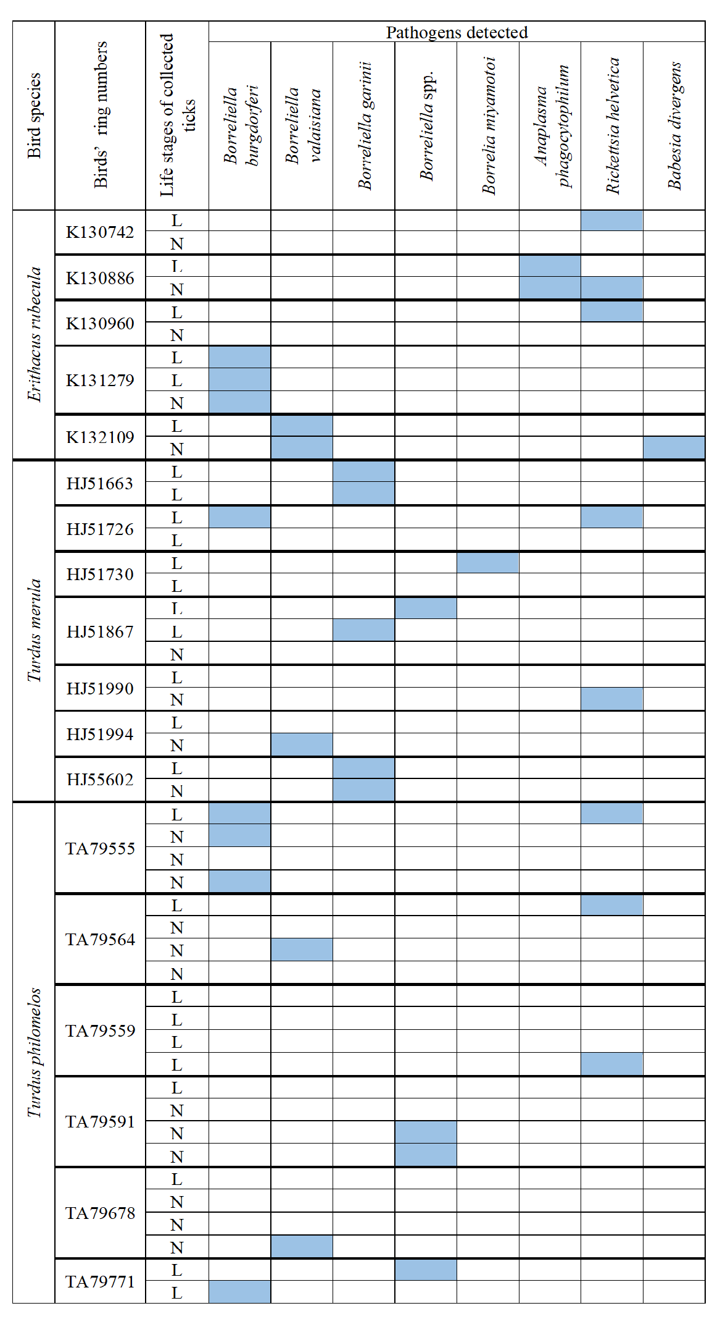
Table S1. List of primers used in molecular analyses
Species | Target gene | Primer sequence | Length (base pairs)
Borreliella burgdorferi sensu stricto | rpoB | GCTTACTCACAAAAGGCGTCTTGCACATCTCTTACTTCAAATCCT | 83
Borreliella garinii | rpoB | TGGCCGAACTTACCCACAAAAACATCTCTTACTTCAAATCCTGC | 88
Borreliella afzelii | fla | GGAGCAAATCAAGATGAAGCAATTGAGCACCCTCTTGAACAGG | 116
Borreliella valaisiana | ospA | ACTCACAAATGACAGATGCTGAAGCTTGCTTAAAGTAACAGTACCT | 135
Borrelia miyamotoi | glpQ | CACGACCCAGAAATTGACACAGTGTGAAGTCAGTGGCGTAAT | 94
Borreliella spielmanii | fla | ATCTATTTTCTGGTGAGGGAGCTCCTTCTTGTTGAGCACCTTC | 71
Borreliella lusitaniae | rpoB | CGAACTTACTCATAAAAGGCGTCTGGACGTCTCTTACTTCAAATCC | 87
Borreliella bissettii | rpoB | GCAACCAGTCAGCTTTCACAGCAAATCCTGCCCTATCCCTTG | 118
Borreliella spp. | 23S rRNA | GAGTCTTAAAAGGGCGATTTAGTCTTCAGCCTGGCCATAAATAG | 73
Anaplasma marginale | msp1b | CAGGCTTCAAGCGTACAGTGGATATCTGTGCCTGGCCTTC | 85
Anaplasma platys | groEL | TTCTGCCGATCCTTGAAAACGCTTCTCCTTCTACATCCTCAG | 75
Anaplasma ovis | msp4 | TCATTCGACATGCGTGAGTCATTTGCTGGCGCACTCACATC | 92
Anaplasma centrale | groEL | AGCTGCCCTGCTATACACGGATGTTGATGCCCAATTGCTC | 79
Anaplasma phagocytophilum | msp2 | GCTATGGAAGGCAGTGTTGGGTCTTGAAGCGCTCGTAACC | 77
Anaplasma spp. | 16S rRNA | CAGAGTTTGATCCTGGCTCAGAACGGAGTTTGCCGGGACTTCTTCTGTA | 421
Ehrlichia spp. | 16S rRNA | TGCATAGGAATCTACCTAGTAGAGTAYCGRACCAGATAGCCGC | 629
Ehrlichia ruminantium | dsb | CTCAGAGGGTAATAGATTTACTCGTATGCAATATCTTCAAGCTCAG | 107
Ehrlichia canis | dsb | AATACTTGGTGAGTCTTCACTCAGTTGCTTGTAATGTAGTGCTGC | 110
Ehrlichia chaffeensis | dsb | TATTGCTAATTACCCTCAAAAAGTCGAGCTATCCTCAAGTTCAGATTT | 117
Neoehrlichia mikurensis | groEL | AGAGACATCATTCGCATTTTGGATTCCGGTGTACCATAAGGCTT | 96
Hepatozoon canis | 18S rRNA | GGTATGGTATTGGCTTACCCGAGCTTTTTAACTGCAACA | 309
Rickettsia conorii | 23S-5S ITS | CTCACAAAGTTATCAGGTTAAATAGCGATACTCAGCAAAATAATTCTCG | 118
Rickettsia slovaca | 23S-5S ITS | GTATCTACTCACAAAGTTATCAGGCTTAACTTTTACTACAATACTCAGC | 138
Rickettsia massiliae | 23S-5S ITS | GTTATTGCATCACTAATGTTATACTGGTTAATGTTGTTGCACGACTCAA | 128
Rickettsia helvetica | 23S-5S ITS | AGAACCGTAGCGTACACTTAGGAAAACCCTACTTCTAGGGGT | 79
Rickettsia spp. | gltA | CCTTTTGTAGCTCTTCTCATCCGCGATGGTAGGTATCTTAGCAA | 145
Bartonella henselae | pap31 | AGGCTGGCTGATACACGGAGTAAGCGATTTCTGCATCATCTGCT | 107
Bartonella quintana | bqtR | TCCATCACAAGATCTCCGCGCGTGCCAATGCTCGTAACCA | 80
Francisella tularensis | tul4 | ACCCACAAGGAAGTGTAAGATTAGTAATTGGGAAGCTTGTATCATGAATGGCAGGCTCCAGAAGGTTCTAAGT | 76
Coxiella burnettii | idc | AGGCCCGTCCGTTATTTTACGCGGAAAATCACCATATTCACCTT | 74
Babesia divergens | hsp70 | CTCATTGGTGACGCCGCTACTCCTCCCGATAAGCCTCTT | 83
Babesia caballi | Rap1 | GTTGTTCGGCTGGGGCATCCAGGCGACTGACGCTGTGT | 94
Babesia canis | 18S rRNA | TGGCCGTTCTTAGTTGGTGGAGAAGCAACCGGAAACTCAAATA | 104
Babesia vogeli | hsp70 | TCACTGTGCCTGCGTACTTCTGATACGCATGACGTTGAGAC | 87
Babesia venatorum | 18S rRNA | GCGCGCTACACTGATGCATTCAAAAATCAATCCCCGTCACG | 91
Babesia microti | CCTeta | ACAATGGATTTTCCCCAGCAAAAGCGACATTTCGGCAACTTATATA | 145
Babesia bovis | CCTeta | GCCAAGTAGTGGTAGACTGTAGCTCCGTCATTGGTTATGGTA | 100
Babesia bigemina | 18S rRNA | ATTCCGTTAACGAACGAGACCTTCCCCCACGCTTGAAGCA | 99
Babesia major | CCTeta | CACTGGTGCGCTGATCCAATCCTCGAAGCATCCACATGTT | 75
Babesia ovis | 18S rRNA | TCTGTGATGCCCTTAGATGTCGCTGGTTACCCGCGCCTT | 92
Theileria equi | ema1 | GGCTCCGGCAAGAAGCACACTTGCCATCGACGACCTTGA | 66
Theileria annulata | 18S rRNA | GCGGTAATTCCAGCTCCAATAAAACTCCGTCCGAAAAAAGCC | 126
Apicomplexa | 18S rRNA | GTTTCTGACCTATCAGCTTTCGACGGTCAGAGGTGAAATTCTTAGATTTG
Ixodes ricinus | ITS2 | CGAAACTCGATGGAGACCTGATCTCCAACGCACCGACGT | 77
Dermacentor reticulatus | ITS2 | AACCCTTTTCCGCTCCGTGTTTTGCTAGAGCTCGACGTAC | 83
Dermacentor marginatus | ITS2 | GCACGTTGCGTTGTTTGCCCCGCTCCGCGCAAGAATCT | 139
Tick | ITS | TCATAAGCTCGCGTTGATTAGCTGGCTGCGTTCTTCAT
Escherichia coli | eae | CATTGATCAGGATTTTTCTGGTGATACTCATGCGGAAATAGCCGTTA | 102
Michelet L, Delannoy S, Devillers E, Umhang G, Aspán A, Juremalm M, et al. High-throughput screening of tick-borne pathogens in Europe. Front Cell Infect Microbiol. 2014; doi.org/10.3389/fcimb.2014.00103.

Table S2. List of primers used in validation of microfluidic real-time PCR assay
Pathogen | Target gene | Primer Sequence | Amplicon size (base pairs)
Borreliella spp. | clpA | GACAAAGCTTTTGATATTTTAGCAAAAAAAACATCAAATTTTCTATCTC | 850
Anaplasma phagocytophilum | msp4 | ATGAATTACAGAGAATTGCTTGTAGGTTAATTGAAAGCAAATCTTGCTCCTATG | 849
Rickettsia spp | gltA | GGGGGCCTGCTCACGGCGGTTGCAAAAAGTACAGTGAACA | 381
Babesia spp. | 18S rRNA | GYYTTGTAATTGGAATGATGGCCAAAGACTTTGATTTC | 559
Michelet L, Delannoy S, Devillers E, Umhang G, Aspán A, Juremalm M, et al. High-throughput screening of tick-borne pathogens in Europe. Front Cell Infect Microbiol. 2014; doi.org/10.3389/fcimb.2014.00103.

