Supplementary file 1
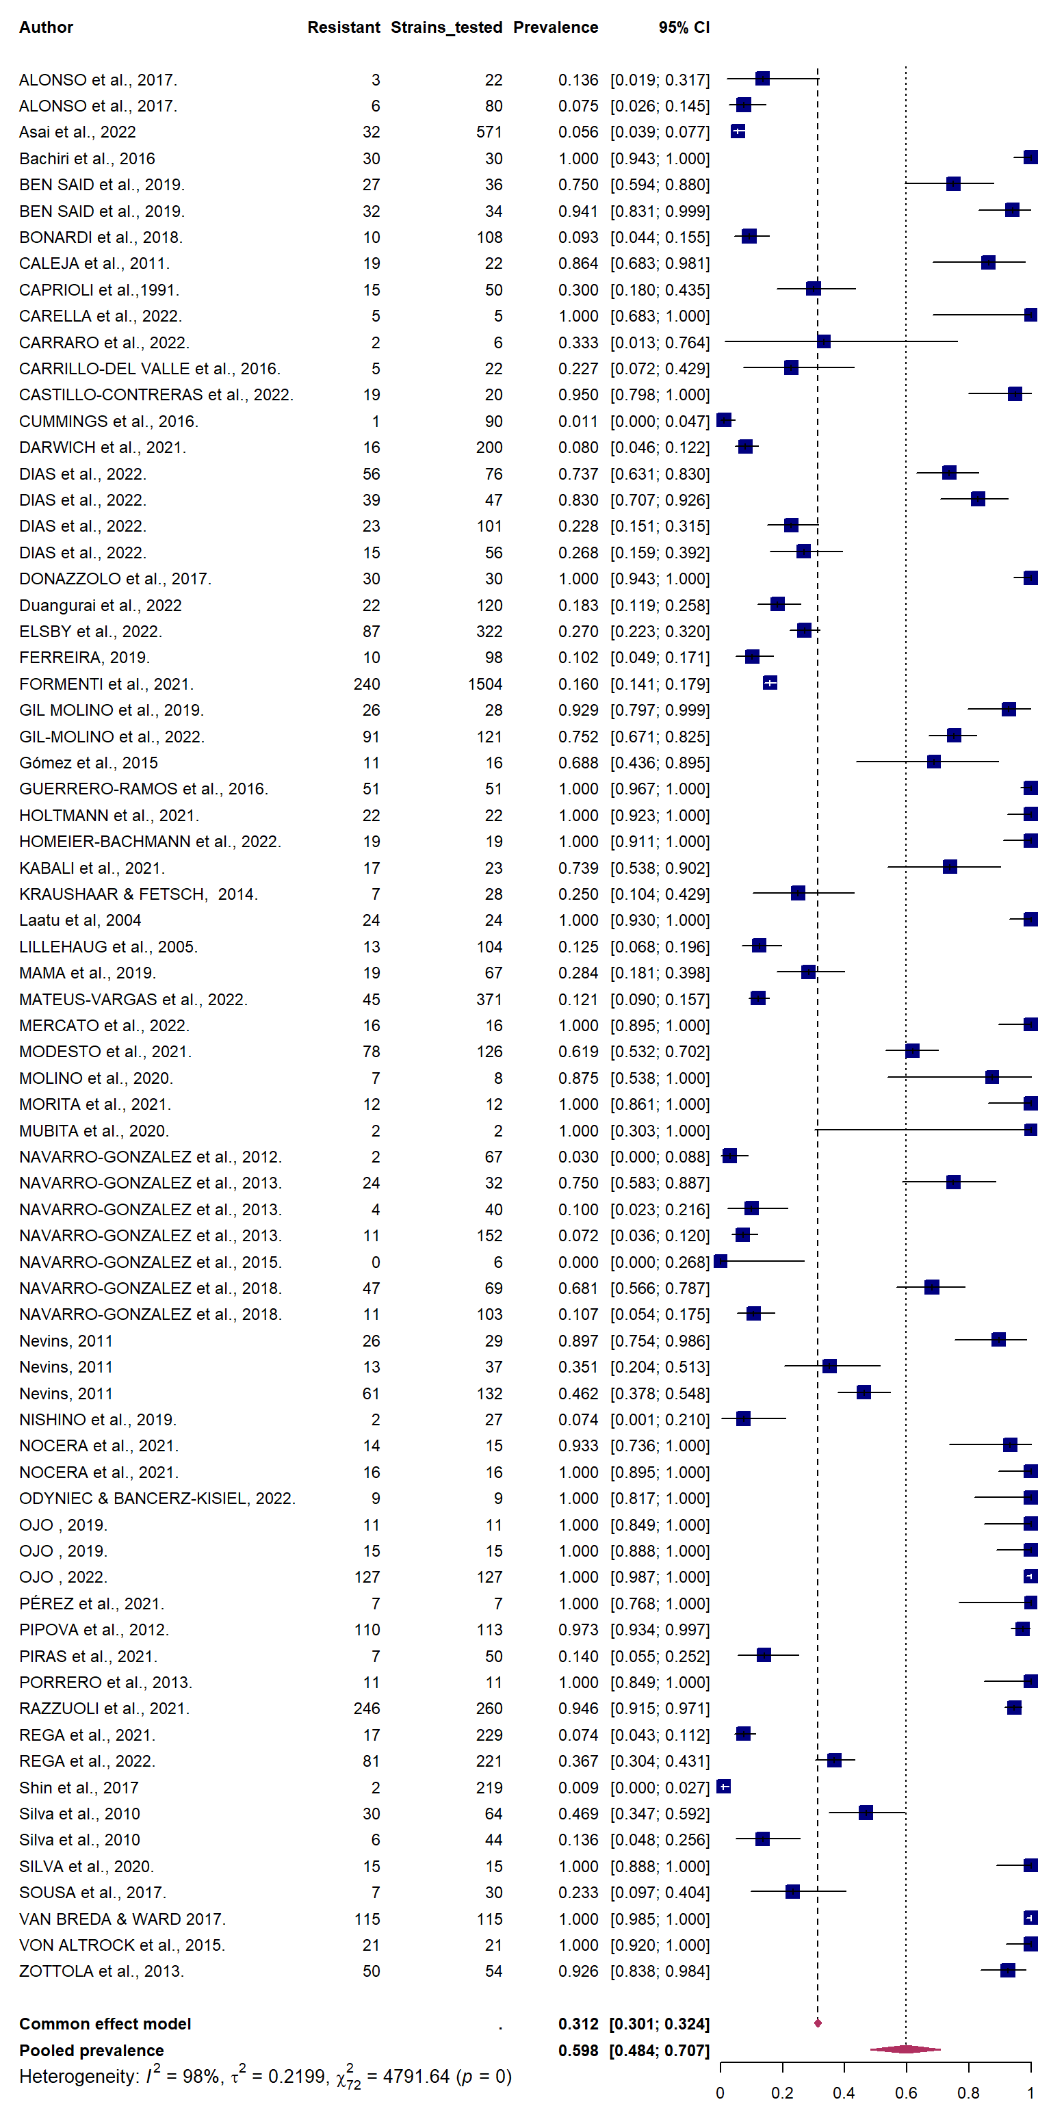
Figure 1: Forest plot showing pooled prevalence of antibiotic resistance among strains of bacteria isolated from wild game reported up to April 2023. The red diamond represents the pooled prevalence. The horizontal lines and blue boxes represent the 95% confidence interval and weighed prevalence, respectively for each included study. Shorter horizontal lines suggest better precision of the study results. “Strains_tested” represents the number of strains tested for antibiotic resistance in each study, “Resistant” represents the number of strains that showed resistance to at least one antibiotic, while “Prevalence” is the “Resistant” divided by the “Strains_tested.” The weights contributed by each study to the summarized effect size, for both fixed and random effects models, are shown as percentages in the last two columns.

