Supplementary file 6
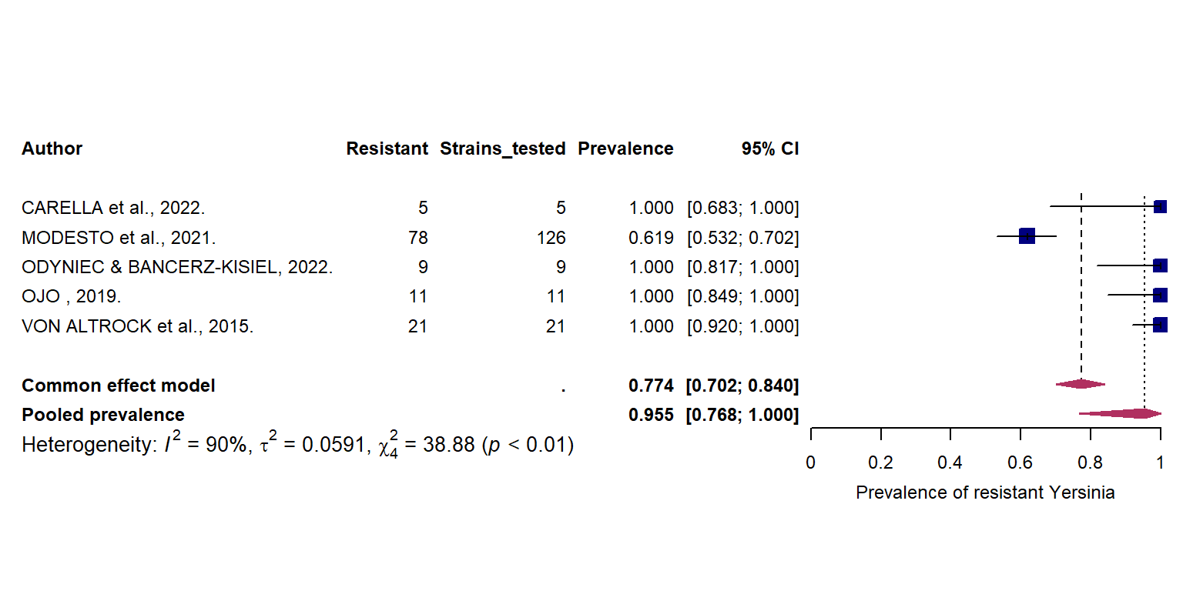
Figure 1: Pooled prevalence of antibiotic resistance in Yersinia sp. isolated from wild game mammals.

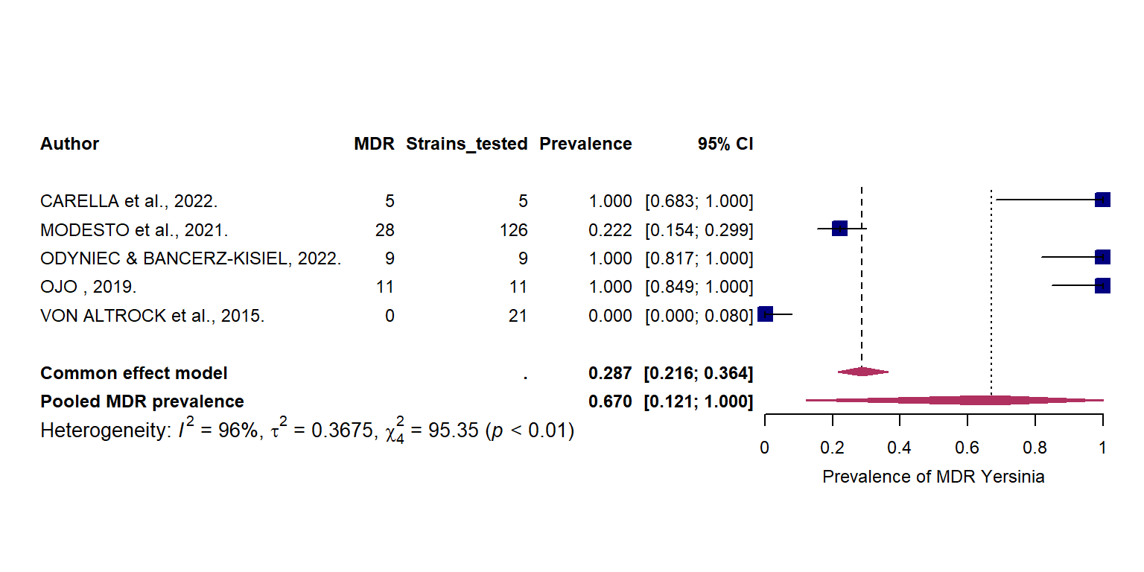
Figure 2: Pooled prevalence of multidrug resistance in Yersinia sp. isolated from wild game mammals.
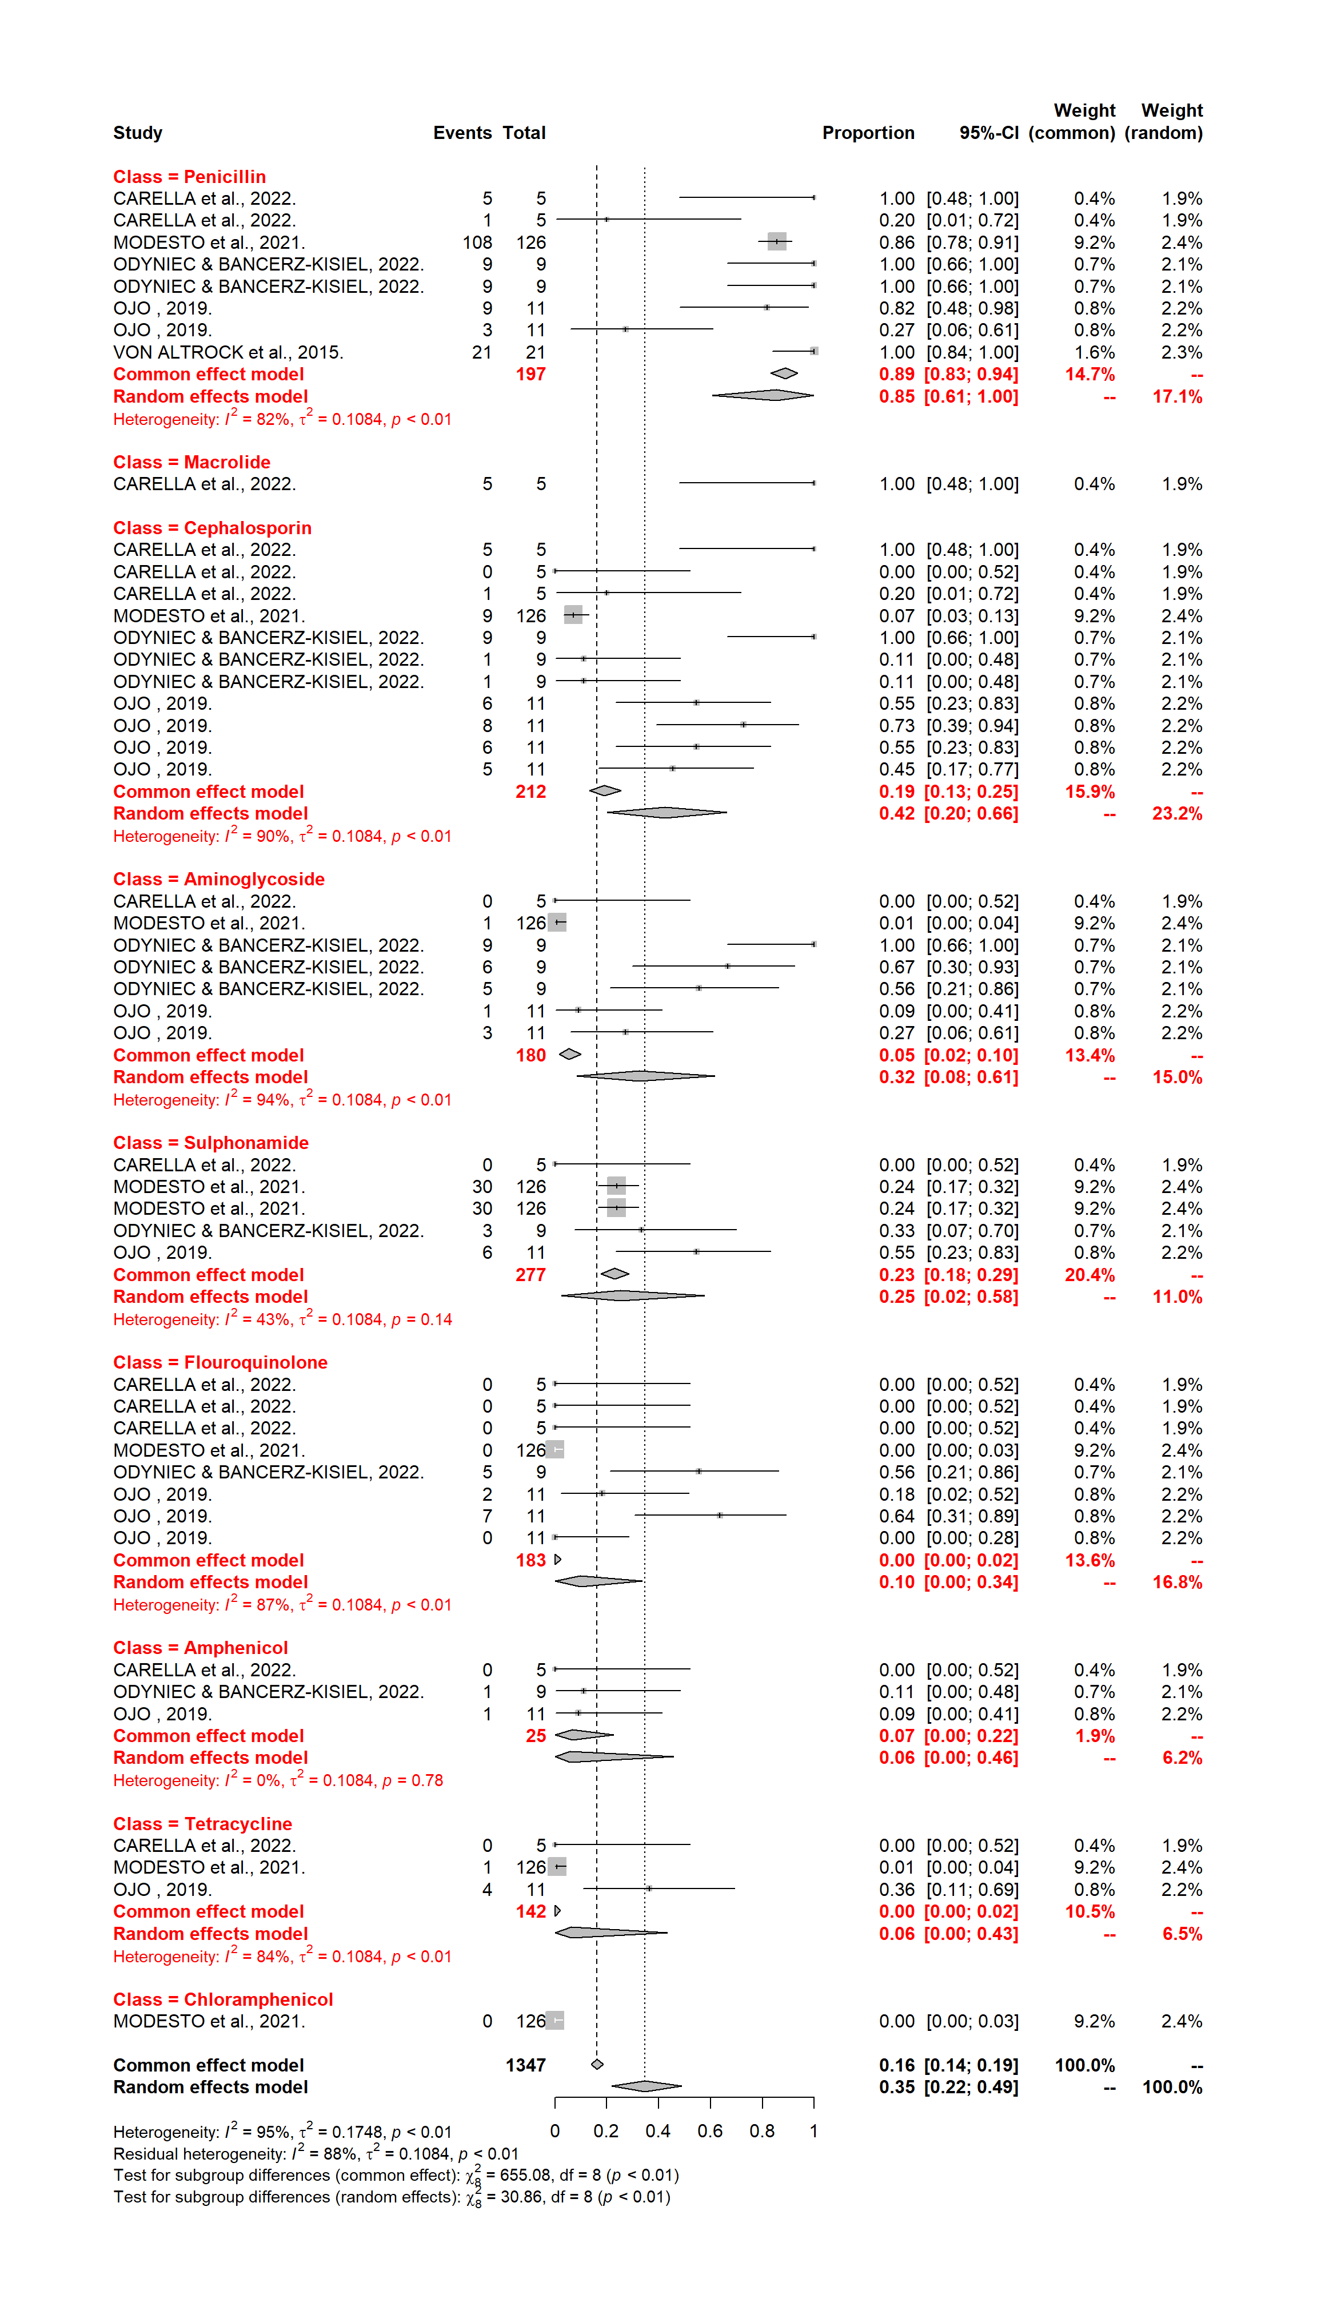
Figure 3: Resistance of Yersinia sp. isolated from wild game mammals to different classes of antibiotics.

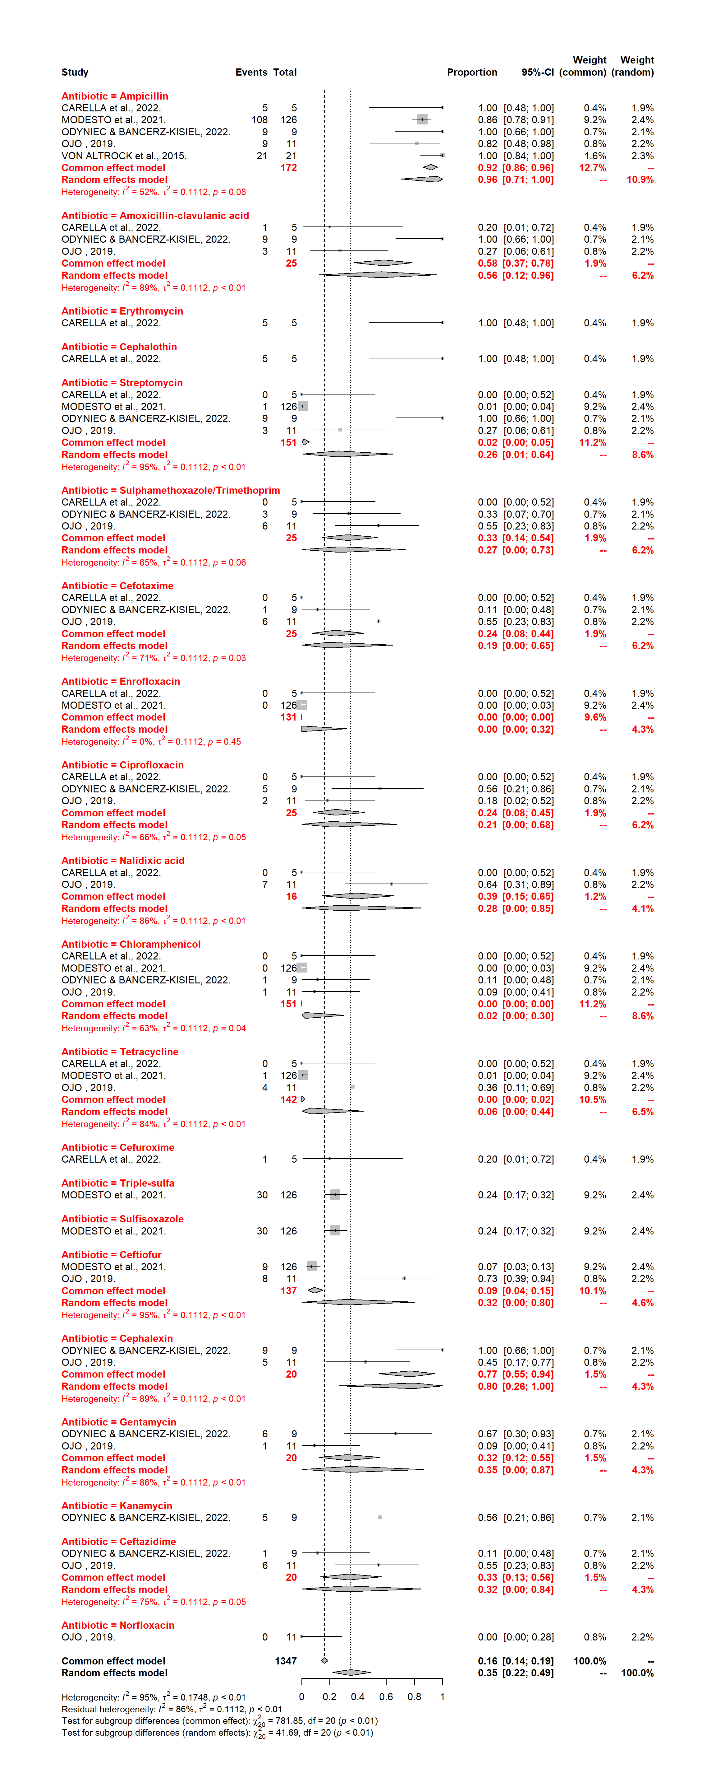
Figure 4: Resistance of Yersinia sp. isolated from wild game mammals to specific antibiotics.

