Additional File 1
Methodology
Immunocyto-chemical analysis of tropomyosin receptor kinase A (TRKA) and P75 receptors
To determine if recombinant rabbit beta NGF (rrBNGF) activity in pheochromocytoma of the rat adrenal medulla (PC12) cells was mediated by its classic receptors, immunostaining was performed to detect tropomyosin receptor kinase A (TRKA) and p75 expression in the cells. PC12 cells were grown on Poly-L-Lysine (Sigma Aldrich) coated coverslips in Roswell Park Memorial Institute (RPMI, GIBCO, Thermo Fisher, Washington, US)-160A complete medium. After 7 days, the medium was discarded, and cells were fixed using 4% paraformaldehyde (PanReac, Barcelona, Spain) for 15 min at room temperature (RT). According to Quiroga et al. [1], cells were then rinsed in 1x phosphate-buffered saline (PBS) and permeated with 1% Triton-X 100 (Sigma Aldrich) in 1xPBS. Without washing, PC12 cells were blocked with PBS containing 10% (v/v) foetal bovine serum (FBS) and 0.2% (v/v) Tween-20 (Sigma Aldrich) for 2 h at 20–25◦C, and then incubated with primary antibody anti-TRKA1 (AF175; R&D Systems, Minneapolis, USA) diluted 1/100 in PBS with 5% FBS and 0.1% Tween-20 at 4◦C overnight (o/n). The next day, cells were incubated with secondary antibodies (Alexa Fluor-488, Thermo Fisher) diluted 1/1000 for 2 h at 20–25◦C. Nuclei were stained with Hoechst 33258 (Sigma Aldrich), and sections were mounted using Vectashield (Vector Laboratories, Newark, USA) fluorescence medium. For P75 antibody detection, samples were incubated with anti-P75 (ab3125; AbCam, Cambridge, UK) diluted 1/200 and incubated overnight at 37◦C. Then, donkey anti-mouse antibody conjugated to biotin (M32315; Thermo Fisher Scientific) diluted 1:200 was added for 1 h at RT. For signal amplification, the Vectastain ABC kit (Vector Laboratories) with NovaRED (Vector Laboratories) was used.

Assessment of potency of in vitro rrBNGF
Comparison of potency of rrBNGF synthesized by Genescript (GenBank KX528686; Genscript Biotech, New Jersey, USA) [2] to commercial murine BNGF (mrBNGF; R&D Systems, Minneapolis, USA) was first established. The following experimental groups were: i) Control, complete RPMI medium; ii) rNGF25, RPMI medium + 25 ng/ml rrBNGF; iii) rNGF50, medium + 50 ng/ml rrBNGF; iv) mNGF50, medium + 50 ng/ml mrBNGF; and v) mNGF100, medium + 100 ng/ml mrBNGF. Differentiation medium was refreshed every 48 h. Morphological cell features (rounded, fusiform or star-like cells; cells with 1, 2-3 or more than 3 neurites; cells with ramified neurites; and cells with neurites shorter or longer than one cell diameter and neurite density) were evaluated based on microscopic images taken on days 3, 5 and 7 after BNGF addition. All these parameters were determined in 5 fields with cells in 3 different wells, and 3 independent replicates were done. According to Sanchez Rodriguez et al. [2], ImageJ software was used for image analysis.
Cell viability analysis was performed with 2H-Tetrazolium, 2-(4,5-dimethyl-2-thiazolyl)-3,5-diphenyl-bromide (MTT, Thermo Fisher Scientific) assay according to manufacturer instructions.

Statistical analysis
For morphometric studies, a two-way ANOVA with repeated measures test was performed. rrBNGF supplemented medium (control, mNGF50, mNGF100, rNGF25, rNGF50) and analysis examination days (3, 5 and 7) were used as fixed effects. Interaction between fixed effects was also analysed in the statistical test. For cell viability study, a one-way ANOVA test was conducted with supplemented medium (control, mNGF50, mNGF100, rNGF25, rNGF50) as the fixed effect and treatment as independent variable. Each of the morphological parameters analysed were considered dependent variables. Results are shown as mean±S.D.
Results
rrBNGF receptors on PC12 cells
After seven days in culture, PC12 cells showed positive signals for TRKA (Fig. 1A) and p75 (Fig. 1B) staining in the cell membrane (Additional Figure 1).
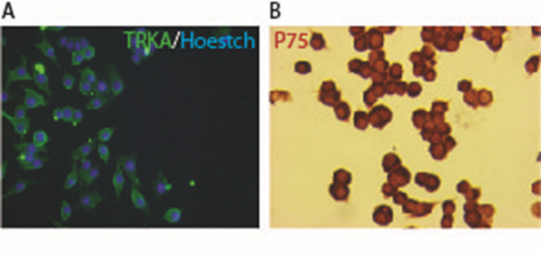
Additional Figure 1. Analysis of NGF receptor expression on PC12 cells. Subcellular localization of BNGF receptors by immunocytochemistry analysed with (A) fluorescence for TRKA and (B) NovaRed for p75.

rrBNGF potency
While 95% of control PC12 cells remained undifferentiated (rounded) at all stages, this percentage was low and decreased over time in all groups treated with BNGF (Additional Figure 2A). In line with these results, the percentage of differentiated cells showing fusiform (Additional Figure 2B) and star-like morphologies (Additional Figure 2C) was higher in cells grown with NGF-supplemented medium than in control medium cells and increased over time. In the case of star-like shaped cells, groups mNGF50 and rNGF50 showed the highest increase (Additional Figure 2C), indicating that these two concentrations elicit similar effects on PC12 differentiation. When cells with 1, 2-3, and more than 3 neurites were analysed (Additional Figure 2D), a similar effect was detected, with mNGF50, mNGF100 and rBNGF50 showing the most potent results.
Analysis of cell complexity showed that the percentage of neurites shorter than average cell diameter was lower in NGF-treated groups (Additional Figure 2E) than in control medium cells and decreased over time. In accordance with this, the percentage of neurites longer than average cell diameter increased over time, reaching its highest levels at day 7 for cells growing in mNGF50, mNGF100, and rNGF50 supplemented media. Furthermore, the percentage of branched neurites, which indicate highly complex and differentiated cells, also increased over time in all NGF-treated cells (Additional Figure 2F), with the mNGF50, mNGF100 and rNGF50 groups showing the highest increase. Overall, this analysis showed that the NGF-supplemented media in terms of differentiation were mNGF100 and rNGF50 and that our novel rrBNGF has a similar differentiation potential as the commercial mrBNGF. Furthermore, cell viability was not affected by BNGF supplementation and was similar for all experimental groups (Additional Figure 2).
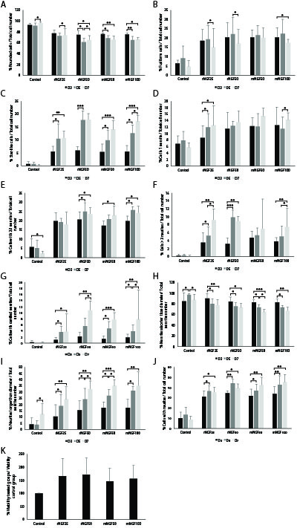
Additional Figure 2. Study of the potency of the recombinant rabbit NGF (rrbNGF) compared to murine NGF (mNGF) using PC12 cultures. Morphological and differentiation analysis 3, 5 and 7 days after free NGF media supplementation is shown. Experimental groups: Control (RPMI complete medium), rNGF25 (25 µg/ml rrbNGF), rNGF50 (50 µg/ml rrbNGF), mNGF50 (50 µg/ml rmbNGF) and mNGF100 (100 µg/ml rbNGF). Percentage of rounded (A), fusiform (B) and star-like cells (C) in relation to total cell number. Percentage of cells with 1 (D), 2-3 (E) and more than 3 neurites (F) in relation with total cell number. Percentage of cells displaying ramified (G), shorter than 1 cell diameter (H) and longer than 1 cell diameter (I) neurites in relation to total cell number. (J) Percentage of cells with neurites in relation to total cell number. (K) Percentage of cell viability analysed by MTT. Data is represented as mean ±SD. *p<0.05, **p<0.005, ***p>0.001.
Additional Figure 3. Experimental design.
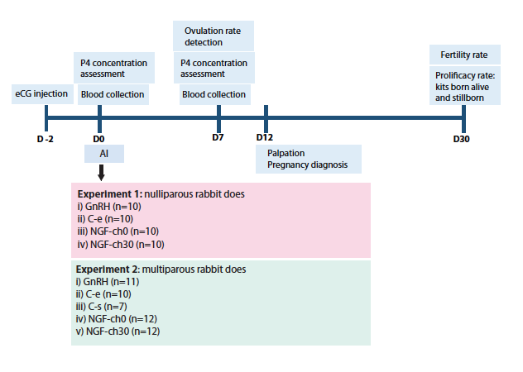
AI: Artificial insemination; eCG: equine Chorionic Gonadotropin. P4 Progesteroneassessment. GnRH: inseminated after i.m injection of C-e: stimulated with an empty catheter, NGFch-0: inseminated simultaneously with NGF-chitosan administration. NGFch-30: inseminated 30 min after NGF-chitosan intravaginal administration. C-s: stimulated with a catheter containing diluted semen.

References
1. Quiroga AC, Stolt CC, del Corral RD, et al. Sox5 controls dorsal progenitor and interneuron specification in the spinal cord. Dev Neurobiol. 2015;75(5):522-538.
2. Sanchez-Rodriguez A, Abad P, Arias-Alvarez M, et al. Recombinant rabbit beta nerve growth factor production and its biological effects on sperm and ovulation in rabbits. PLoS One. 2019;14(7):e0219780.

