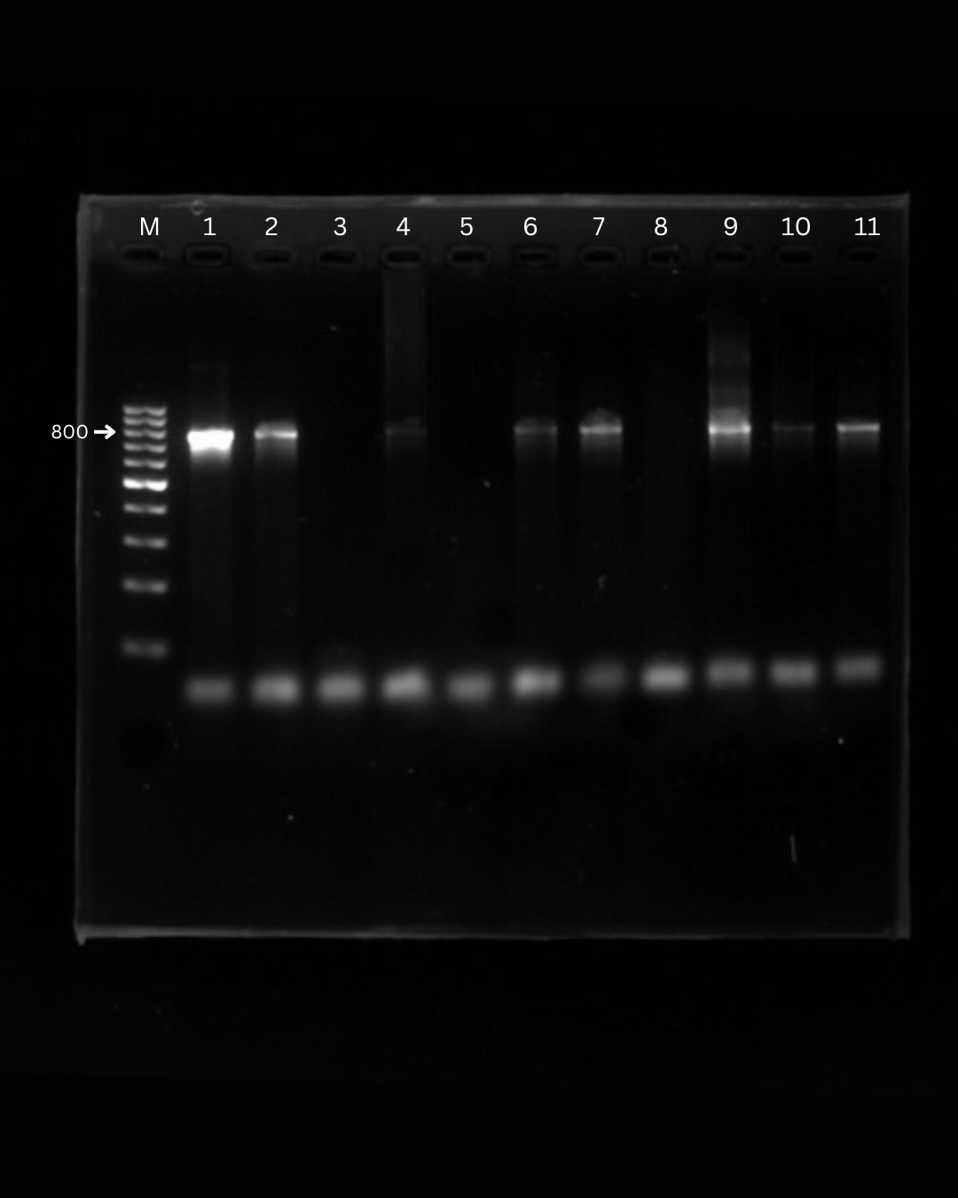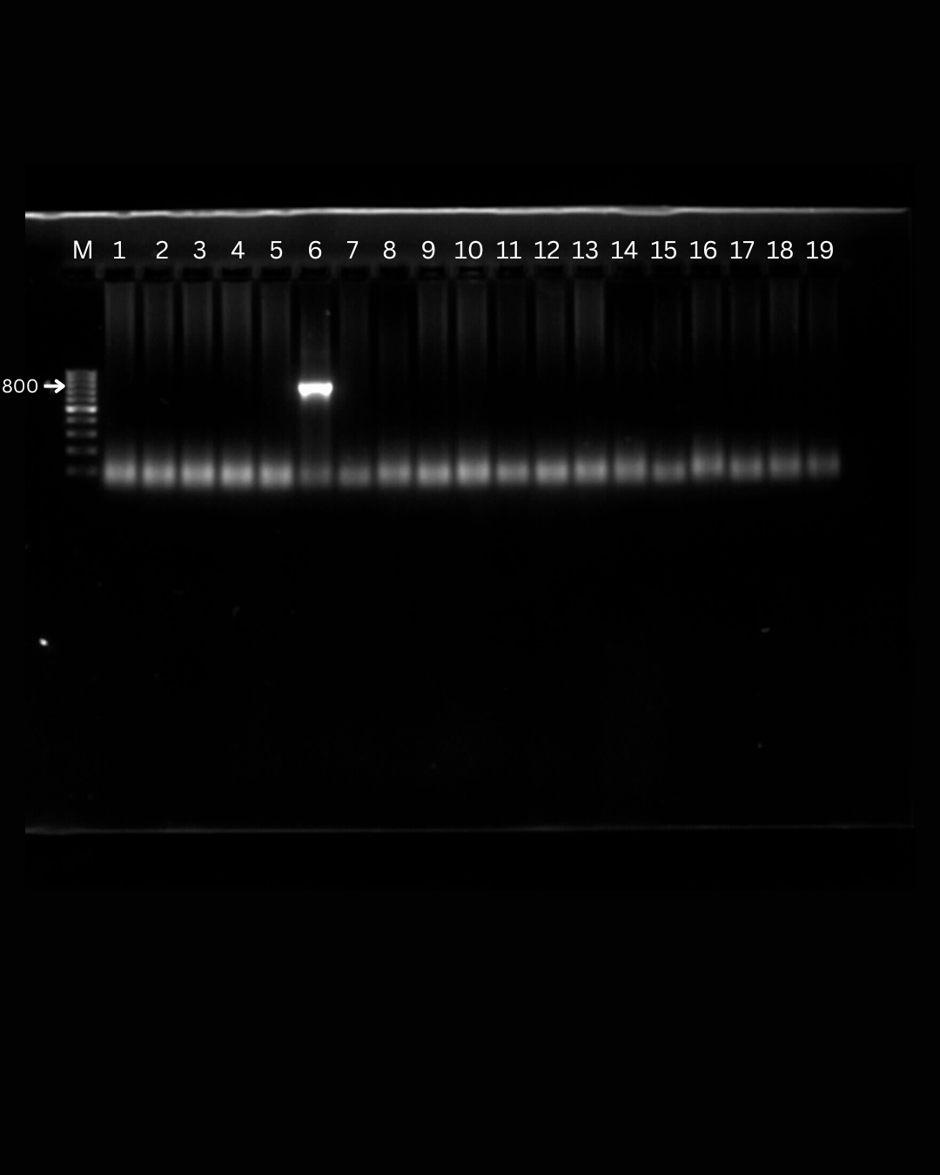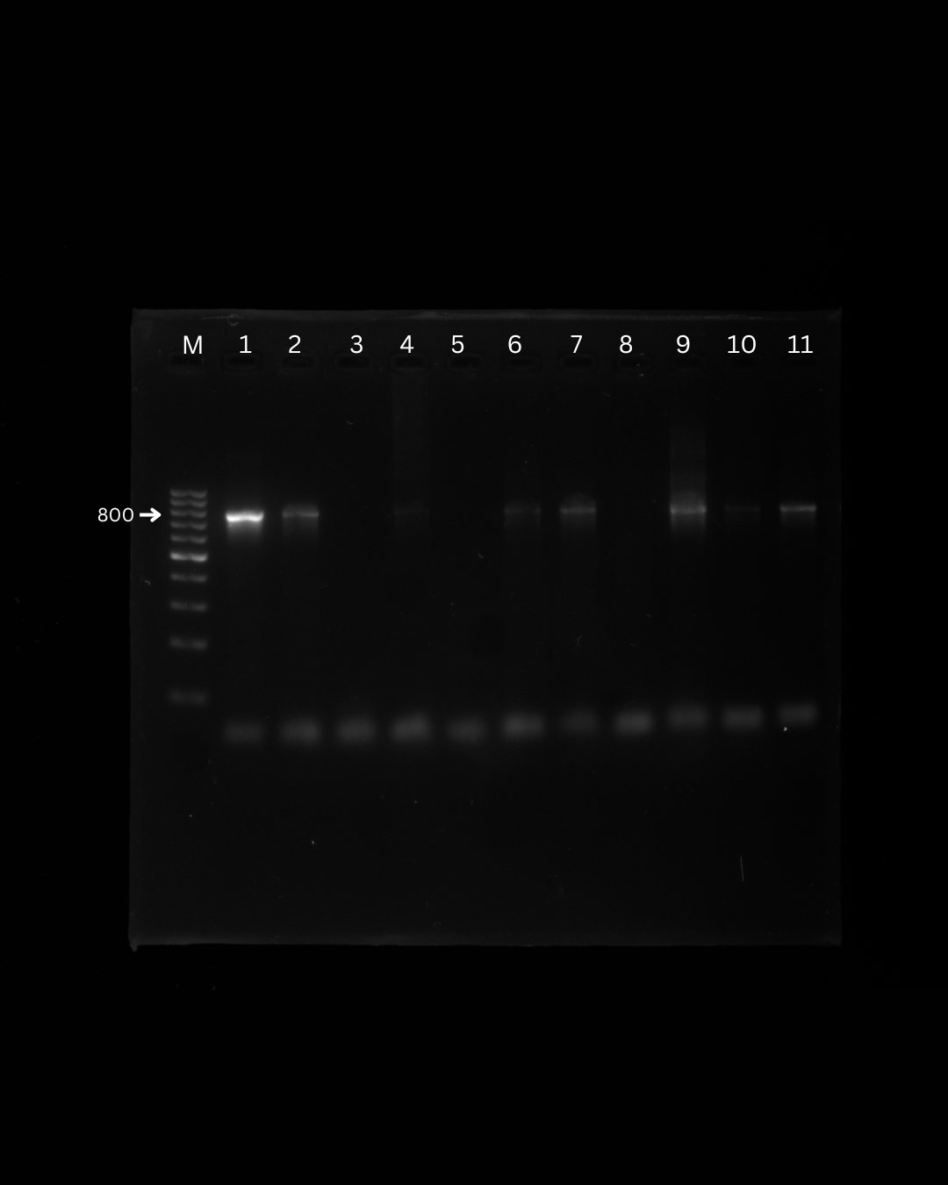
1A
1B
1C
Supplementary Figure 1: Detection of Babesia spp. by gel electrophoresis (1A, 1B, 1C).
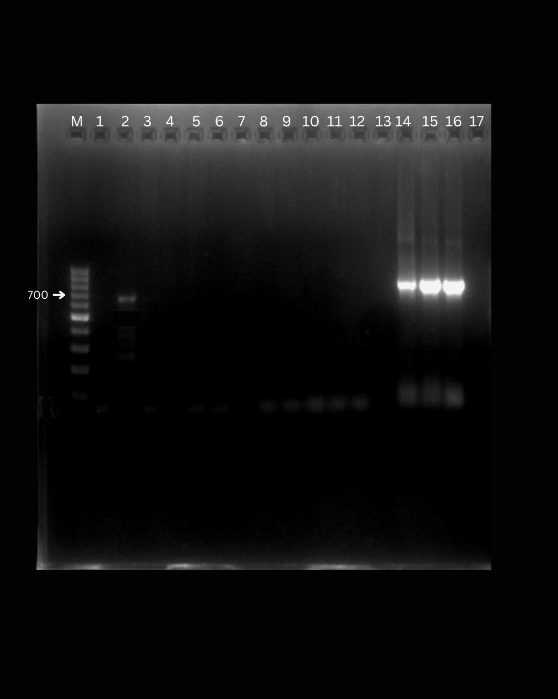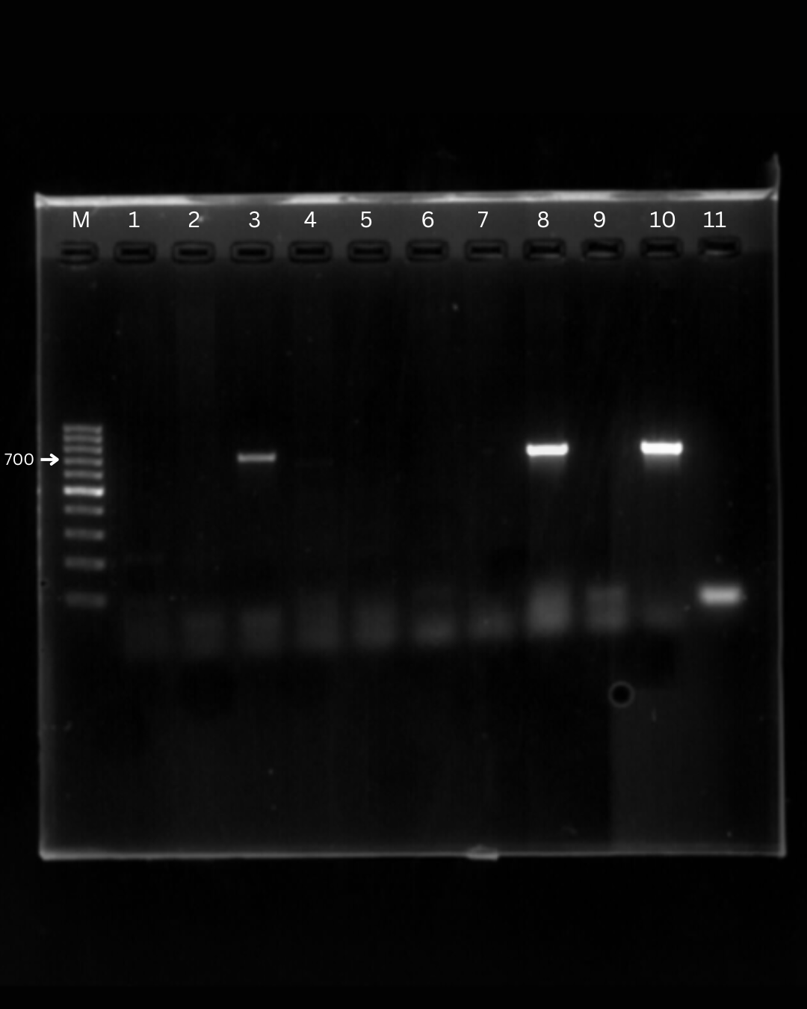
2A
2B

Supplementary Figure 2: Detection of Hepatozoon canis by gel electrophoresis (2A, 2B).
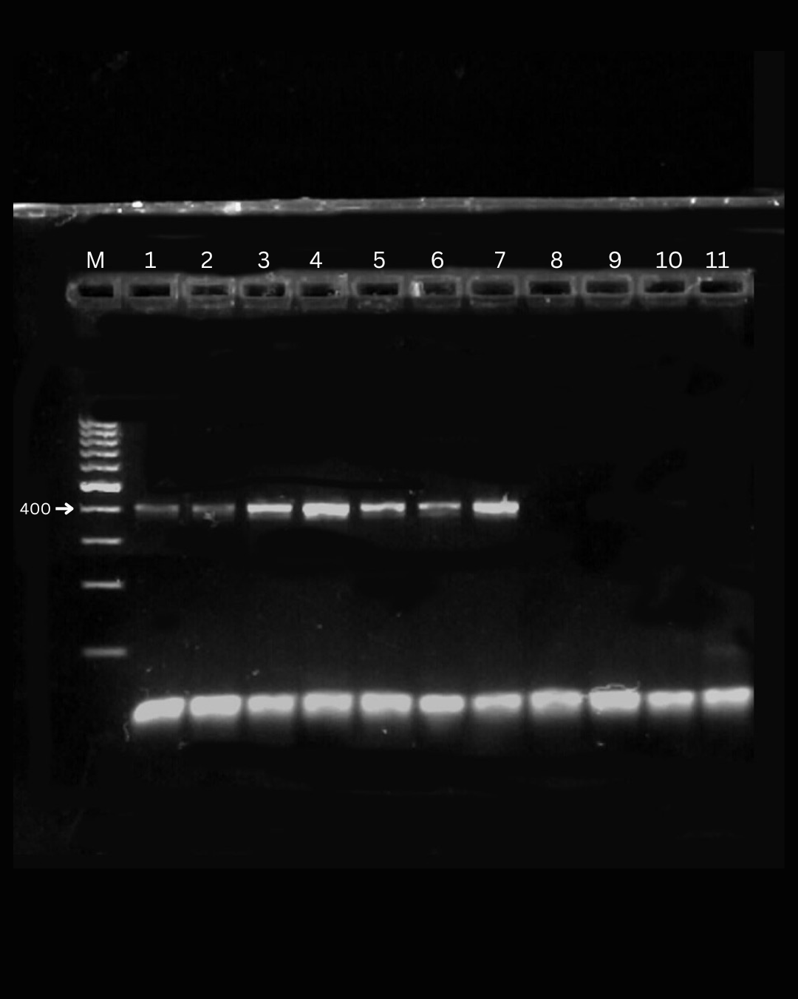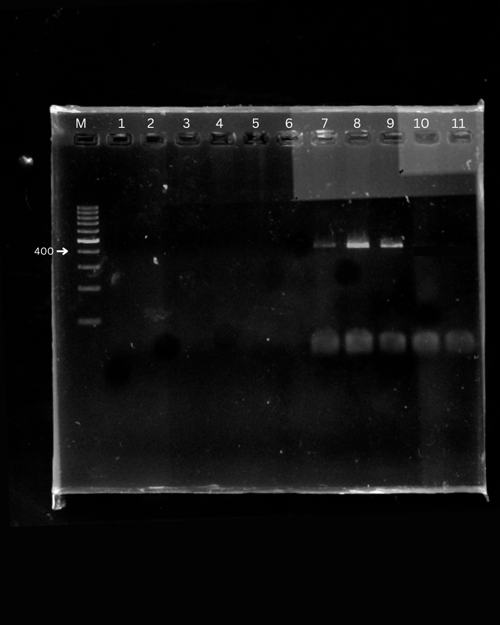
3A
3B
Supplementary figure 3: Detection of Ehrlichia canis based on gel electrophoresis (3A, 3B).

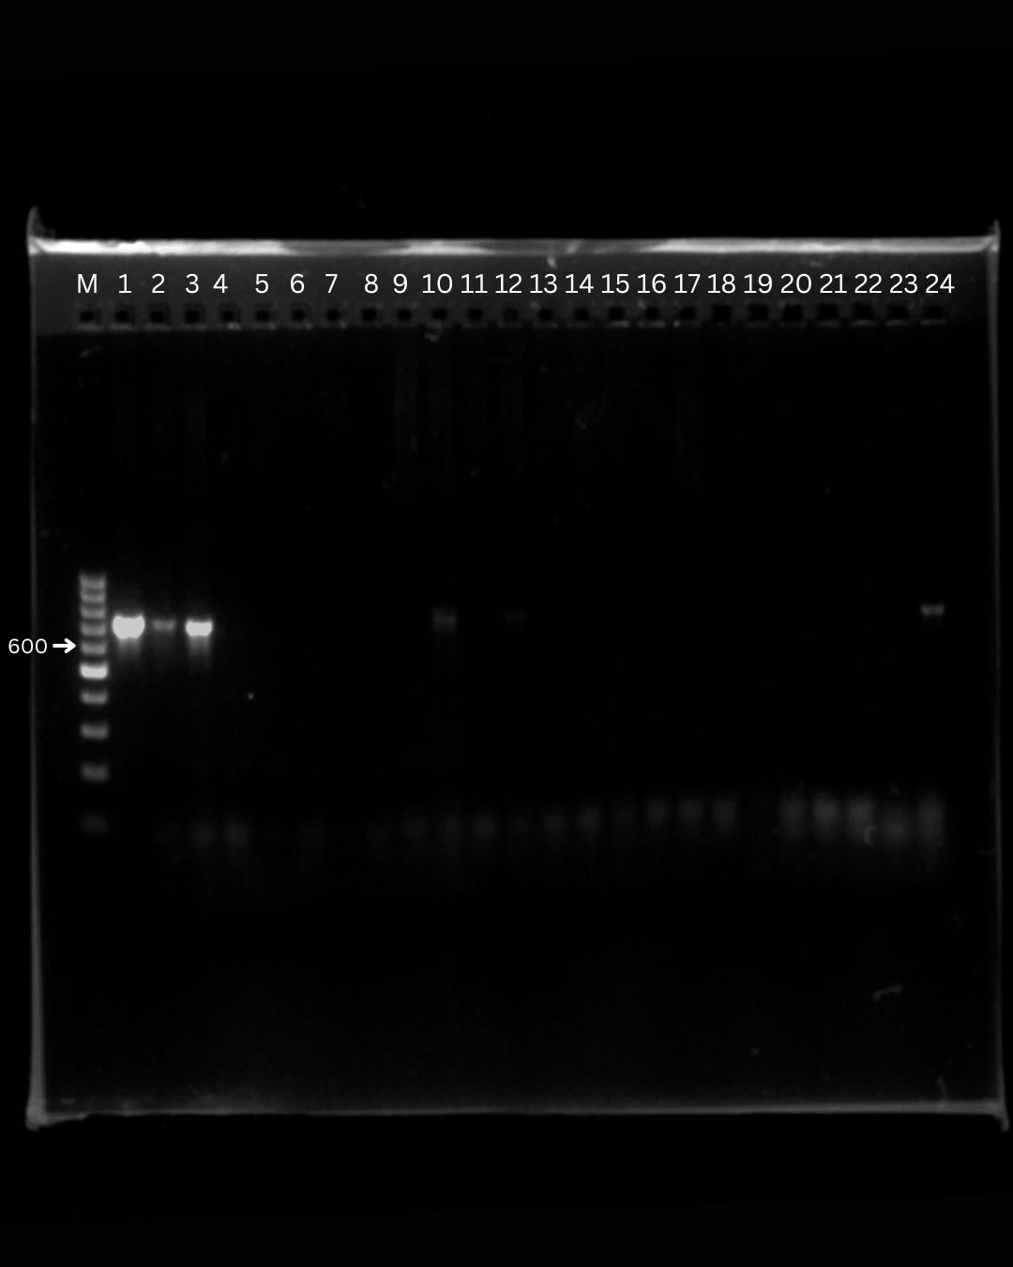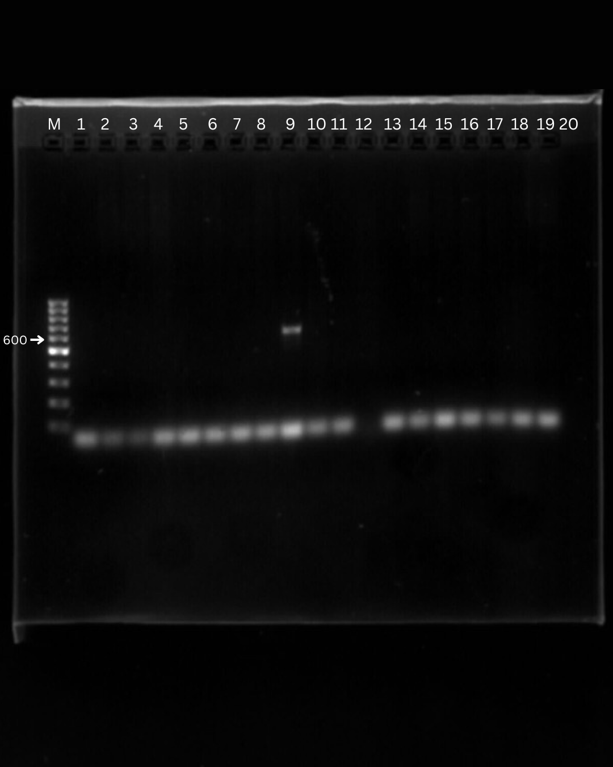
4A
4B
Supplementary figure 4: Detection of Anaplasma platys canis based on gel electrophoresis (A,B).

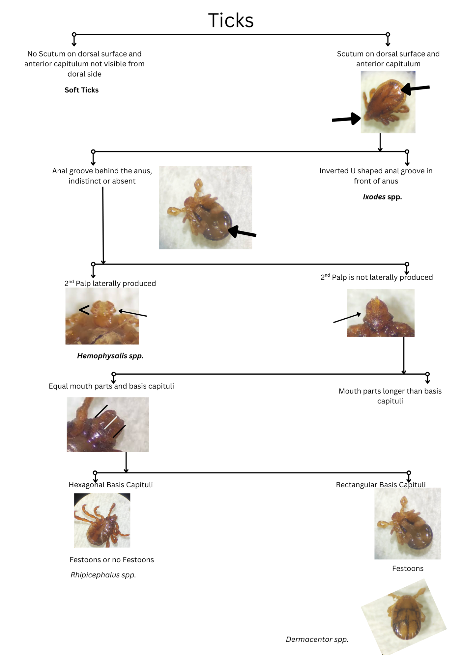
Supplementary figure 5: Schematic representation of identification ticks upto the genera level.

