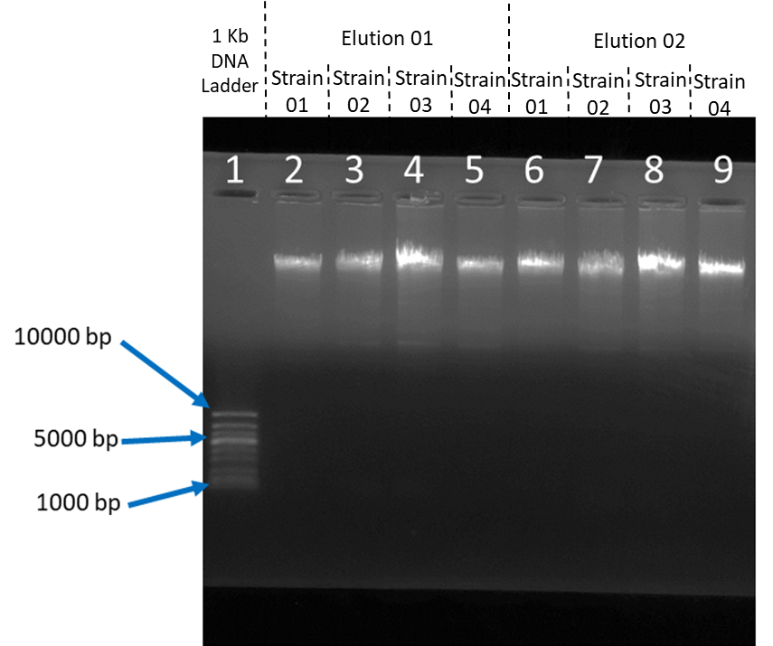
Supplementary figure 1. Gel image of extracted DNA. DNA was run through 0.8% agarose gel in 1X TBE (Tris-Borate-EDTA) running buffer. Lane 1: 1 kb DNA ladder. Lane 2: Elution 1 of Strain 01. Lane 3: Elution 1 of Strain 02. Lane 4: Elution 1 of Strain 03. Lane 5: Elution 1 of Strain 04. Lane 6: Elution 2 of Strain 01. Lane 7: Elution 2 of Strain 02. Lane 8: Elution 2 of Strain 03. Lane 9: Elution 2 of Strain 04.
1000 bp
5000 bp
10000 bp
1
7
3
4
5
6
8
9
10
2

Supplementary figure 2. Original unprocessed gel image of extracted DNA upon request after desk assessment. DNA was run through 0.8% agarose gel in 1XTBE (Tris-Borate-EDTA) running buffer. Lane 1: 1 kb DNA ladder (GelPilot 1 kb, Cat. No. 239085). Lane 2: Elution 1 of Strain 01. Lane 3: Elution 1 of Strain 02. Lane 4: Elution 1 of Strain 03. Lane 5: Elution 1 of Strain 04. Lane 6: Elution 2 of Strain 01. Lane 7: Elution 2 of Strain 02. Lane 8: Elution 2 of Strain 03. Lane 9: Elution 2 of Strain 04. Lane 10: 100 bp DNA ladder (Promega G2101). * In lane 10, the 100 bp ladder did not run properly, likely due to the use of 0.8% agarose gel instead of the recommended 2% concentration.

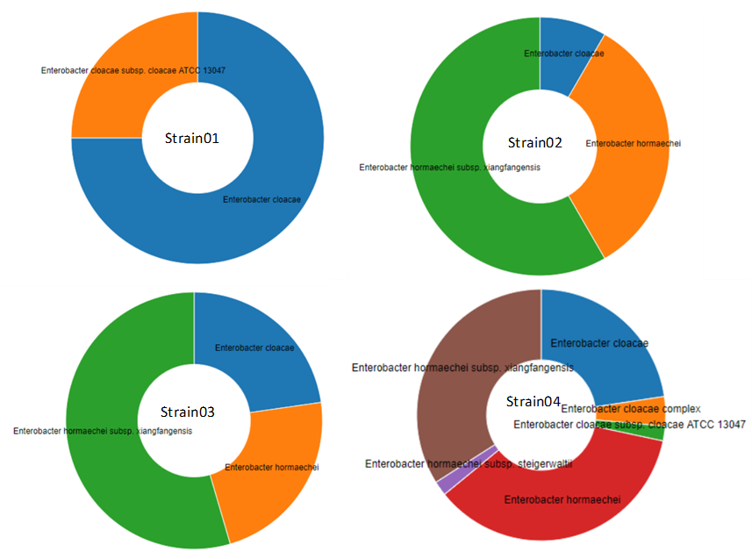
Supplementary figure 3. Results of What’s In My Pot (WIMP) Analysis.

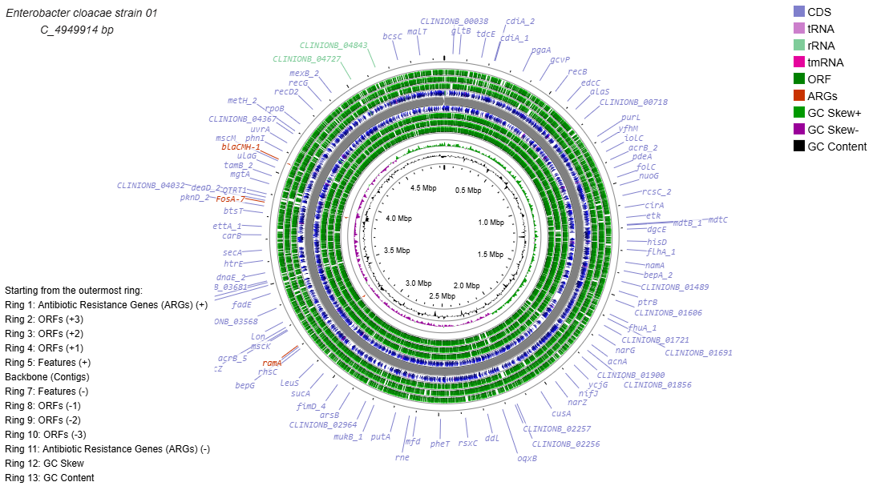
Supplementary figure 4. Genome map of strain 01. The bacterial chromosome (C) with 4.9 Mb in size. Antibiotic resistance genes are highlighted in red.

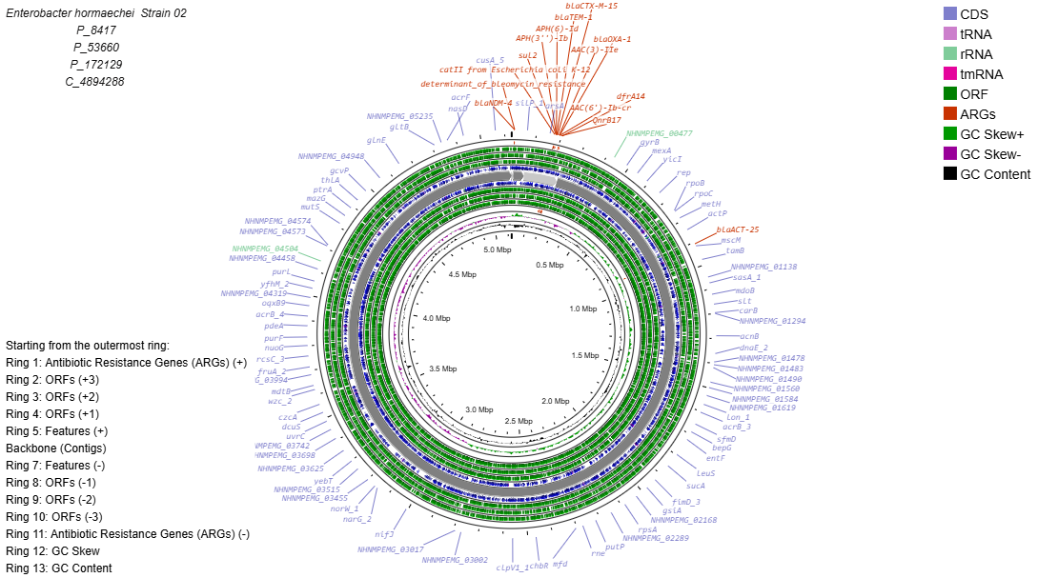
Supplementary figure 5. Genome map of strain 02. The bacterial chromosome (C) with ~ 4.9 Mb in size and three plasmids (P) with 8 kb – 0.17 Mb in size. Antibiotic resistance genes are highlighted in red.

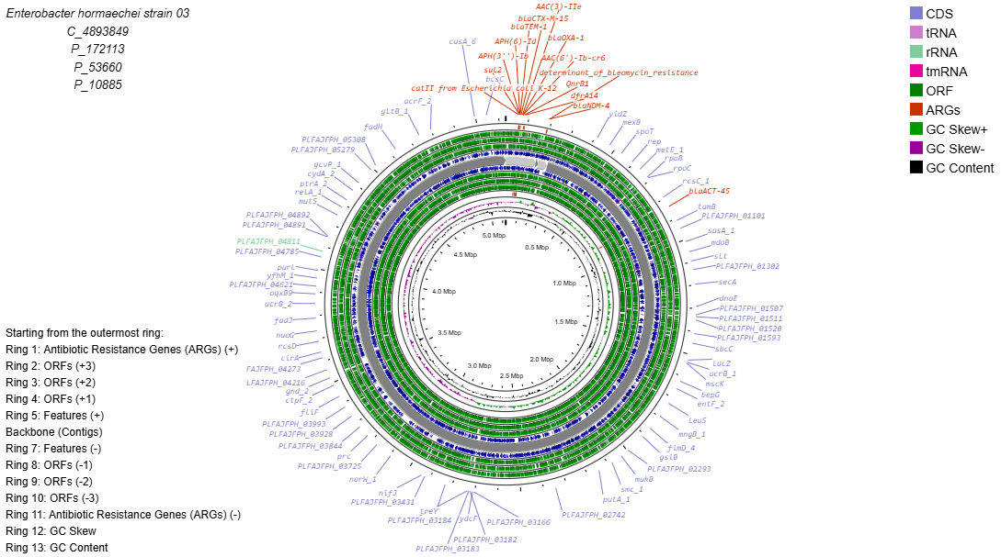
Supplementary figure 6. Genome map of strain 03. The bacterial chromosome (C) with ~ 4.9 Mb in size and tree plasmid (P) with 11 kb – 0.17 Mb in size. Antibiotic resistance genes are highlighted in red.

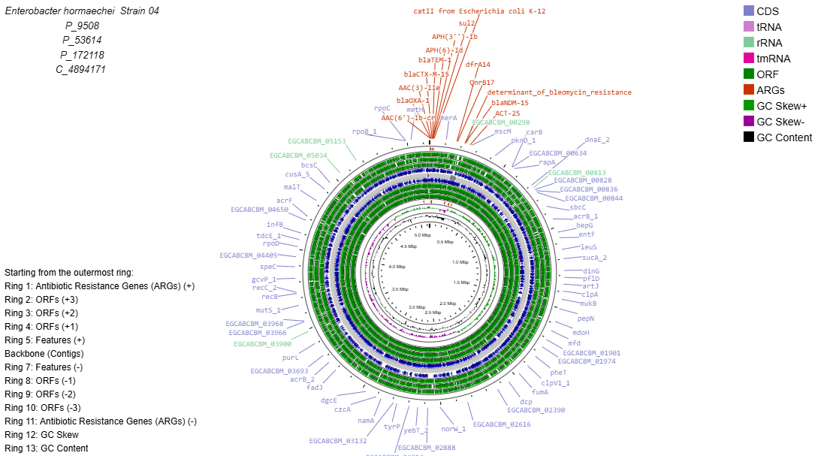
Supplementary figure 7. Genome map of strain 04. The bacterial chromosome (C) with ~ 4.9 Mb in size and three plasmids (P) with 9 kb – 0.17 Mb in size. Antibiotic resistance genes are highlighted in red.

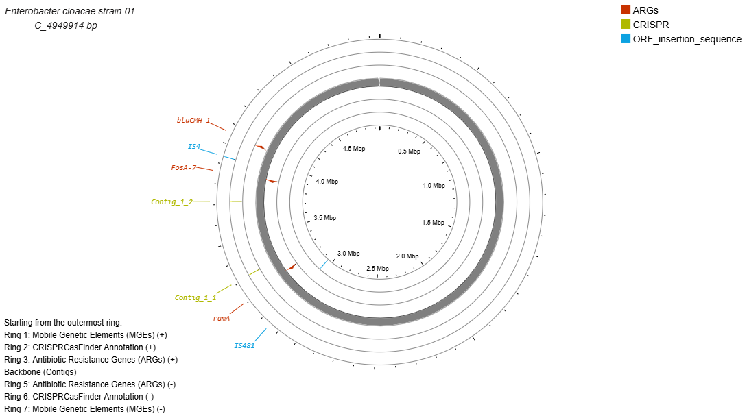
Supplementary figure 8. Genome map representing the location of resistance genes, CRISPR, and mobile genetic elements of strain 01.

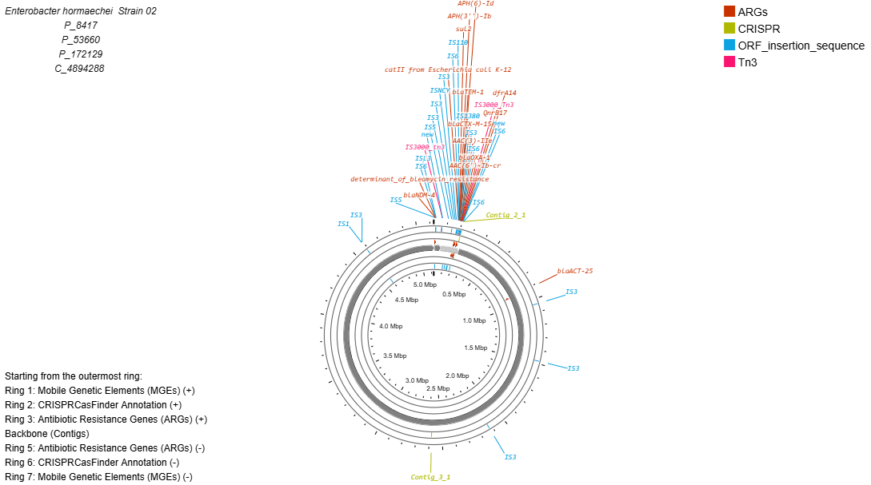
Supplementary figure 9. Genome map representing the location of resistance genes, CRISPR, and mobile genetic elements of strain 02.

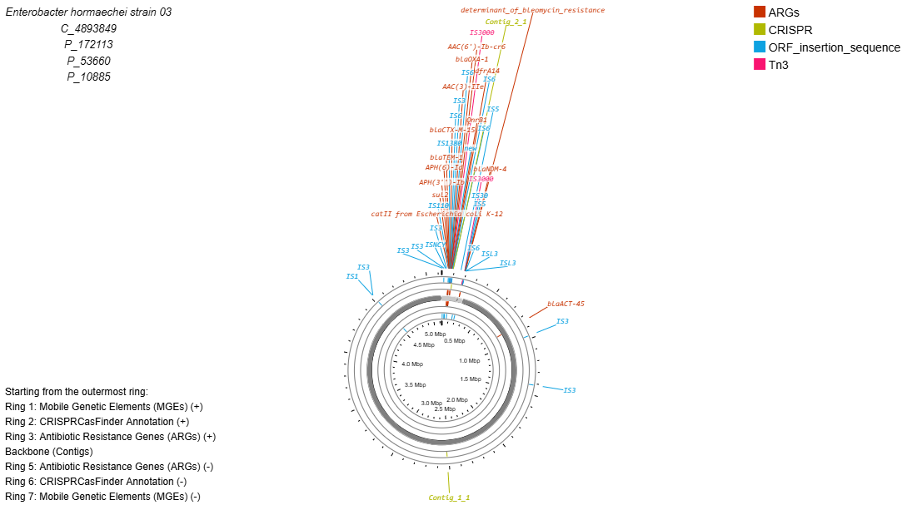
Supplementary figure 10. Genome map representing the location of resistance genes, CRISPR, and mobile genetic elements of strain 03.

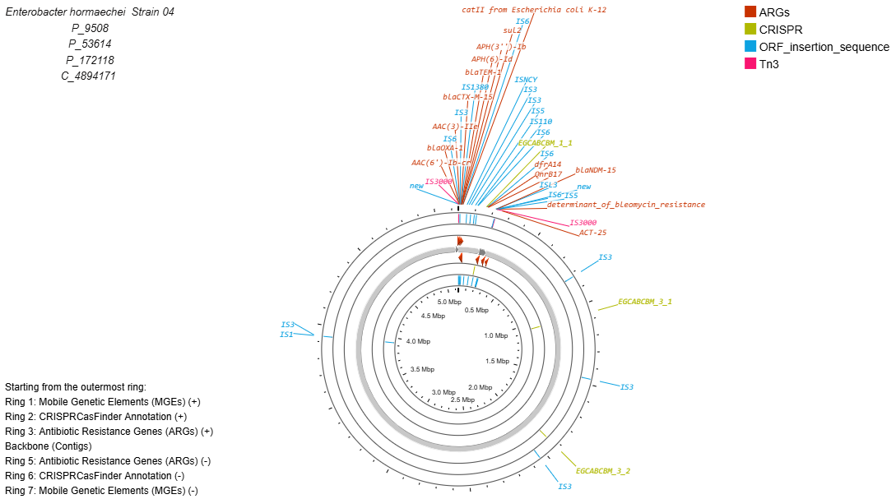
Supplementary figure 11. Genome map representing the location of resistance genes, CRISPR, and mobile genetic elements of strain 04.

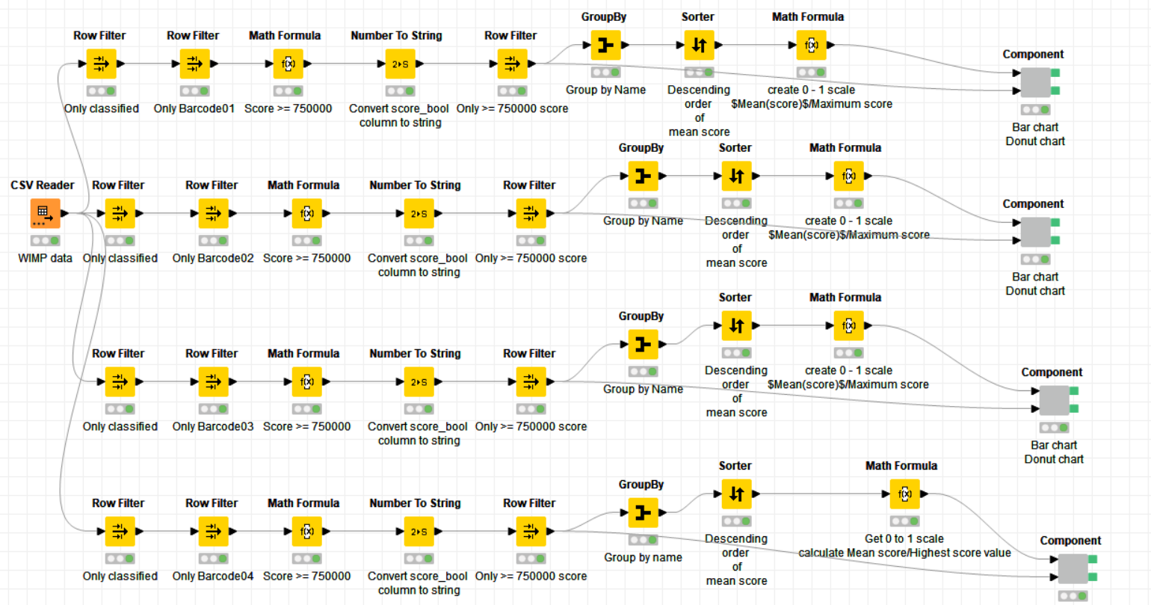

Supplementary figure 12. KNIME workflows to analyze WIMP results by filtering ≥ 750000 scores.

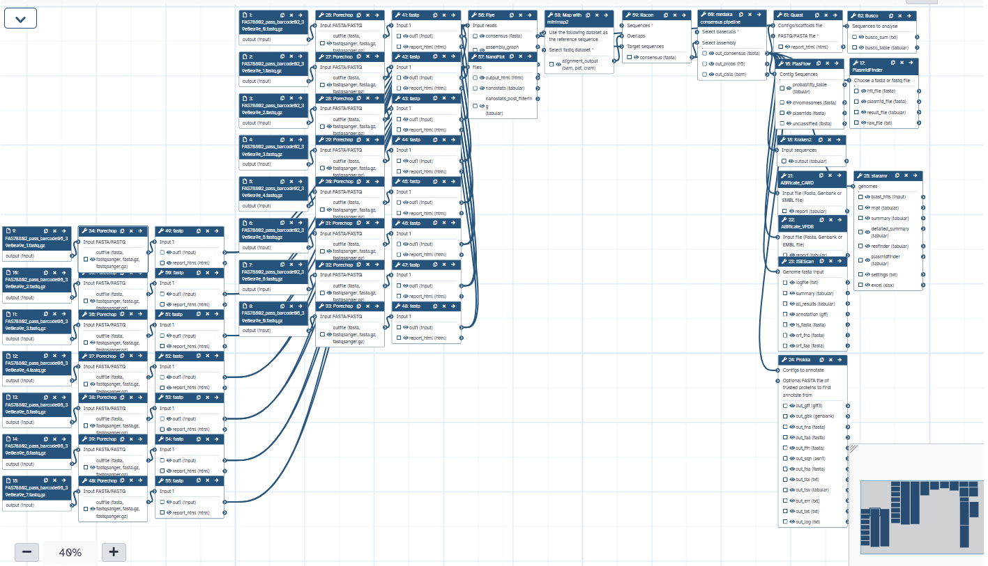
Supplementary figure 13. Built up GALAXY workflow.

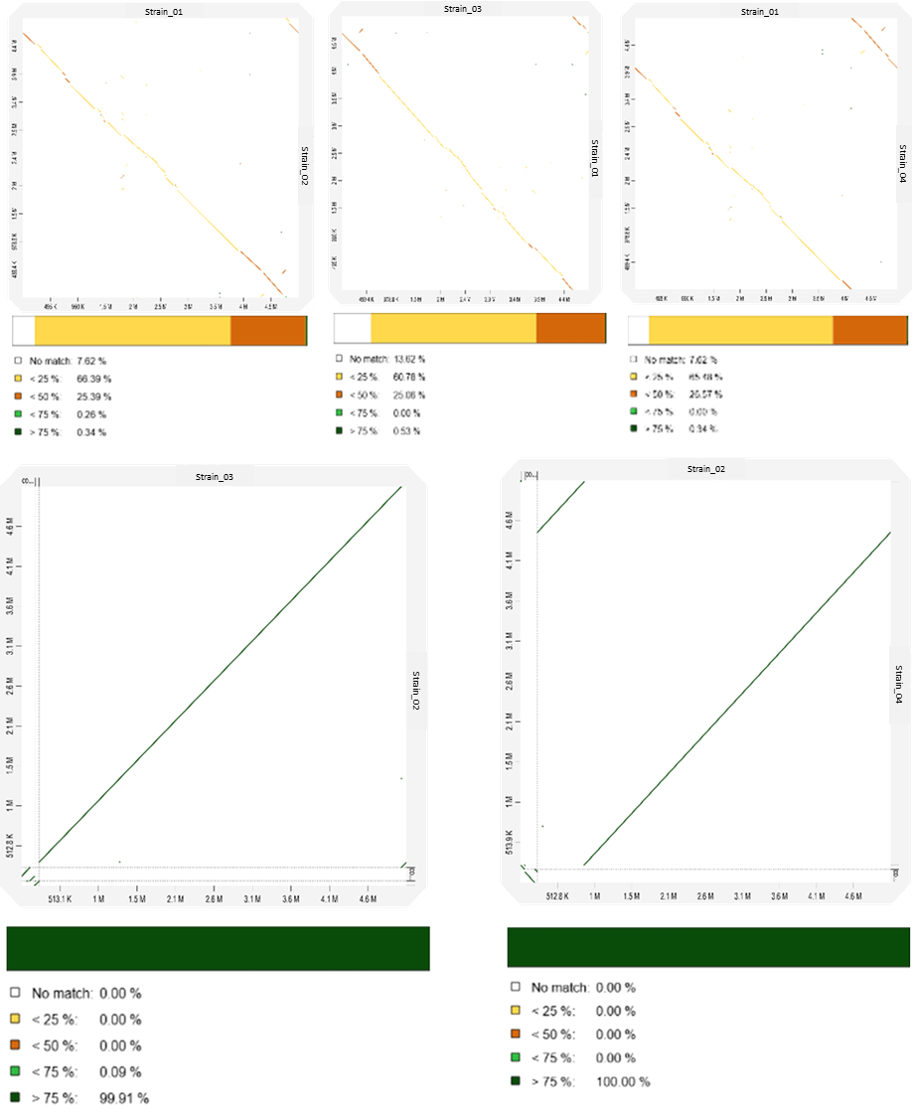

Supplementary figure 14. Genome-wide similarity comparison using D-GENIES.
(A) Dot plot generated by D-GENIES showing pairwise alignment between each genome. Each dot represents a syntenic block; diagonal lines indicate conserved regions, while breaks or shifts suggest structural variations.
(B) Similarity matrix derived from the same alignment, representing the percentage identity between corresponding genomic regions. Higher similarity is indicated by darker shades.

