Additional Files
A.
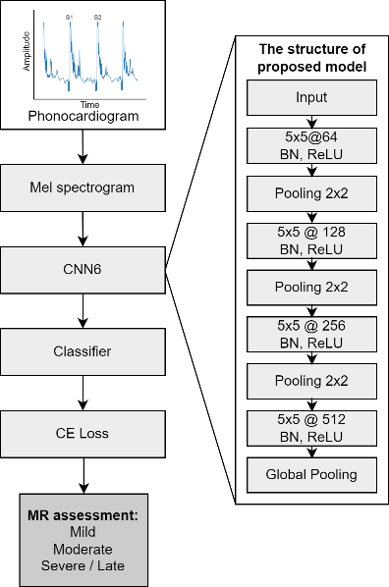

B.
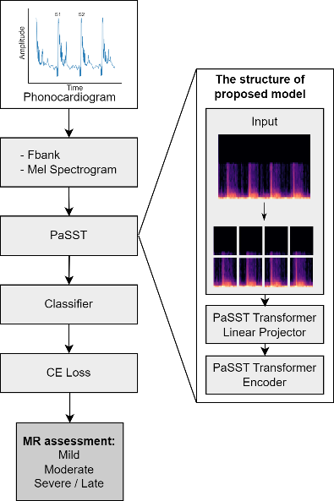

C.
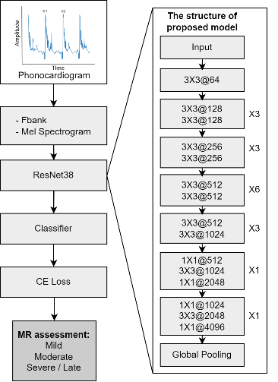

Additional Figure 1. The architecture of the deep learning models for evaluating mitral regurgitation severity using other methods.
This figure illustrates the architectures of three supplementary models used for mitral regurgitation (MR) assessment that are not represented in the main data: (A) CNN6-Mel spectrogram model, (B) PaSST-based model, and (C) ResNet38-based model. In each model, phonocardiogram (PCG) signals are first transformed into filter bank (Fbank) or Mel spectrogram representations. These representations are then processed through the respective models—PaSST, ResNet38, and CNN6—which consist of various layers and structures to determine murmur severity and categorize it as mild, moderate, or severe. The model layer details are shown on the right.

