Additional Files
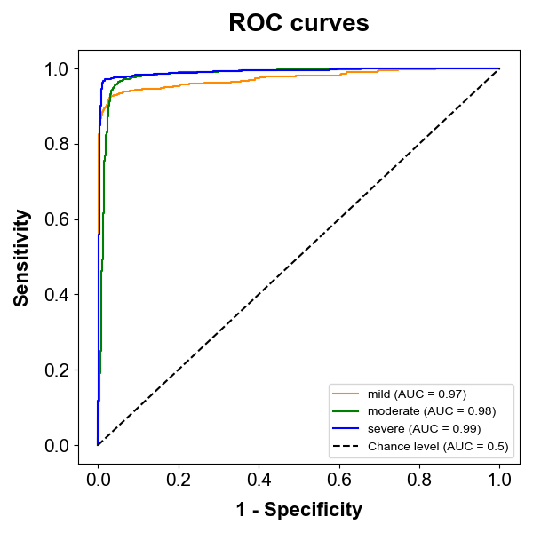

Additional Figure 2. Receiver operating characteristic curves for mitral regurgitation severity classification using the CNN6-Fbank model. This figure presents the receiver operating characteristic (ROC) curves for the CNN6-Fbank model used to evaluate the severity of mitral regurgitation (MR). The ROC curves depict the performance of the model in classifying MR severity into three categories: mild, moderate, and severe. The area under the curve (AUC) values for each category are as follows: mild (AUC=0.97), moderate (AUC=0.98), and severe (AUC=0.99).

