Additional Files
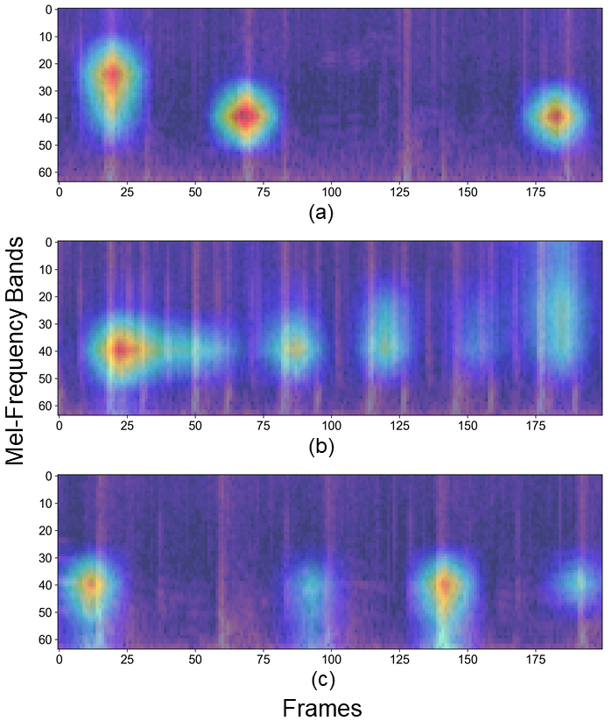
Additional Figure 3. Grad-CAM visualization of the CNN6-Fbank model for mitral regurgitation classification.
This figure depicts the regions of interest identified by deep learning models for classifying the severity of mitral regurgitation. The color intensity represents the relative contribution of each region to the model’s decision, with warmer colors (e.g., red) indicating higher importance and cooler colors (e.g., blue) indicating lower importance. (a) Mild, (b) Moderate, and (c) Severe.

