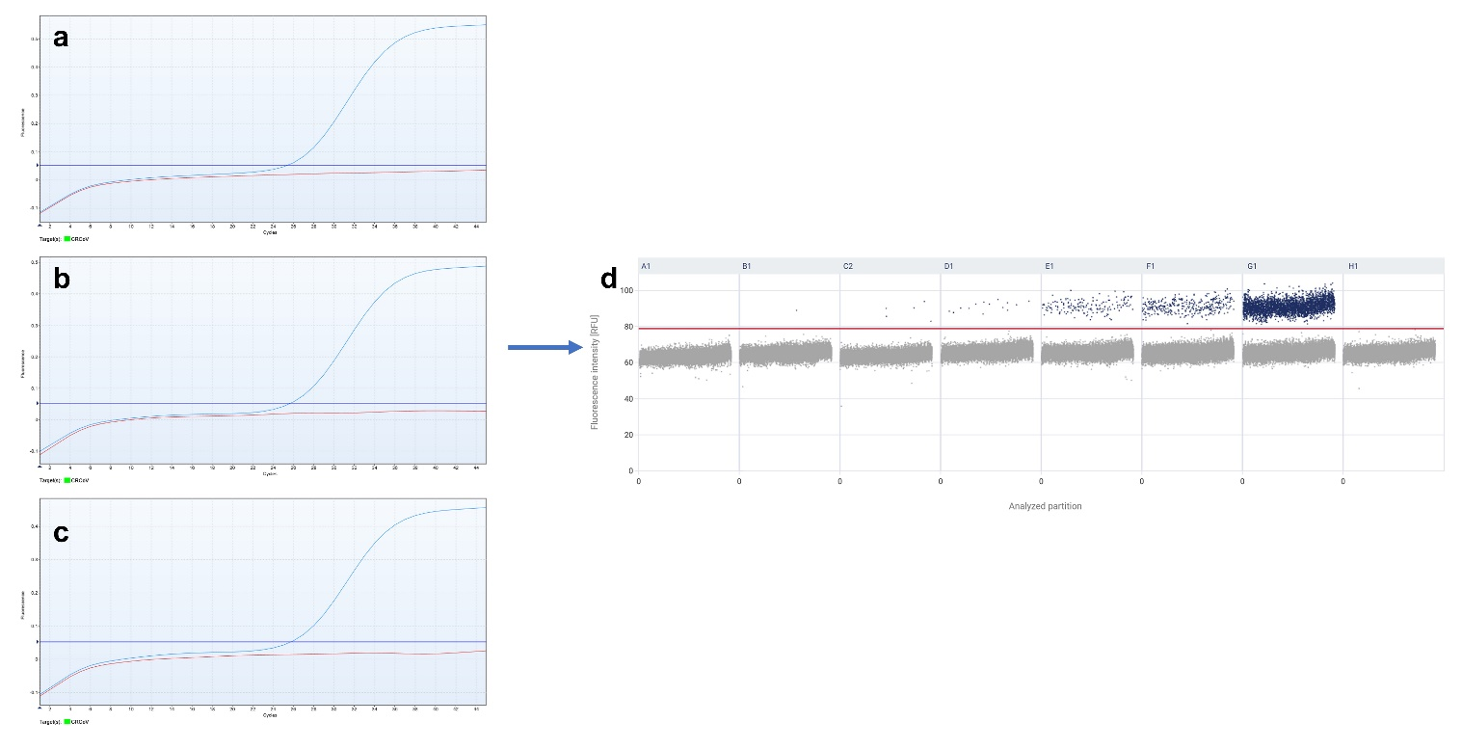
Fig. S1. (a-c) The amplification plots of RT-qPCR assay varied based on the annealing temperatures of (a) 51℃, (b) 53℃, and (c) 55℃, respectively. (d) The 1D scatterplot from RT-dPCR assay was conducted under the optimized condition at an annealing temperature of 53℃.

