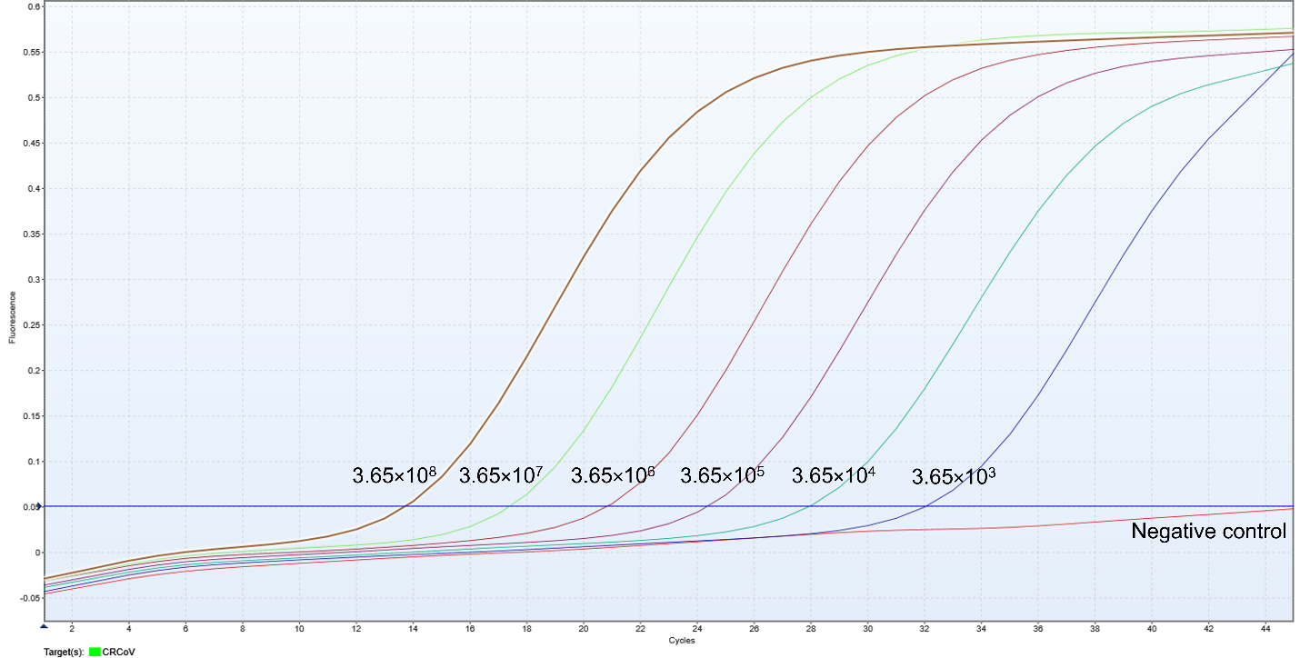

Fig. S2. The amplification curve for the RT-qPCR assay shown in Fig.1a. The graph displays the amplification curves for the CRCoV standard positive control across a dilution range from 3.65×10⁸ to 3.65×10³ copies/µL.

