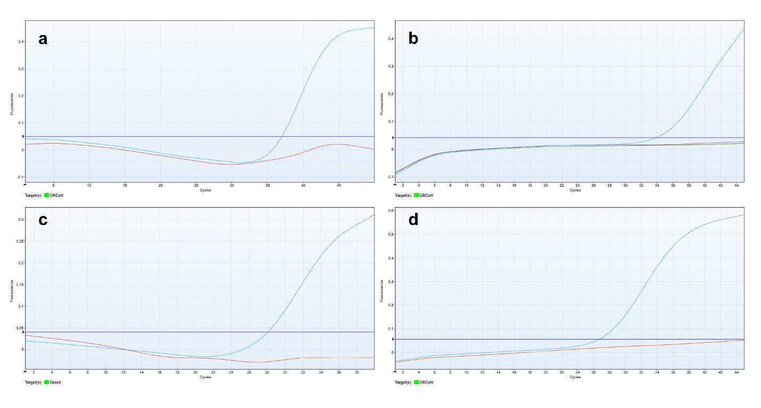
Fig. S4. Analytical specificity of the RT-qPCR assay for CRCoV detection. (a) CRCoV, Vanguard® HTLP5/CV-L vaccine (containing CDV, CAV-2, CPIV, CPV, and CCoV) and negative control. (b) CRCoV, CaHV-1, SARS-CoV-2, TGEV and negative control. (c) CRCoV, CIV, and negative control. (d) CRCoV, FCoV, and negative control.

