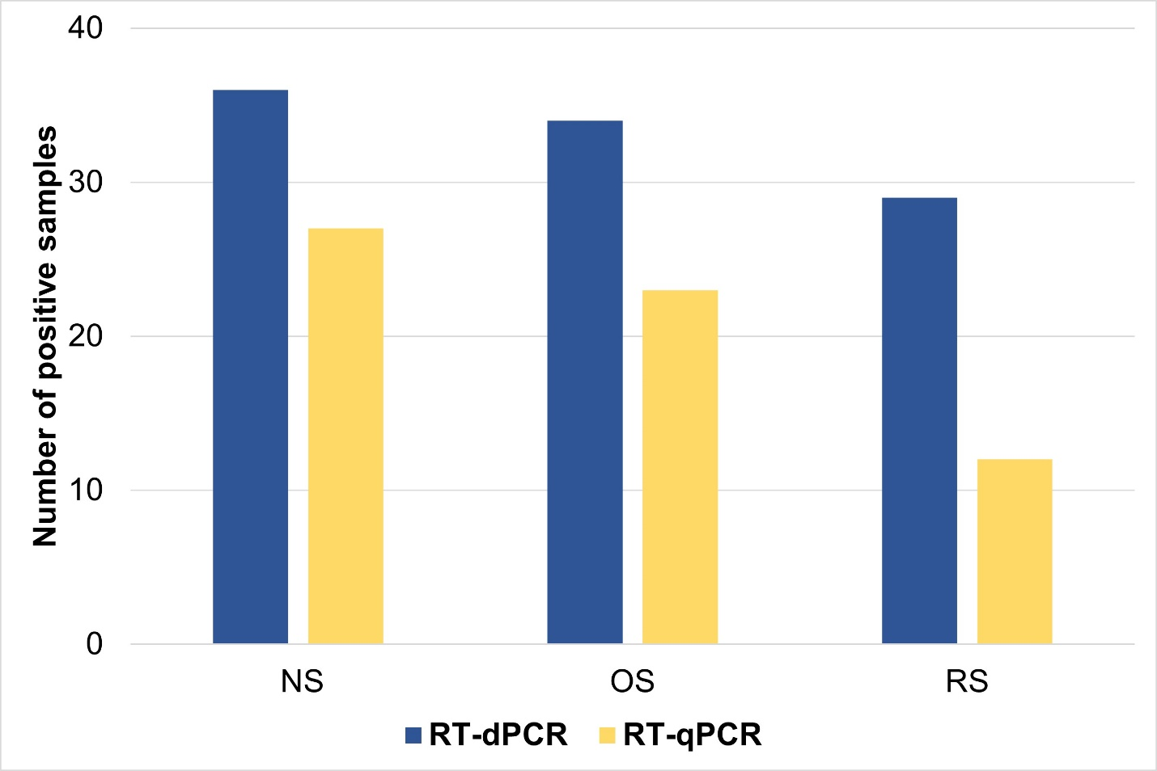
Fig. S5. Comparison of positive samples detected by RT-dPCR and RT-qPCR assays across three sampling sites (NS = nasal swab, OS = oropharyngeal swab, RS = rectal swab). RT-dPCR detected a higher number of positive samples for CRCoV compared to RT-qPCR in all sample types.

