M 1 2 3 4 5 6 7 8 9 10 11 12 13 14
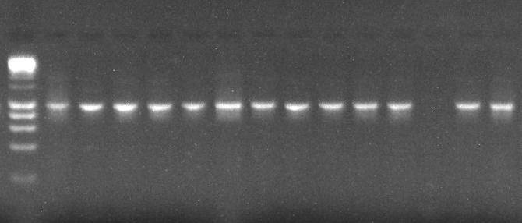
1000bp
Fig.2 Agarose gel electrophoresis showing PCR amplicons of the Aeromonas species gene fragment 16s rDNA (1000bp) from the isolates obtained from water from the study area
Lane M = 100bp size markers, Lane 1 = positive control, Lanes 2-11, 13 and 14 = positive samples, Lanes 12= negative samples

