Supplementary Material:
Table 1: EMS phenotype ponies list. Tabel including study subjects Age, sex, Body condition score (BCS), Cresty neck score (CNS), Basal insulin concentration (BIC), post oral sugar test (OST) insulin concentration, triglycerides and laminitis status for each pony.
Age | Sex | BSC (1-9) | CNS (0-5) | BIC μU/mL | OST µU/mL | Triglycerides mmol/L | Laminitis (Yes or No)
12 | Gelding | 7 | 3 | 55 | 300 | 0.4 | Yes
24 | Gelding | 7 | 2 | 131 | 300 | 0.4 | Yes
21 | Gelding | 8 | 3 | 20 | 297 | 0.3 | No
15 | Gelding | 8 | 4 | 21 | 173 | 0.3 | Yes
21 | Mare | 7 | 3 | 80 | 92 | 0.3 | Yes
12 | Mare | 7 | 2.5 | 15 | 85 | 0.4 | No
10 | Mare | 7 | 2 | 3 | 80 | 0.7 | No
9 | Gelding | 7 | 2 | 25 | 80 | 0.2 | No
16 | Mare | 8 | 4 | 10 | 73 | 0.5 | Yes
16 | Mare | 6 | 2 | 8 | 67 | 0.3 | Yes
16 | Gelding | 7 | 3 | 11 | 60 | 0.3 | Yes
12 | Mare | 6 | 2.5 | 2 | 57 | 1.5 | Yes
12 | Gelding | 7 | 2 | 3 | 53 | 0.3 | No
10 | Mare | 7 | 2 | 2 | 51 | 0.5 | Yes
14 | Mare | 8 | 3 | 6 | 51 | 0.4 | No

Table 2: Control group. Tabel including study subjects Age, sex, Body condition score (BCS), Cresty neck score (CNS), Basal insulin concentration (BIC), post oral sugar test (OST) insulin concentration, triglycerides and laminitis status for each pony.
Age | Sex | BSC (1-9) | CNS (0-5) | BIC μU/mL | OST µU/mL | Triglycerides mmol/L | Laminitis (Yes or No)
17 | Mare | 4.5 | 2 | 2 | 35 | 0.5 | No
6 | Mare | 5 | 1 | 6 | 29 | 0.2 | No
9 | Gelding | 6 | 2 | 2 | 26 | 0.3 | No
13 | Gelding | 6 | 1 | 2 | 26 | 0.3 | No
6 | Gelding | 6 | 2 | 2 | 16 | 0.3 | No
10 | Gelding | 5 | 1 | 2 | 13 | 0.2 | No
18 | Mare | 5 | 1.5 | 5 | 12 | 0.4 | No
5 | Gelding | 5 | 2 | 3 | 12 | 0.4 | No
10 | Gelding | 5 | 2 | 2 | 11 | 0.3 | No
15 | Gelding | 6 | 2 | 2 | 10 | 0.2 | No
9 | Gelding | 5 | 2 | 5 | 6.8 | 0.2 | No
11 | Gelding | 5.5 | 1.5 | 2 | 4.9 | 0.2 | No
5 | Mare | 6 | 2 | 5 | 4 | 0.3 | No
7 | Mare | 6 | 1 | 2 | 3.6 | 0.5 | No
5 | Gelding | 6 | 2 | 2 | 2 | 0.3 | No

Serum Metabolome analysis

Sample preparation and metabolite analysis
Serum samples were prepared for targeted metabolomic analysis according to the MxP® Quant 500 assay manual (Biocrates Life Sciences, Innsbruck, Austria). Firstly, 10 µL of serum was loaded onto a 96 well plate. Samples were dried for 30 mins under nitrogen followed by derivatization using 50 µL of 5% phenyl isothiocyanate solution in ethanol/water/pyridine (volume ratio 1/1/1)). Subsequently samples were incubated for 60 mins at room temperature. The plate was then dried under nitrogen. Following the addition of 300 µL 5 mM ammonium acetate in methanol the plate was placed on a shaker for 30 mins. In the next step, the plate was centrifuged at 500×g for 2 mins, and 150 µL of elute was diluted with 150 µL of HPLC-grade water for liquid chromatography tandem mass spectrometry (LC-MS/MS) analysis, and 10 μL of eluate was diluted with 490 μL of methanol running solvent for flow injection analysis tandem mass spectrometry (FIA-MS/MS) analysis.
Metabolites were identified and analysed by a Sciex ExionLC series Ultra-High-Performance Liquid Chromatography (UHPLC) system coupled to a Sciex QTRAP 6500+ mass spectrometer with electrospray ionization (ESI) mode. The UHPLC column, provided with MxP® Quant 500 assay was installed and 100% water and 95% acetonitrile both adding 0.2% formic acid were prepared as mobile phase A and B, respectively. In the LC-MS/MS analysis, amino acids, amino acid related metabolites bile acids, biogenic amines, carboxylic acids, hormones, indoles and derivatives, nucleobases, fatty acids, and some other metabolites such as trigonelline, trimethylamine N-oxide, p-Cresol sulphate, and choline were quantified. Lipid classes such as lysophosphatidylcholines, phosphatidylcholines, sphingomyelins, ceramides, dihydroceramides, hexosylceramides, dihexosylceramides, trihexosylceramides, cholesteryl esters, diglycerides, triglycerides were quantified in FIA-MS/MS analysis; additionally, acylcarnitines and the sum of hexose were also quantified in FIA-MS/MS analysis. The multiple reaction monitoring (MRM) method, which was optimized by Biocrates Life Sciences was applied to quantify all metabolites. Data were acquired by AB Sciex Analyst® version1.7.2 software.

Tabel 3: List of EMS Group ponies’ diet
Number | Pony code | Diet
1 | EMS 6 | Hay
2 | EMS 14 | Grass (Pasture)
3 | EMS 24 | Hay
4 | EMS 42 | Hay
5 | EMS 47 | Haylage
6 | EMS 59 | Hay
7 | EMS 62 | Grass (Pasture)
8 | EMS 64 | Grass (Pasture)
9 | EMS 66 | Hay
10 | EMS 67 | Hay
11 | EMS 72 | Hay
12 | EMS 78 | Grass (Pasture)
13 | EMS 84 | Grass (Pasture)
14 | EMS 97 | Grass (Pasture)
15 | EMS 102 | Grass (Pasture)

Tabel 4: List of Control group ponies’ diet
Number | Pony code | Diet
1 | EMS 4 | Hay
2 | EMS 7 | Grass (Pasture)
3 | EMS 29 | Hay
4 | EMS 44 | Haylage
5 | EMS 45 | Haylage
6 | EMS 46 | Haylage
7 | EMS 48 | Haylage
8 | EMS 53 | Hay
9 | EMS 58 | Hay
10 | EMS 65 | Hay
11 | EMS 68 | Grass (Pasture)
12 | EMS 76 | Haylage
13 | EMS 77 | Grass (Pasture)
14 | EMS 81 | Hay
15 | EMS 100 | Haylage

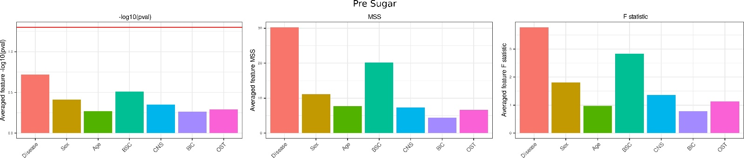

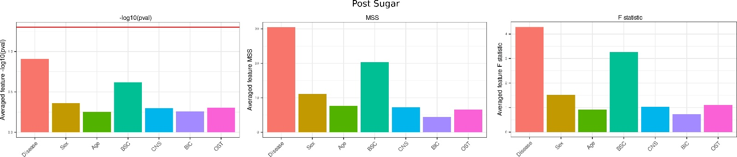

Figure: ANOVA statistics summarizing average values of log10 p-values, Mean Sum Square and F statistics. The top bar charts represent the Pre-OST and the bottom row represents the Post-OST analysis

