Figure S1: Gel electrophoresis showing positive amplicons of CDV during sequencing RT-PCR

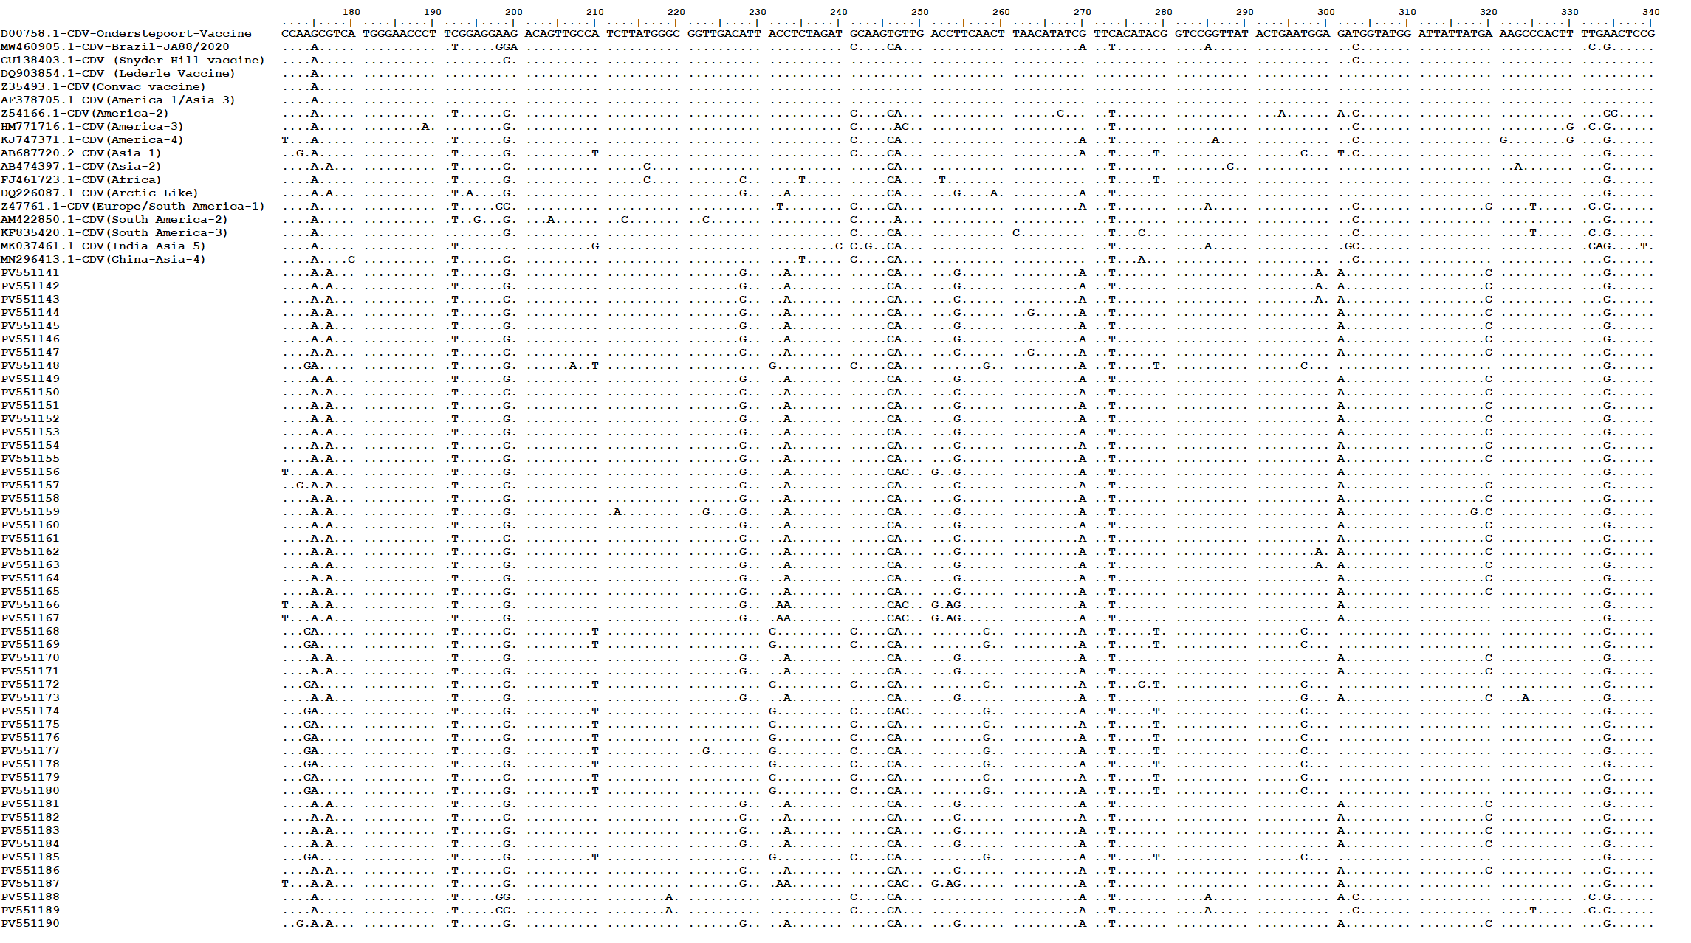
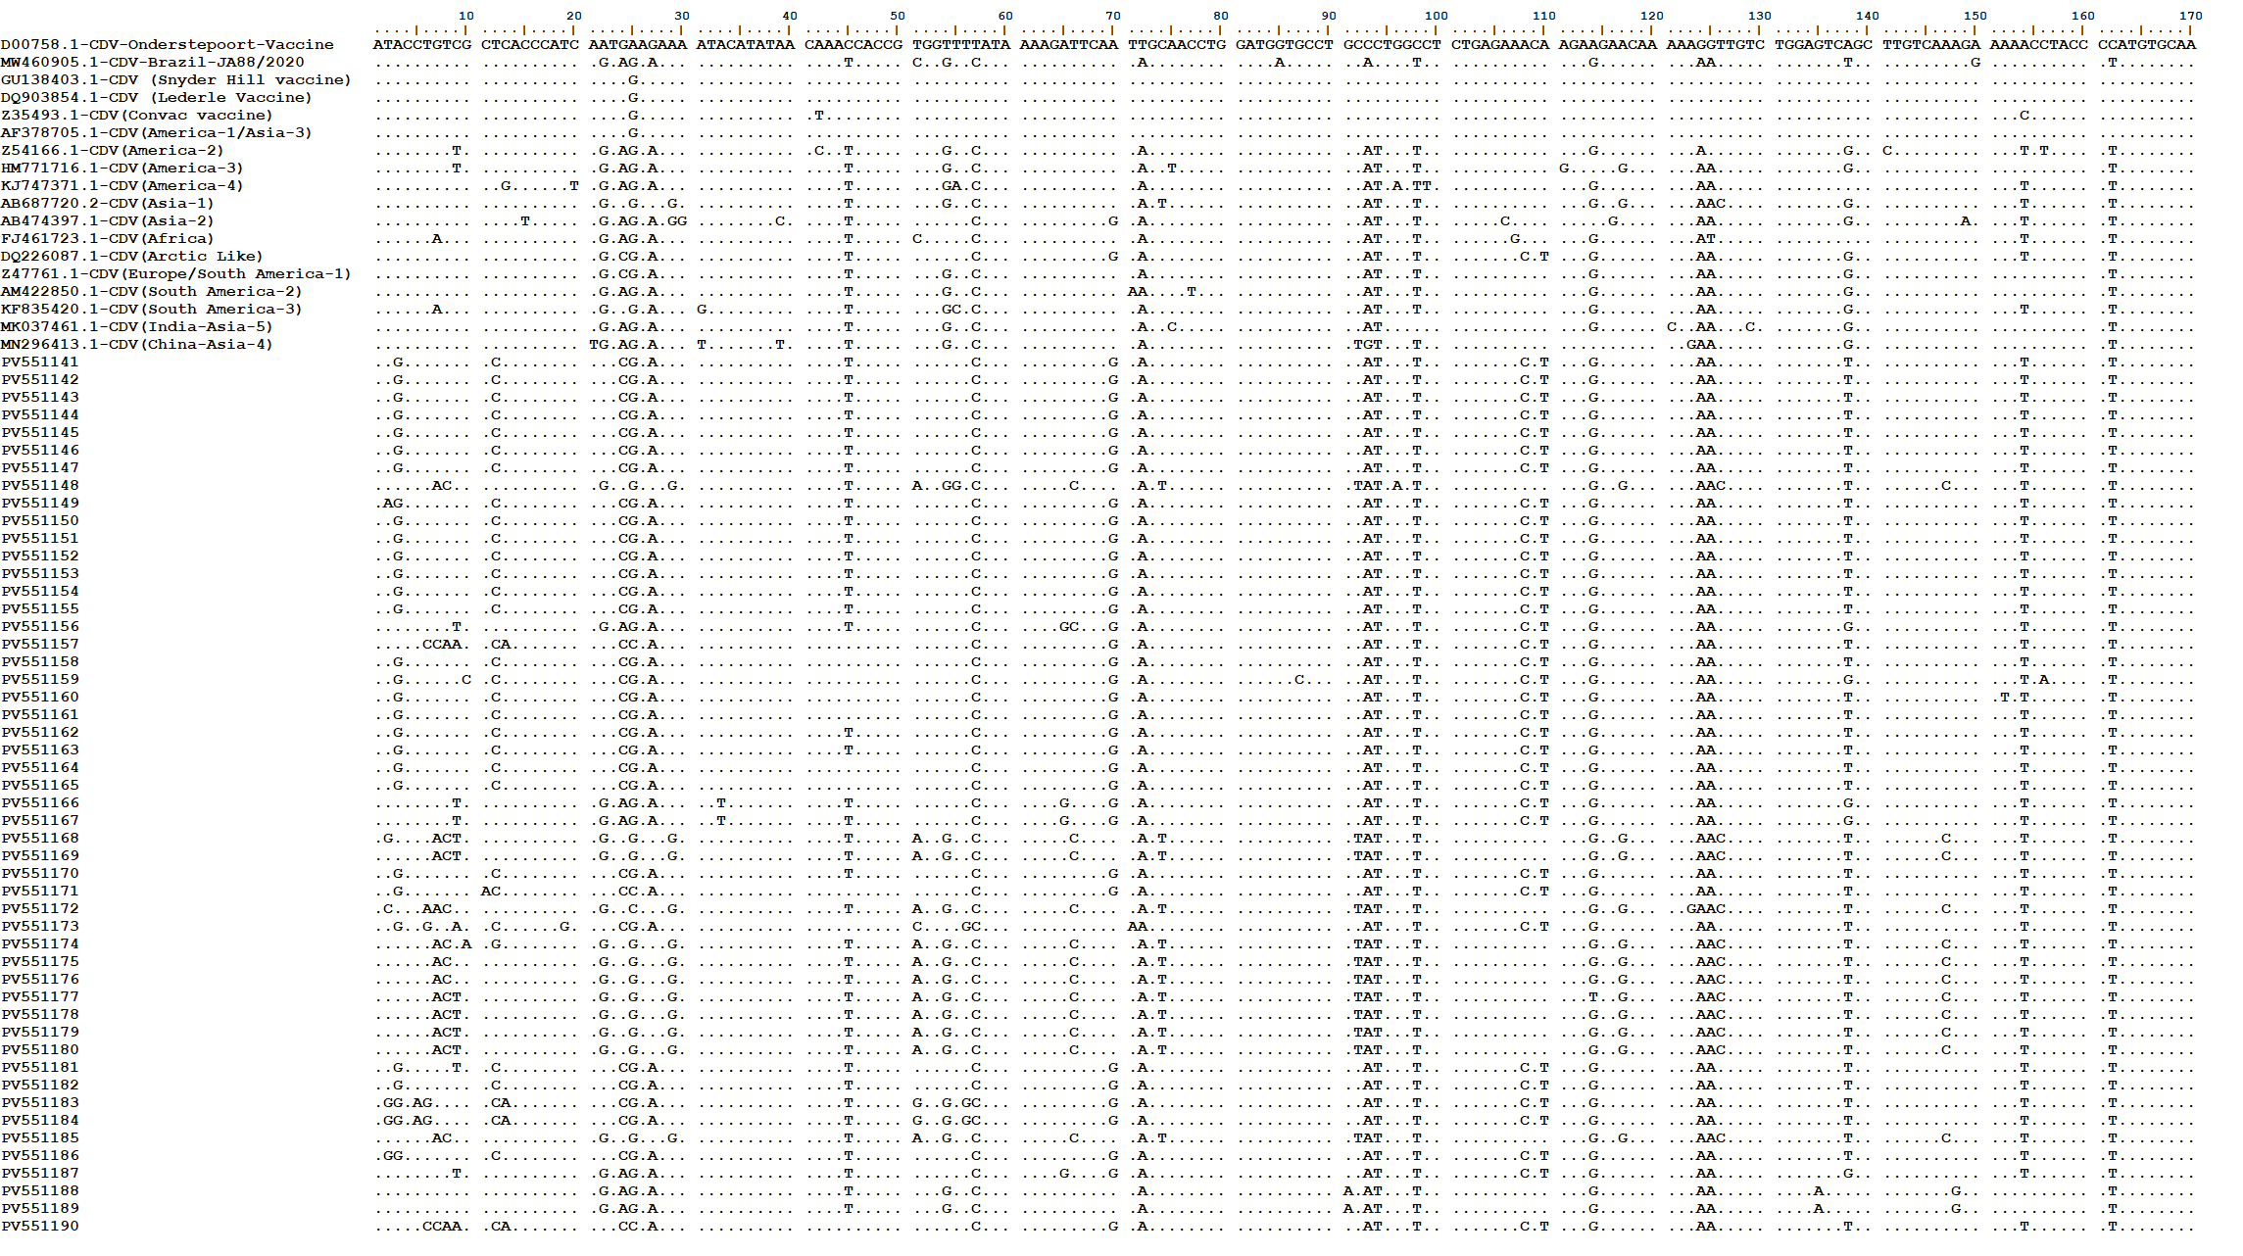
Figure S2: Comparative Nucleotide analysis of Hemagglutinin (H) gene
