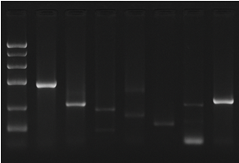
Figure S1: PCR gel electrophoresis

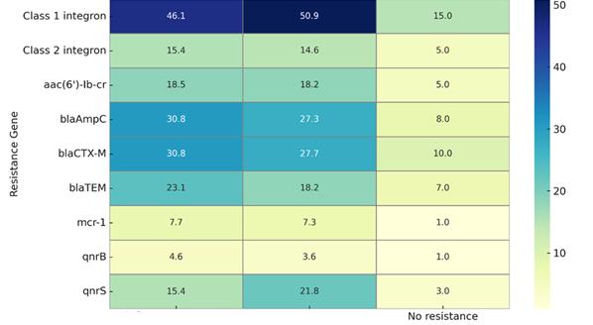
Figure S2: Heatmap of gene-phenotype associations

