Comparative virulence study of locally circulating Peste des Petits Ruminants Virus (PPRV) strains in Indigenous Ethiopian Goats

Supplementary File
Text S1: Research design

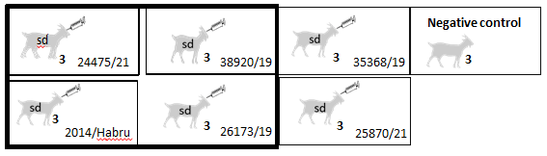

Sampling:
Daily 0-12 dpi
- Clinical signs and rectal temperature were monitored and recorded.
Other
- Serology : 0, 1, 3, 5, 7, 10, and 12 dpi
- Swabs for AgELISA: 1, 3, 5, 7, 10, and 12 dpi
- Swabs for RT-qPCR : 1, 3, 5, 7, 10, and 12 dpi
Sacrifice:
- 1 goat from each barn/isolate on 7, 10, and 12 dpi
- 14 tissues and LNs were collected for RT-qPCR and histopathology analysis that included:- retropharyngeal LN, palatine tonsil, third eyelid, nasal mucosa, tongue apex, tracheal LN, bronchial LN, mediastinal LN, lung cranial, lung caudal, mesenteric LN, spleen, jejunal and ilial Peyer’s patch and colon.
- For the virus isolate/strain information (refer to Table 1)

Text S2: Veterinary attention/care
All goats received deworming treatment using a broad-spectrum anthelmintic (Albendazole 300mg bolus, administered at a rate of one bolus per 40kg body weight of the goat). Long-acting oxytetracycline was administered as required.

Text S3: Summarized procedure of RT-qPCR test
The reaction mixture included components such as Express Universal SuperScript mix, Express SuperScript enzyme mix, ROX reference dye (Invitrogen, Thermo Fisher Scientific), primers, probe, and RNase-free water, with the extracted RNA, making up a total reaction volume of 20μl. Amplification was carried out using an Applied Biosystems 7500 FAST thermal cycler with reverse transcription at 50°C for 15 minutes, DNA polymerase activation at 95°C for 20 seconds, and subsequent cycling comprising denaturation at 95°C for 3 seconds and annealing/extension at 60°C for 30 seconds, following the protocol outlined by (Batten et al., 2011, Aklilu et al., 2024).
Text S4: Virus isolation summarized procedures and origin of isolates
For virus isolation, VDS cells were prepared by washing with PBS and then inoculated with 100-200μl of supernatants from ocular, nasal, and rectal swabs or processed tissues, which had been previously homogenized and centrifuged at 1650g for 20 minutes at 4°C. These cells, with over 70% confluence in 24-well plates, underwent a pre-adsorption process, followed by an hour of incubation at 37°C with 5% CO2 and 96% humidity, with intermittent agitation every 15 minutes to facilitate virus adsorption. After removing the inoculum and washing with serum-free DMEM, 500μl of DMEM with 2% serum was added to each well. The cultures were then examined under an inverted microscope for non-specific reactions before a final incubation of five to seven days under the same conditions to detect CPE indicative of viral replication, following the protocol outlined by (Gomes et al., 2016, Aklilu et al., 2024).
Regarding the origin of the virus isolates, in the present study, two isolates (26173/19 and 25870/21) were obtained during our recent outbreak investigations. The remaining four isolates (from 2014, 38920/19, 24475/21, and 35368/19) were retrieved from our repository of PPR-positive samples collected during previous outbreaks. All isolates, regardless of origin, were propagated in Vero Dog SLAM (VDS) cells and confirmed as PPRV-positive by RT-qPCR prior to sequencing and lineage-level characterization.

Text S5: Euthanasia method
Goats were euthanized at pre-determined periods i.e. at 7, 10, and 12 dpi’s, with one randomly selected from each barn/group. In this experiment, we utilized captive bolt stunning as the chosen method for animal euthanasia due to its humane nature. Immediately after stunning, the animals were bled efficiently to reduce any undue stress or pain during the post-mortem procedure. The Bolt Stunner Model KS, manufactured by Karl Schermer GmbH in Germany, was selected for its effectiveness with goats and sheep.
Text S6: Histological analysis and grading
Histopathological examination was conducted on a total of 252 tissue samples to evaluate cellular changes induced by PPRV infection. For the specimens collected from each individual animal (see sampling section). Standard operating procedures (SOPs) of the AHI pathology laboratory were followed. In summary, formalin-fixed tissue samples were dehydrated in graded ethanol and clarified with xylene using the Shandon Citadel 1000 tissue processor (Thermo Fisher Scientific, Waltham, MA, USA) before embedding in paraffin with the TEC2900 modular Tissue Embedding Centre (Histo-Line Laboratories, Milan, Italy). Tissue sections with a thickness of 4-5 μm were prepared and stained with Hematoxylin and Eosin. These sections were then examined under light microscopy at magnifications of 4x, 10x, and 40x, and histopathological lesions were scored using a grading system ranging from 0 (no lesions) to 4 (severe lesions), as outlined in (Aklilu et al., 2024).
Text S7: Clinical signs observed for each individual strain
Experimental goats infected with lab code 24475/21, lineage IV PPRV, showed some disease signs started from 4 days post-infection (dpi) through 12 dpi. Some of the observed signs including:- muco-purulent nasal discharge (MPND) (Figure S1B) congested mucous membrane (CMM), (Figure S1D), and ocular discharge (OD) (Figure S1A) and erosive mouth lesion (Figure S1C).

Infection with lineage IV 2014 Ethiopian isolate
Typical clinical signs were observed started from 4 dpi to 12 dpi, including fever, nasal discharge (ND) and congested mucous membrane (CMM) diarrhea and coughing.
Infections with strain lab code 38920/19, lineage-IV Ethiopian isolate
Experimental goats infected with this virus showed only one clinical sign from 6 to 9 dpi, i.e slight nasal discharge (ND). The maximum temperature recorded in this group was 39.4°C at 9 dpi, which was below the cutoff of 39.5°C.

Infection with strain lab code 26173/19, lineage-III PPRV
Some clinical signs were observed started from 4 dpi to 12 dpi, including nasal discharge (ND), congested mucous membrane (CMM), fever coughing, and diarrhea.

Infection with strain lab code 35368/19, lineage-III PPRV
Evident signs including fever, serous nasal discharge (ND) that later became muco-purulent nasal discharge (MPND), congested mucous membrane (CMM), cough, and later-stage diarrhea were recorded started from 4 dpi through 12 dpi.
Infection with strain lab code 25870/21, Lineage –IV PPRV
Typical clinical signs were observed started from 4 dpi until 12 dpi, including fever, serous nasal discharge (ND), muco-purulent nasal discharge (MPND), congested mucous membrane (CMM), cough, diarrhea, and erosive mouth lesion.
Text S8: Detail results of antigen detection of individual strains
Specifically goats infected with strain 24475/21 produced 5/12 (41.6%); strain 2014 7/12 (58.33%); strain 38920/19, 1/12 (8.3%); strain 26173/19 produced 6/12 (50%); strain 35368/19 produced 9/12 (75%); and strain 25870/21 produced 9/12 (75%) antigen positive result from nasal swabs. While from rectal swabs strain 24475/21 produced 4/12 (33.3%); strain 2014/Habru, 5/12 (41.66%); strain 38920/19, 1/12 (8.3%); strain 26173/19 produced 1/12, (8.3%); strain 35368/19 produced 6/12 (50%); and strain 25870/21 produced 9/12 (75%) antigen positive result from rectal swabs.
Text S9: Detail RT-qPCR result of swab samples for individual strains
Goats infected with the 24475/21 strain had 5/9 swabs positive at 5 dpi, with all swabs testing positive by 7 dpi. By 10 dpi, all 6 tested swabs were positive, and at 12 dpi, all 3 swabs from the last goat were positive. Goats infected with the 2014 Ethiopian strain showed increasing positivity: 2/9 swabs positive at 5 dpi, 8/9 at 7 dpi, and all swabs positive at 10 and 12 dpi. Goats infected with 38920/19 strain, had 2/9 positive at 5 dpi and 3/9 positive at 7 dpi, but all swabs tested negative at 10 and 12 dpi. Goats infected with the 26173/19 strain, showed 8/9 positive at 5 dpi, all positive at 7 dpi, 5/6 positive at 10 dpi, and 2/3 positive at 12 dpi. Goats infected with the 35368/19 strain had 7/9 swabs positive at 5 dpi, 8/9 at 7 dpi, and all 6 swabs positive at 10 dpi, but only 1/3 was positive at 12 dpi. Goats infected with the 25870/21 strain, had all tested swabs (ocular, nasal, and rectal) positive at 5, 7, 10, and 12 dpi.
Text S10: Detail individual strain gross pathology results
Gross pathological findings were evaluated as per the criteria outlined by (Aklilu et al., 2024). Accordingly, goats infected with strain 24475/21 and sacrificed at 7, 10 and 12 dpi’s manifested some PPRV characteristics grade 2 gross lesions. Including: swelling with edema, congestion and hemorrhage in most of the inspected tissues and lymph nodes (LNs) were observed. Particularly a goat sacrificed by 10 dpi showed distinct signs on lung tissue like hepatization and meaty appearance (Figure S2), thickened mucosa of jejunum and congested Peyer’s patch were also observed. From the same lineage IV, a goat infected with 2014/Habru strain showed grade 2 gross pathological lesions, like congested lungs and jejunum mucosa and catarrhal enteritis. By 10 dpi, lungs became emphysematous, hemorrhagic and hepatized. At 12 dpi, showed hepatized and hemorrhagic cranial lung and meaty and congested middle lung. In addition, thickened mucosa of jejunum and congested Peyer’s patch were also noticed.
From the same lineage IV, a goat infected with 38920/19 strain and sacrificed at 7 dpi, showed grade 1 gross lesion, like slight enlargement in some of inspected LNs and slightly hepatized cranial lung. While goats sacrificed at 10 and 12 dpi’s from the same group showed no typical gross lesions observed on inspected tissues and LNs.
Moreover, goats inoculated with same lineage IV, 25870/21 strain produced grade 2 gross lesions at 7 dpi, including hepatized cranial and caudal lungs. By 10 dpi, meaty cranial lung and emphysematous caudal lung and redness of ileum Peyers’ patch was observed. At 12 dpi, hepatized, hemorrhagic and emphysematous cranial lung and catarrhal enteritis were observed.
Experimental goats inoculated with lineage III, 26173/19 virus strain showed grade 2 gross lesions, particularly hepatization on cranial lung. By 10 dpi, hepatizations of the cranial lung along with redness of the jejunal mucosa were also observed. At 12 dpi, cranial lung atelectasis, hemorrhage in the middle lung, and hepatization of the caudal lung and catarrhal enteritis were observed. A goat infected with the same lineage III, 35368/19 strain manifested grade 2 gross lesion starting from 7 dpi. By 10 dpi, cranial as well as caudal lungs were hepatized. Similarly at 12 dpi, hepatized (meaty) cranial lung and emphysematous caudal lung were observed.
Text S11: Histopathological findings
Histopathological lesions of virus inoculated goats were evaluated as per the methods outlined in (Aklilu et al., 2024). In the current study, the consistently observed histological lesions were characterized as grade 2 histopathological lesions except (38920/19 strain from lineage IV), and were observed beginning at 7 dpi in sacrificed goats, included lymphocyte cell depletion (characterized by pyknosis and karyolysis), congestion, and hemorrhage of the head, lung-associated, and mesenteric lymph nodes, as well as in other inspected non-lymphoid organs. Different degrees of histological lesions were recorded in the tonsils of most of the sacrificed goats, specifically in 83.33% (15/18) of the goats, particularly tonsil was characterized by lymphoid tissue cells depletion and syncytial cell formation (Figure S3A). In lung tissue both the caudal and cranial lobes of the lungs exhibited various typical histological lesions of the PPR virus in nearly all experimental groups, with an occurrence rate of 88.8%% (16/18), particularly hemorrhage and emphysema, (Figure S3B) aggregation of lymphocytes, thickening of lobal septa, Broncho-interestitial pneumonia were commonly observed. Among the inspected GIT tissues, the colon was commonly affected organ by the inoculated viruses, showing pathology characterized by necrosis, sloughed mucosa (Figure S3E) and lamina propria infiltrated with mononuclear cells (Figure S3F). This was observed in 83.33% (15/18) of the inspected goats. In the small intestine, the jejunum and ileum were consistently affected tissues by the virus and histopathological examinations revealed the presence of lymphoid depletion, eosinophils and syncytial cells (Figure S3C), short villi, congestion of lamina propria and mononuclear cells in the lamina propria (Figure S3D), necrosis and sloughing also commonly observed. The Peyer's patches in the jejunum and ileum were also affected, characterized by cell depletion in 77.7% (14/18) of the inspected goats. The spleen was also affected and exhibited various pathologies, including white pulp cell depletion, red pulp hyper cellularity, and hemosiderin deposition in 83.3% (15/18) goats. Upon inspection, the third eyelid was characterized by cell depletion, congestion, and sometimes the presence of syncytial cells. Pathological changes in the third eyelid were observed in 77.7% (14/18) of goats. Histologically, 16.6% (3/18) of nasal mucosa and 11.1% (2/18) of tongue tissues were affected by the infected virus.

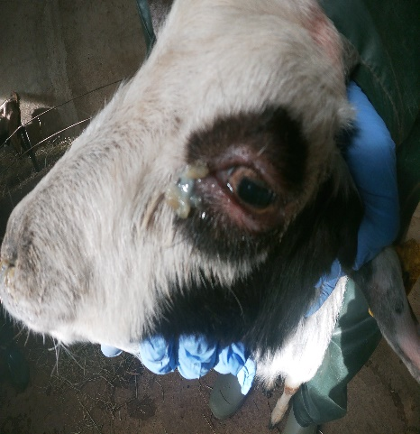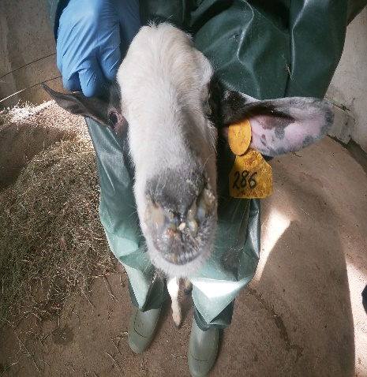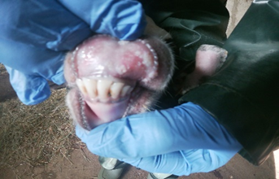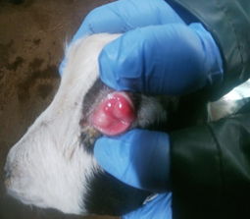
B
D
C
A

Figure S1: Typical clinical signs resulting from PPR virus infection (24475/21 strain)
(A) Muco-purulent ocular discharge (B) Muco-purulent nasal discharge (C) Erosive mouth lesion and (D) Congested mucous membrane of the conjunctiva (Taken by GoPro Camera, Animal ID: 286 at 9 dpi).

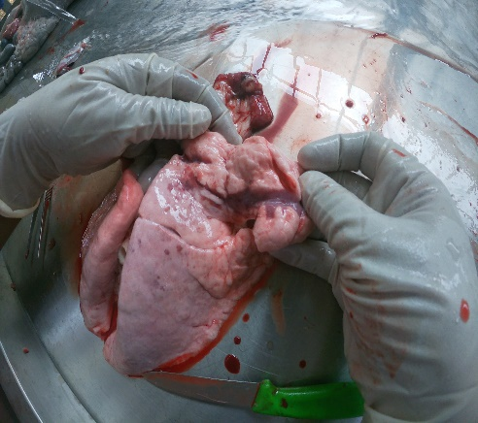

Figure S2: Lung hepatization and meaty appearance
The gross pathology of the lung tissue from the sacrificed goat (strain code 24475/21, at 10 dpi) shows a lesion with a hepatized and meaty appearance in the right cranial lobe (indicated by the yellow arrow).
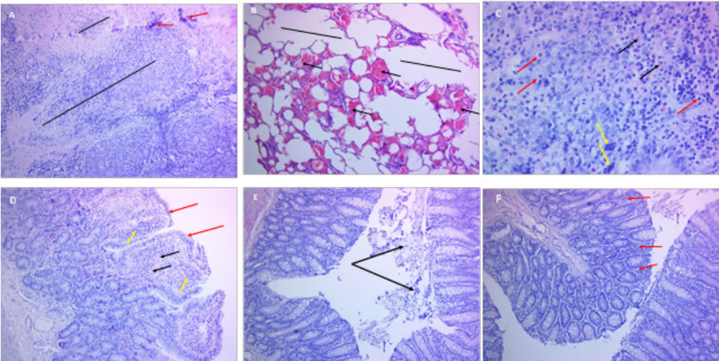
Figure S3: Histopathological findings resulted due to different PPR virus strains (A) In Tonsil tissue lymphoid tissue cells depletion (black line) and syncytial cell formation (red arrow), ID: 277, 7 dpi (24475/21 strain); (B) Caudal lung, hemorrhage (black arrow) and emphysema (black line) due to PPR virus, ID: 280, 12 dpi ( 25870/21 strain) ; (C) Ileum manifested depleted cells (red arrow) and eosinophils (black arrow) and syncytial cells (yellow arrow), ID: 276, 7 dpi (25870/21 strain); (D) Ileum short villi (red arrow) and congestion of lamina propria (black arrow) infiltrated with mononuclear cells (yellow arrow), ID, 276, 7 dpi (25870/21 strain); (E) Colon characterized by sloughed and necrotized mucosa (black arrow) (F) lamina propria infiltrated with mononuclear cells (red arrow) ID: 293, 12 dpi (26173/19 strain). All subfigures (A) through (E) stain with hématoxyline- éosine, 10 x magnifications.

Table S1: Summary of the range of days post infection for which clinical scores were above the lowest category for 18 experimentally infected goats inoculated with six different PPRV strains.

Strain | Animal ID | Temp  (≥39.5)^{(a)} | General signs ^{(a)} | Nasal/Ocular  Discharges ^{(a)} | CMM  ^{(a)} | Diarrhea  ^{(a)} | Respiratory  Signs ^{(a)}
24475/21 | 277 | 5-7 | 4-7 | 5-7 | 6-7 | - | 7
 | 286 | 4-8 | 4-12 | 5-12 | 5-12 | 7-11 | 7-12
 | 296 | 4-10 | 4-10 | 4-10 | 4-10 | 6-10 | 4-10
2014/Habru | 279 | 4-7 | 4-7 | 5-7 | 5-7 | - | -
 | 289 | 5-7 | 4-12 | 4-12 | 5-12 | 5-12 | 7-12
 | 292 | 4-9 | 4-10 | 4-10 | 5-10 | 5-10 | 7-10
38920/19 | 299 | - | - | 6-9 | - | - | -
 | 300 | - | - | 7 | - | - | -
 | 301 | - | - | 6-9 | - | - | -
26173/19 | 281 | 4-7 | 4-7 | 4-7 | 4-7 | - | -
 | 291 | 8 | 4-10 | 5-10 | 5-10 | - | 8
 | 293 | 8 | 4-12 | 4-12 | 6-12 | 7-9 | -
35368/19 | 278 | 5-8 | 4-10 | 5-10 | 4-12 | - | -
 | 294 | 4-12 | 4-12 | 4-12 | 4-12 | 8-12 | 5-12
 | 298 | 4-7 | 4-7 | 4-7 | 4-7 | - | -
25870/21 | 276 | - | 4-7 | 4-7 | 5-7 | 7 | -
 | 280 | 4-11 | 4-12 | 4-12 | 5-12 | 8-12 | 9
 | 283 | 4-10 | 4-10 | 4-10 | 4-10 | 8-9 | 6-10

-, negative; CMM, Congested mucous membrane; General signs, including loss of appetite, inactivity, rough coat, dullness/depression; ^{(a)}, Duration of clinical signs

Table S2: RT-qPCR positivity and virus isolation results from swabs and tissue samples from experimental goats inoculated with six different PPRV strains at various days post-inoculation (dpi).
Strain/  Isolate | RT-qPCR |  |  |  | Virus culture/isolation
Strain/  Isolate | Total swabs (of ocular, nasal, rectal) collected at 5, 7, 10 and 12 dpi |  | Total tissue and LNs collected at sacrifice days i.e. 7, 10 and 12 dpi |  | Proportion and percentage of virus culture positive swabs and tissues at various dpi’s
Strain/  Isolate | Positivity | Percentage | Positivity | Percentage | dpi 7 |  | dpi 10 and 12 combined
 |  |  |  |  | swabs | tissues | swabs | tissues
24475/21 | 23/27 | 85.1 | 25/42 | 59.5 | (7/9, 77.77) | (5/12, 41.66) | (0/3, 0) | (0/13, 0)
2014/Habru | 19/27 | 70.3 | 32/42 | 76.16 | (8/8, 100) | (7/12, 58.33) | (0/3, 0) | (0/20, 0)
38920/19 | 5/27 | 18.5 | 15/42 | 35.7 | (2/3, 66.66) | (8/12, 66.66) | NA | (0/3, 0)
26173/19 | 24/27 | 88.8 | 28/42 | 66.6 | (2/9, 22.22) | (5/11, 45.45) | (0/3, 0) | (0/17, 0)
35368/19 | 22/27 | 81.4 | 29/42 | 69 | (3/8, 37.5) | (7/14, 50.0) | (0/6, 0) | (0/15, 0)
25870/21 | 27/27 | 100 | 34/42 | 80.9 | (5/9, 55.55) | (5/13, 38.46) | (0/7, 0) | (0/21, 0)
NA= Not Applicable

Table S3: Detail RT-qPCR results of the 14 individual tissue/LN samples on different days of post-infection inoculated with six different PPRV strains
Tissue type | Strain used, LIV |  |  | Strain used, LIV |  |  | Strain used, LIV |  |  | Strain used, LIV |  |  | Strain used, LIII |  |  | Strain used, LIV
Tissue type | 38920/19 |  |  | 24475/21 |  |  | 2014/Habru |  |  | 25870/21 |  |  | 26173/19 |  |  | 35368/19
Tissue type | ID | ID | ID | ID | ID | ID | ID | ID | ID | ID | ID | ID | ID | ID | ID | ID | ID | ID
Tissue type | 300 | 299 | 301 | 277 | 296 | 286 | 279 | 292 | 289 | 276 | 283 |  | 281 | 291 | 293 | 298 | 278
Tissue type | dpi7 | dpi10 | dpi12 | dpi7 | dpi10 | dpi12 | dpi7 | dpi10 | dpi12 | dpi7 | dpi10 | dpi12 | dpi7 | dpi10 | dpi12 | dpi7 | dpi10 | dpi12
3rdEyelid | 18.1 | UD | UD | 15.4 | UD | UD | 18.1 | 15.4 | 29.6 | 19.3 | 25.1 | 28.8 | 20.5 | 27.8 | UD | 20.9 | 26.7 | UD
NasMuc | UD | UD | UD | 31.7 | 24.5 | 22.3 | UD | 31.7 | 27.2 | 33.1 | 30.2 | 26.1 | 26.3 | UD | UD | 31.5 | UD | UD
Tongue | UD | UD | UD | 26.5 | UD | UD | UD | 26.5 | UD | 26.1 | UD | UD | 26.6 | UD | UD | 25.8 | UD | UD
Tons | 18.7 | UD | UD | 15.7 | 32.4 | 30.1 | 18.7 | 15.7 | 26.2 | 14.7 | 24.7 | 24.8 | UD | 25.0 | 29.3 | 17.5 | 21.8 | 28.4
Retroph LN | 15.7 | UD | UD | 18.3 | 28.9 | 23.1 | 15.7 | 18.3 | 23.8 | 16.1 | 21.1 | 21.5 | 18.7 | 23.9 | 24.8 | 18.3 | 19.5 | 25.9
TrachLN | 17.2 | UD | UD | 25.1 | UD | 23.9 | 17.2 | 25.1 | 31.1 | 17.9 | 23.7 | 24.5 | 21.9 | 30.8 | 26.5 | 20.9 | 21.5 | 32.9
BronchLN | 22.6 | UD | 24.8 | 23.8 | 33.4 | 24.1 | 22.6 | 23.8 | UD | 16.9 | 22.9 | 23.4 | 19.0 | 23.9 | 26.3 | 18.7 | 22.4 | UD
LungCran | 20.4 | UD | 28.8 | UD | UD | UD | 20.4 | UD | UD | UD | UD | UD | UD | UD | UD | 24.2 | UD | UD
LungCaud | 25.3 | UD | UD | UD | UD | UD | 25.3 | UD | UD | 26.8 | UD | UD | UD | UD | UD | 30.1 | UD | UD
MediLN | 20.1 | UD | UD | 20.4 | UD | 22.7 | 20.1 | 20.4 | 25.2 | 16.6 | 23.1 | 25.1 | 18.1 | 34.5 | 25.3 | 18.4 | 21.7 | 24.8
MesLN | 15.7 | UD | UD | 21.8 | UD | 22.5 | 15.7 | 21.8 | 23.5 | 16.9 | 28.5 | 25.3 | 17.7 | 24.2 | 23.9 | 18.1 | 18.7 | 30.2
Spln | 19.1 | UD | UD | 18.1 | UD | 24.7 | 19.1 | 18.1 | 27.2 | 16.5 | 19.6 | 26.4 | 17.9 | 26.7 | 32.2 | 17.7 | 22.5 | 32.9
Colon | 18.2 | UD | UD | 19.6 | UD | UD | 18.22 | 19.6 | UD | 19.1 | 25.1 | 31.3 | 18.9 | 26.4 | UD | 23.8 | 22.8 | UD
PP | 17.6 | UD | UD | 18.2 | 29.4 | UD | 17.6 | 18.2 | UD | 17.3 | 34.3 | UD | 17.1 | UD | 28.7 | 17.8 | UD | UD

DPI", days post-infection ; NasMuc - Nasal Mucosa; Tons - Tonsil; 3rdEyelid - Third Eyelid; RPLN - Retropharyngeal Lymph Node; Tongue - Tongue (Apex); TrachLN - Tracheal Lymph Node; BronchLN - Bronchial Lymph Node; LungCran - Lung Cranial; LungCaud - Lung Caudal; MediLN - Mediastinal Lymph Node; Spln - Spleen; PP - Ileal & Cecal Peyer's Patches; Colon - Colon; MesLN - Mesenteric Lymph Node.; "UD" Undetermined with RT-qPCR CT >35.

