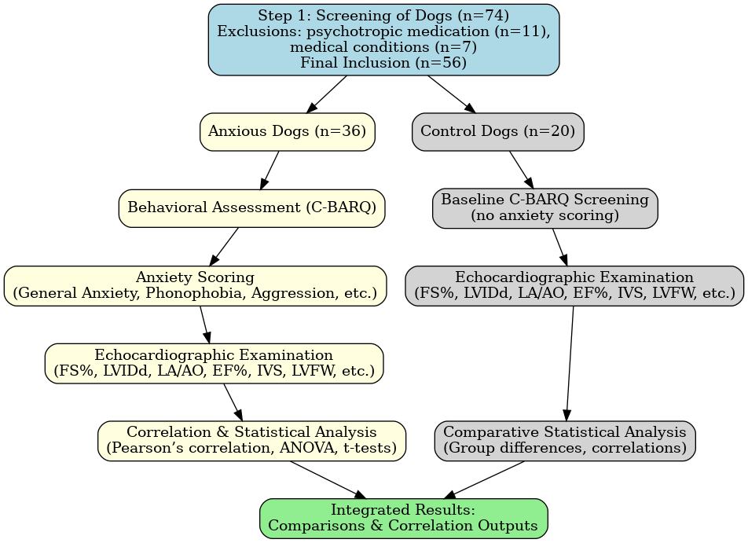
Supplementary Figure S1. Flowchart of study design and sample allocation.A total of 74 dogs were screened, of which 18 were excluded (psychotropic medication, n = 11; medical conditions, n = 7). This yielded 36 anxious dogs who met the inclusion criteria. In parallel, 20 clinically healthy dogs were recruited as controls. C-BARQ was administered in both groups; in controls, it was used only to confirm low scores across domains. Both groups subsequently underwent echocardiographic evaluation and statistical analyses (Tables 1–6; Figures 1–3)

