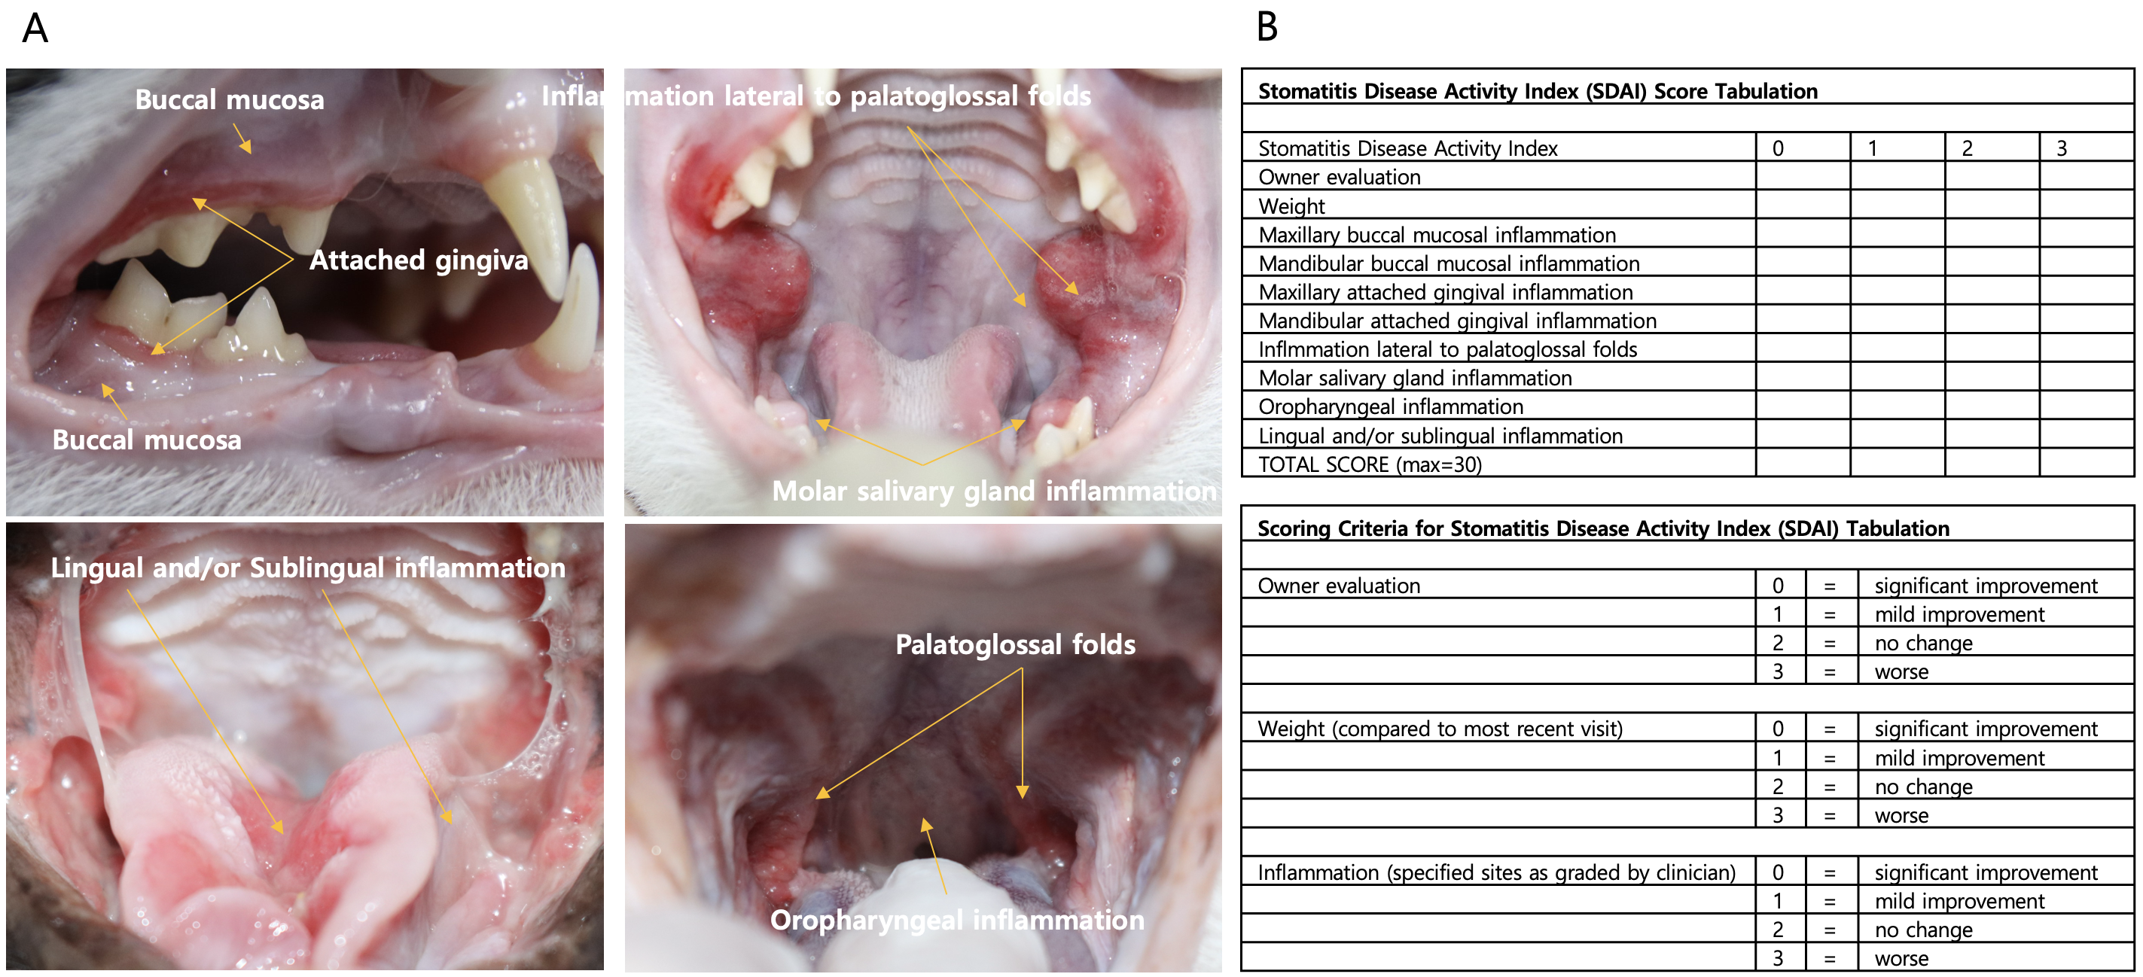
Figure S1. Representative inflammation sites and tabulation scheme for the Stomatitis Disease Activity Index (SDAI).
(A) Images show inflammation of the buccal mucosa, attached gingiva, molar salivary gland, palatoglossal folds, oropharyngeal, and lingual/sublingual areas used for scoring.
(B) The right panel summarizes the 0–3 scoring criteria applied to each component (0 = significant improvement, 1 = mild improvement, 2 = no change, 3 = worse).

