Additional File 1
Supplementary Table 1. Feed formulation for experimental fish diet.
Ingredients | % inclusion | per g/kg
Wheat meal | 32.7 | 326.85
Sunflower meal | 5.0 | 50.00
Soybean meal | 20.0 | 200.00
SPC60 | 32.4 | 323.89
Rapeseed oil | 6.6 | 65.79
Vitamin premix | 1.0 | 10.00
Lysine HCL | 0.1 | 1.47
DL methionine | 1.1 | 11.00
Gelatin | 1.0 | 10.00

Supplementary Table 2. List of primers used for the qRT-PCR analysis.
Gene name | TM (°C) | Primer name | Primer sequences (5′-3′) | Accession number
Toll like receptor 2 (tlr2) | 58 | tlr2-F | TCTCCGTCTTGGTTTCAC | NM_212812.1
 |  | tlr2-R | GGTCCCACAGTTGAGTATG
Toll like receptor 4 (tlr4) | 58 | tlr4-R | GGAATAATGGGCAGCCGTAAG | AY388400.1
 |  | tlr4-R | AGCGACACCAGGAACTATCAATG
Toll like receptor 5a (tlr5a) | 58 | tlr5a-F | ACTCCGCTGTTGCTTTGA | AY389449.1
 |  | tlr5a-R | GTTTAGACACCACGCAAATGG
Toll like receptor 5b (tlr5b) | 58 | tlr5b-F | GAAACATTCACCCTGGCACA | BC163185.1
 |  | tlr5b-R | CTACAACCAGCACCACCAGAATG
Tumor necrosis factor alpha (tnfα) | 58 | tnfα-F | AGAAGGAGAGTTGCCTTTACCGCT | AY427649
 |  | tnfα-R | AACACCCTCCATACACCCGACTTT
Interleukin 1 beta (il1β) | 58 | il1b-F | TCAAACCCCAATCCACAGAG | AY340959.1
 |  | il1b-R | TCACTTCACGCTCTTGGATG
Chemokine (C-C motif) ligand 34a (ccl34a.4) | 55 | ccl34a.4-F | TGCAGCTCAACCAGAAGATG | BC162421.1
 |  | ccl34a.4-R | CTTTGACGCATGGAGGATTT
Chemokine CXCL-C1C (cxcl18b) | 55 | cxcl18b-F | CTGCTGCTCGCGGTAGTTTA | NM_001115060
 |  | cxcl18b -R | TCAACTTTGTCGCAGTTTGG
Interferon gamma 1(ifnγ) | 56 | ifnγ-F | ATGATTGCGCAACACATGAT | AB158361
 |  | ifnγ-R | ATCTTTCAGGATTCGCAGGA
Interferon gamma related 1(ifnγ1r) | 58 | ifnγ1-F | AAATGGTGCTACTCTGTGGAC | NM_001020793
 |  | ifnγ1-R | TGGACCGTCGAAATCTGTATG
Mx protein (mx) | 62 | mx-F | AGTCTGCAGATCACCTCTGCCAAT | NM_182942
 |  | mx-R | ACCACGACCAGGTTGATTGTCTCT
Cluster of differentiation 8a (cd8a) | 56 | cd8a-F | AAGAGCATAGCACCGTAG | BC162235.1
 |  | cd8a-R | GACTTCCGTCTGCTTTGCG
Beta defensin like 1 (defβ1) | 62 | defβ1-F | TGTGCAAGTCTCAGTGGTGTTTGC | NM_001081553
 |  | defβ1-R | TTTGCCACAGCCTAATGGTCCGAA
Mucin 5.1 (muc5.1) | 56 | muc5.1-F | TGGCAACTTGGCTGATGATA | XM_009297795.1
 |  | muc5.1-R | TCGTCACACGGACCAGTAGA
Catalase (cat) | 58 | cat-F | CCAAGGTCTGGTCCCATAAAG | NM_130912.2
 |  | cat-R | GCTCAACCTCCGCGAAATA
Superoxide dismutase 1 (sod1) | 58 | sod1-F | AGGTGACTGGTGAAATTACTGG | NM_131294.1
 |  | sod1-R | GTCTCACACTATCGGTTGGC
β- actin | 58 | β-actin-F | AATCTTGCGGTATCCACGAGACCA | AF025305
 |  | β-actin-R | TCTCCTTCTGCATCCTGTCAGCAA
Supplementary Table 3. List of antibodies used for immunoblotting analysis.
Primary antibody | Antibody dilution | Catalog number  and manufacturer | Secondary  antibody | Antibody dilution | Catalog number  and manufacturer
TNF-α | 1:1000 | KP1540Z-100 (Kingfisher Biotech, Inc, MI, USA) | Anti-rabbit Ig-G-HRP | 1:3000 | #7074 (Cell signalling Technology, MA, USA)
IFN-ϒ | 1:1000 | KP1233Z-100 (Kingfisher Biotech, Inc, MI, USA) | Anti-rabbit Ig-G-HRP | 1:3000 | #7074 (Cell signalling Technology, MA, USA)
IL-10 | 1:1000 | KP1267Z-100 (Kingfisher Biotech, Inc, MI, USA) | Anti-rabbit Ig-G-HRP | 1:3000 | #7074 (Cell signalling Technology, MA, USA)
ALP | 1:1000 | GTX112100 (GeneTex, Quebec, Canada) | Anti-rabbit Ig-G-HRP | 1:3000 | #7074 (Cell signalling Technology, MA, USA)
Hsp70 | 1:1000 | #4872 (Cell signalling Technology, MA, USA) | Anti-rabbit Ig-G-HRP | 1:3000 | #7074 (Cell signalling Technology, MA, USA)
GAPDH | 1:1000 | Sc-365062 (Santa Cruz Biology Inc, OR, USA) | Anti-mouse Ig-G-HRP | 1:3000 | GTX2113111-01 (GeneTex, Quebec, Canada)

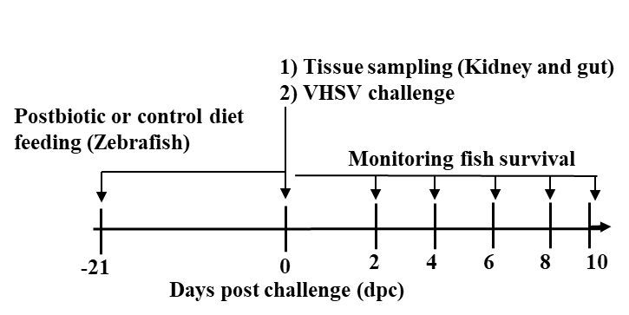

Supplementary Figure 1. Schematic representation of experimental layout and methodology.

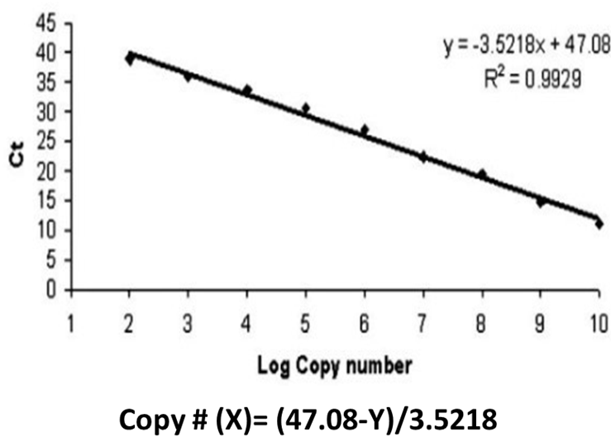

Supplementary Figure 2. Standard curve for VHSV copy number calculation. A standard curve is created using serial dilutions of a known concentration of a VHSV plasmid by analyzing the N gene expression (by qRT-PCR) and threshold cycle (Ct).

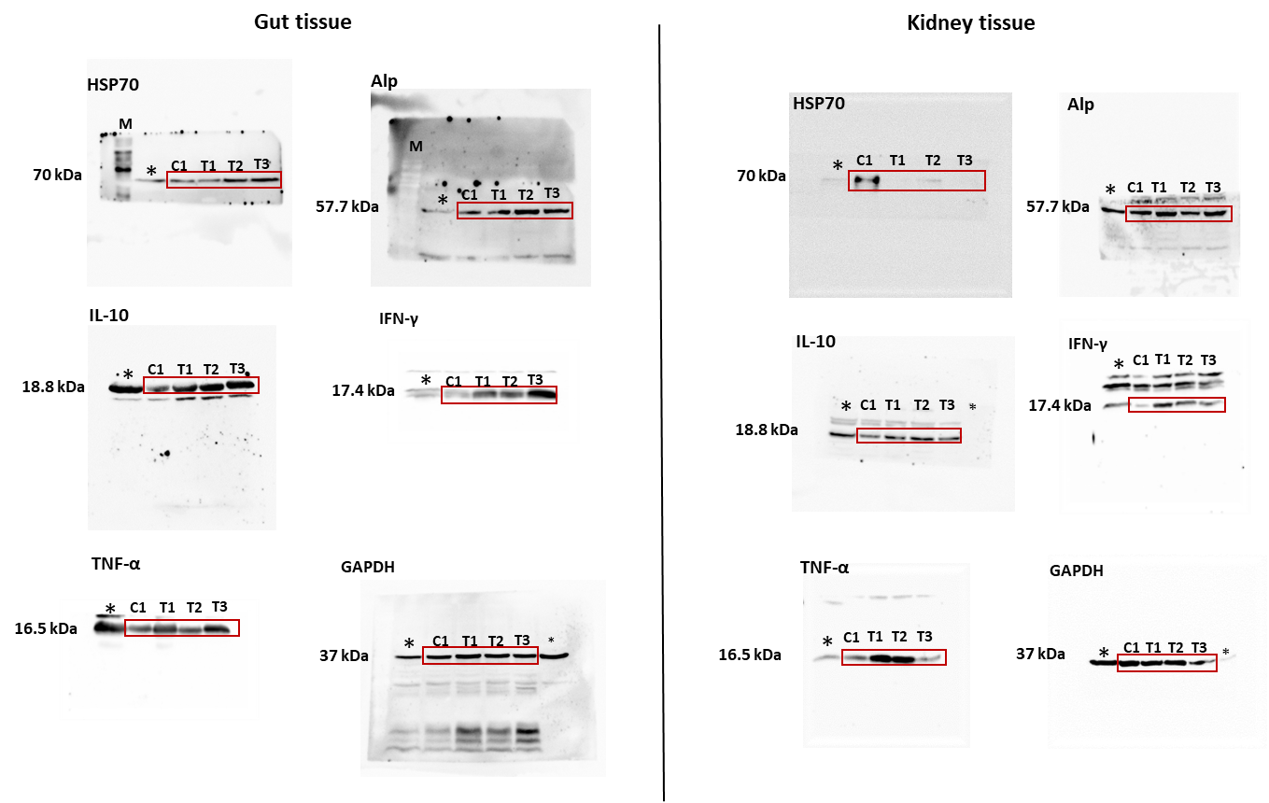
Supplementary Figure 3. Original gel blots images correspond to the western blot data presented in Figure 5. The relevant lanes with corresponding samples included Figure 5 are indicated as C1, T1, T2, and T3. To avoid the inclusion of non-specific signals, the gel blots were sectioned to retain only the molecular weight regions of protein interest prior to antibody incubation. This approach excluded areas displaying non-specific band detection. Furthermore, to minimize the background noise during image acquisition, regions showing non-specific bands were masked using a black board (Ifnγ and TNFα). This procedure ensured that only the specific protein bands of interest were visualized and presented. Lane marked in asterisk (*) represents samples not relevant to the data shown in Figure 5.

