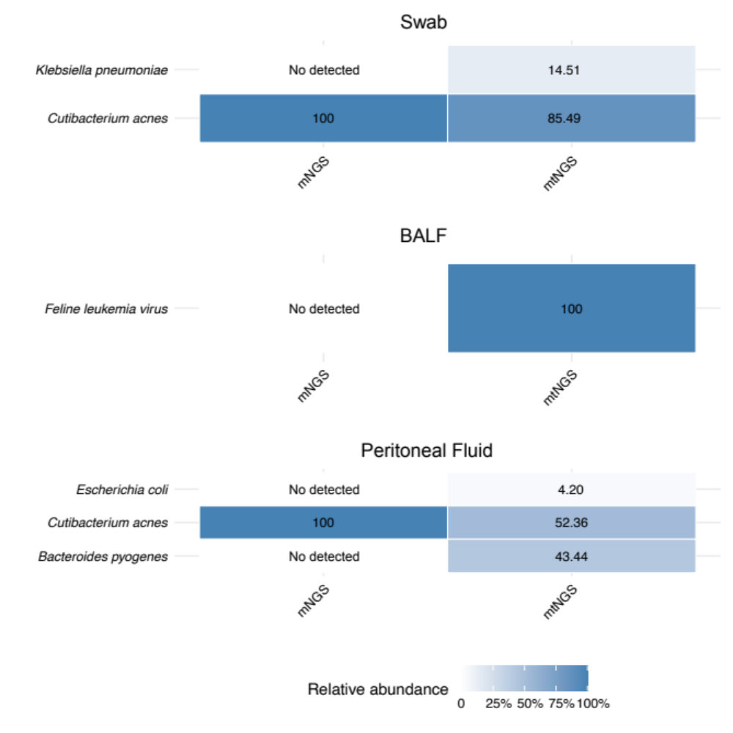
Figure S1. Heatmap of microbiome community profiles in swab, BALF, and peritoneal fluid samples obtained using the mtNGS and mNGS approach. Each heatmap displays the relative abundance of microbiome species across different groups, with cells labeled “No detected” when the species isn’t be detected. The color reflects the relative abundance.

