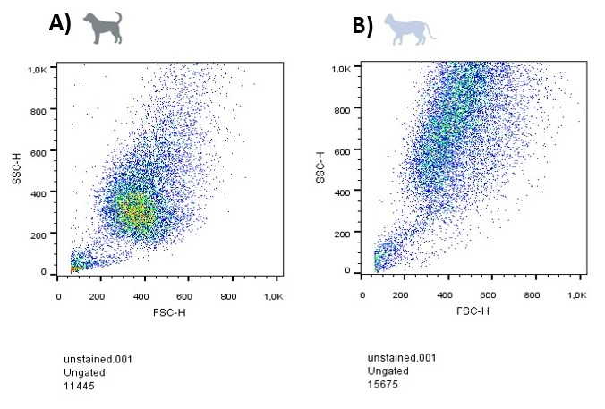
Supplementary Figure 1 – Representative cytometry plots from canine- (A) and feline-derived cells (B) for FSC and SSC parameters. Feline-derived cells exhibited slightly elevated granularity compared to canine-derived cells (SSC MFI: 262 (±16) in canine-derived cells, 369 (±21) in feline-derived cells). FSC: forward scatter, SSC: side scatter.
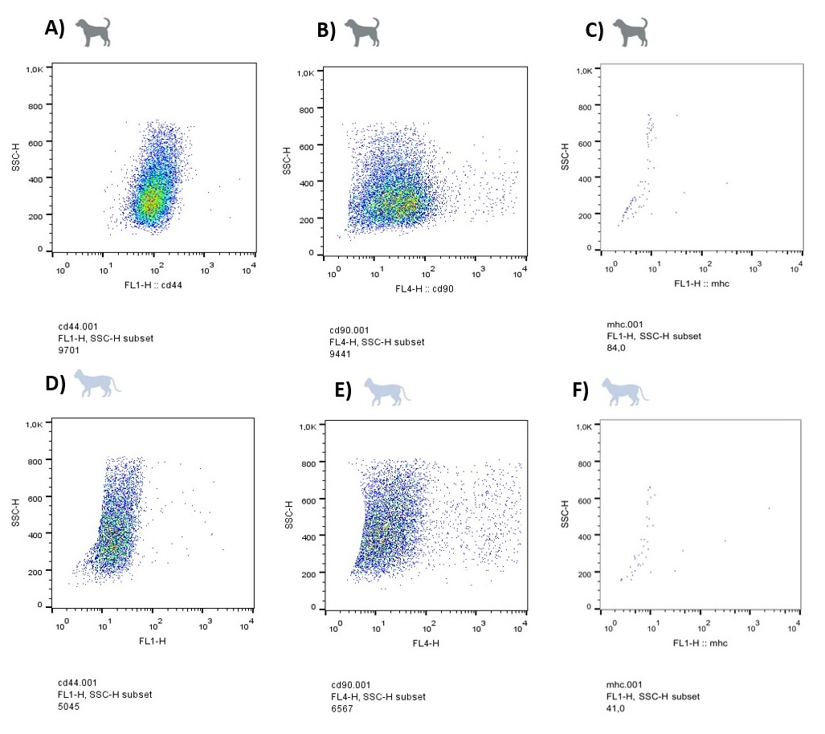
Supplementary Figure 2 – Representative cytometry analysis plots. Surface marker expression of CD44 (A), CD90 (B) and, MHC-II (C) in canine-derived cells. Surface marker expression of CD44 (D), CD90 (E) and, MHC-II (F) in feline-derived cells.

