Evidence of feline chaphamaparvovirus in dogs: molecular detection, genetic recombination, and tissue localization

Chutchai Piewbang^{1,2}, Aisyah Nikmatuz Zahro^{1,2,3}, Panida Poonsin^{1,2}, Tin Van Nguyen^{1,2,3}, Panitnan Punyathi¹, Tanit Kasantikul⁴, Somporn Techangamsuwan^{1,2,*}

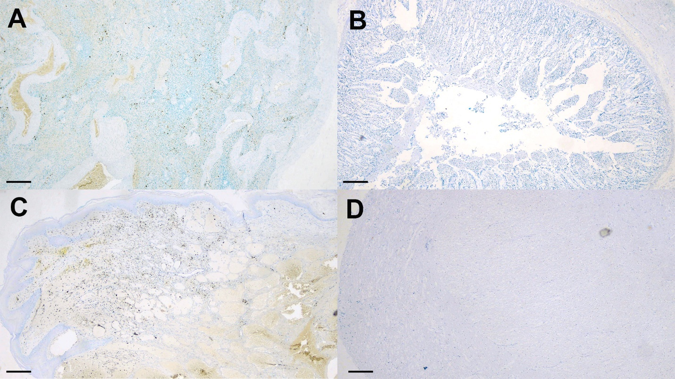
Supplementary Figure S1. Feline chaphamaparvovirus (FeChPV) infection. Case no.3. Negative controls. No hybridization signals presented in the spleen (A), intestine (B), cutaneous hemangioma mass (C), and brain (D) sections incubated with a canine bufavirus probe. Bars indicate 250 µm.

