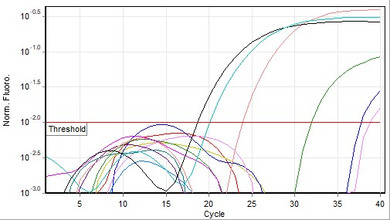

Supplementary Figure 1: Quantitation Data for Cycling A.Green: Amplification Curve for Matrix Gene.
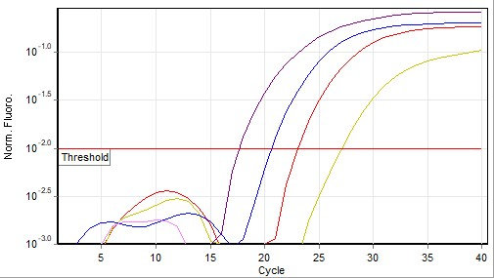

Supplementary Figure 2: Quantitation Data for Cycling A.Green: Amplification Curve for N8 Gene

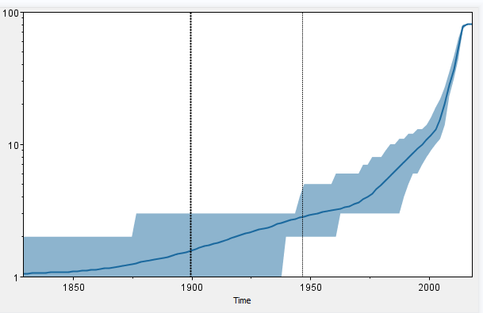
Supplementary Figure 3: Temporal variation in lineages through time in the EI H3N8 in Africa between 2018-2013.The dotted vertical lines represent the 95% HPD for the date of the root of the tree.

