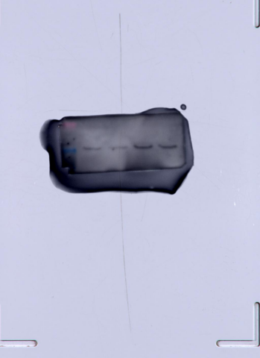
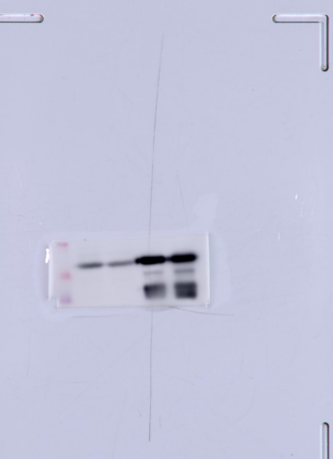
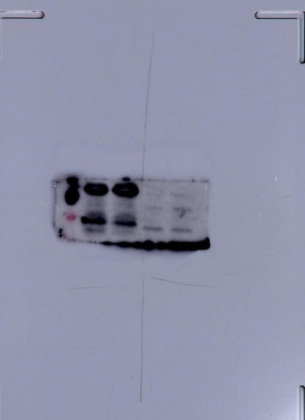
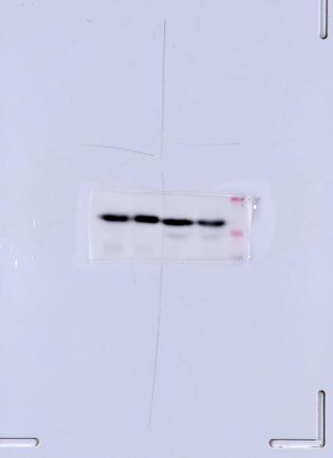
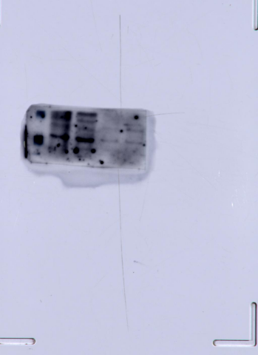
45kD
110kD
PDGFR-α
α-SMA
α-SMA
CD34
39kD
PDGFR-α
β-actin
β-actin
42kD
CD34
CD117
105kD
CD117

