Supplementary Fig. 1 Dorsal view of the dog louse fly Hippobosca longipennis: sharp and triangular apical lobes of the fronto-clypeus with straight internal margins on the head (Red arrowheads)

Supplementary Fig. 2 Wing of Hippobosca longipennis comprising pale veins with dark spots (red encircled)

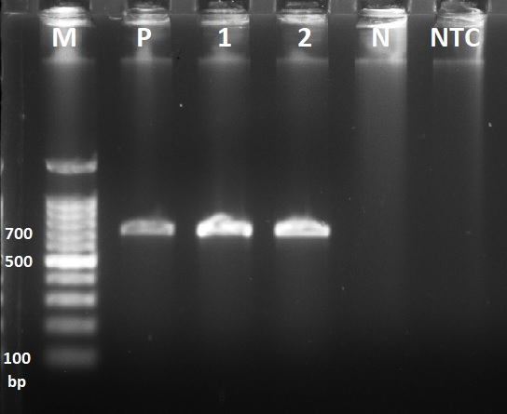
Supplementary Fig. 3 PCR amplification targeting the mitochondrial cox1 gene of invertebrates. M: 100 bp marker; P: Positive control (louse genomic DNA); 1 and 2: PCR products (Hippobosca longipennis isolates); NTC: Negative template (cestode genomic DNA) control; N: No template control

Supplementary Table 1 Details of the dog louse flies H. longipennis collected from different districts of Haryana state
S.N. | Agro-climatic zone | District | Coordinates | Number of flies collected | Municipality/Village/Area/Sub-districts | Isolates designation
1. | I | Panchkula | 30.66° N, 77.06° E | 1 | Panchkula | Panchkula Isolate I
2. | II | Hisar | 29.27° N, 75.72° E | 2 | Hisar | Hisar Isolate I
 |  |  |  |  | Hansi | Hisar Isolate II
2. | II | Rohtak | 28.89° N, 76.58° E | 2 | Rohtak | Rohtak Isolate I
 |  |  |  |  | Sampla | Rohtak Isolate II
3. | III | Bhiwani | 28.76° N, 76.13° E | 1 | Bhiwani | Bhiwani Isolate I
3. | III | Mahendergarh | 28.28° N, 76.15° E | 2 | Mahendergarh | Mahendergarh Isolate I
 |  |  |  |  | Kanina | Mahendergarh Isolate II

